

**INVITATION TO TENDER**

**FOR**

**ELECTRICAL/INSTRUMENT /TELECOMMUNICATION/ANTI-CORROSION MATERIALS FOR 60 WELLS**

**TENDER No.: CMIT-PRT-10.30-160019**

**SECTION 3**

**TECHNICAL PACKAGES**

**TABLE OF CONTENTS**

**GENERAL REQUIREMENTS**

**1.0 GENERAL** ………………………………………………………………………………………... 3

**2.0 STANDARDS AND SPECIFICATIONS** ……………………………………………………….. 4

**3.0 SCOPE OF WORK** ………………………………………………………………………………. 5

**4.0 ENGINEERING REQUIREMENTS** …………………………………………………………… 7

**5.0 QUALITY ASSURANCE, INSPECTION & TESTING** ………………………………………. 7

**6.0 GUARANTEE** ……………………………………………………………………………………. . 9

**7.0 VENDOR DATA REQUIREMENTS** …………………………………………………………… 9

**8.0 PREPARATION OF ELECTRICAL//INSTRUMENT TELECOMMUNICATION/ANTI-CORROSION MATERIALS FOR SHIPMENT** ……………………………………………... 11

**9.0 REQUIREMENT OF BIDDING DOCUMENT** ………………………………………………. 11

**10.0 PROJECT MANAGEMENT** …………………………………………………………………… 12

**TECHNICAL PROPOSAL** …………………………………………………………………………. 14

**INTRODUCTION** …………………………………………………………………………………… . 14

**SECTION I EXECUTIVE SUMMARY** ……………………………………………………….…. 15

**SECTION II GENERAL** ……………………………………………………………………………. 15

**SECTION III PROJECT EXECUTION PLAN** …………………………………………………… 17

**SECTION IV MISCELLANEOUS TECHNICAL SUBMITTALS** ……………………………… 23

**SECTION V VENDOR’ S KEY PERSONNEL** …………………………………………………... 24

**SECTION VI CORRESPONDENCE** …………………………………………………………….. 24

**ATTACHMENT A VENDOR DRAWING AND DATA REQUIREMENT FORM** …………. ... 27

**ATTACHMENT-B TABLE OF COMPLIANCE** …………………………………………………. 29

**EXHIBIT I APPLICABLE CODES AND STANDARDS**

**SPECIFICATIONS** ………………………………………………………………………..30

**EXHIBIT II MATERIAL TAKE OFFAND**

**DATA SHEETS** ……………………………………………………………………………121

**GENERAL REQUIREMENTS**

1. **GENERAL**

CNOOC IRAQ LIMITED Company is developing Missan oil field, which is located in the southern part of Iraq, in the Missan Governorate, 40 km northeast of Amarah city. Now, electrical/instrument/telecommunication/anti-corrosion materials of single well pipelines for next batch 60 wells from year 2016-2018 are to be procured for oil gathering system. This Material Requisition, together with the referenced specifications and Material take-off, describes the minimum requirements for design, materials, manufacture, inspection, testing, and supply of electrical/instrument/telecommunication/anti-corrosion materials for Single Well Pipeline and Accessory Facility Project. The purpose of this document is to define the minimum requirements of the Scope of Work, and provide references, specifications and standards, which the VENDER shall undertake. This document shall be read in conjunction with all others given in the ITT.

Compliance with the requirements of this requisition or any of the documents referred to herein shall not relieve the supplier of his responsibility to supply electrical/instrument/telecommunication/anti-corrosion materials of proper workmanship and materials conforming to good engineering practice to meet the specified conditions.

* 1. **Definition of Terms**

Within this document, unless otherwise the context requires, the following terms shall have the meaning as defined below:

Company means CNOOC IRAQ LTD Company and its successors;

Vendor means Manufacturer / Supplier of the equipment items.

**Purchase Order (or Contract)** means the document generated and issued by Company to Supplier to authorize a purchase transaction. When accepted by the supplier, it becomes a contract binding on both parties.

**Project Reference**, shall mean the CONTRACT, Codes and Standards, Specifications, data sheets, drawings and documents referenced in EXHIBIT Documents.

* 1. **Site and Meteorological Conditions**

All electrical/instrument/telecommunication/anti-corrosion materials must be designed and constructed for continuous service in the hot and dusty conditions. The ambient temperatures and conditions for the site are as follows:

|  |  |  |
| --- | --- | --- |
| Ambient Temp. | ℃ | -2～55 |
| Black Body Temp. | ℃ | 80 |
| Max Rain Fall | mm/d | 57 |
| Avg. Annual Rain | mm/a | 200 |
| Rain Interval | November up to end of March | |
| Prevailing Wind |  | NW-SE |
| Relative Humidity |  | 25%~80% |
| Maximum Wind Velocity | km/h | 80 |
| Design Wind Velocity | km/h | N/A |
| Earth Quake | Not have been seen | |
| Sand & Dust Storms have to be Seen during the Seasons | | |

1. **STANDARDS AND SPECIFICATIONS** 
   1. **General**

VENDOR shall carry out the Works in accordance with the Code and Standard, Specification, data sheets and drawings. The Project Reference, refer to the EXHIBIT I, EXHIBIT II. The design, fabrication, assembly, inspection, testing, painting, supply and shipment of electrical/instrument/telecommunication/anti-corrosion materials shall be in accordance with the latest edition of the codes, specifications and standards (including standards/specifications mentioned therein) listed in this requisition

It is assumed that the standards and specifications listed in EXHIBIT I. If however, any of the documents listed are not in the VENDOR’s possession, they are requested to obtain them from COMPANY before submission of the tender.

The VENDOR shall provide an itemized list of any comments or exceptions to the specification and its attachments. Any deviation from this specification must be approved, in writing, by Company. Such written approval must be obtained prior to the commencement of any work which would constitute such a deviation.

* 1. **Order of Precedence**

The following order of precedence shall apply.

1. Iraq Laws and Regulations
2. Latest International Codes and Standards
3. Project referenced Specifications

Vendor shall meet or exceed the requirements of the codes, regulations and standards except as superseded herein. In case where more than one code, regulation or standard apply to the same condition, the most stringent shall be followed. All specifications and publications shall be the current issue on the date.

VENDOR shall check HSE issues addressed in the Iraq regulations as part of the Regulatory review to ensure most stringent practices are adopted.

In the event of any conflict of data or requirements in any of the above documents, it is the Supplier’s responsibility to resolve these conflicts before proceeding with design, manufacture or purchase. In any case the most stringent requirement shall prevail. However, Company’s interpretation shall be the final.

* 1. **Language and Unit of Measurement**

The governing language of the contract shall be English language. All notices, correspondence, information, literature, data, manuals and other documents required under the contract shall be in English language.

Technical units, quantities, etc, are and shall be expressed, used and abbreviated according to the SI system except that the pipe size shall be in imperial units.

1. **SCOPE OF WORK** 
   1. **General**

This Scope of Work, together with the referenced specifications, describes the minimum requirements for the design, materials, manufacture, inspection, testing supply of electrical/instrument/telecommunication/anti-corrosion materials.

The quantity, size and type of the electrical/instrument/telecommunication/anti-corrosion materials to be supplied shall comply with the valve Material Take Off in EXHIBIT II and the requirements of the Company’s Standards and Specifications.

The Vendor shall have full responsibilities for the design, fabrication, transportation, shipping, testing, inspection, quality and selection of materials, and performance guarantee of the electrical/instrument/telecommunication/anti-corrosion materials, based on the relevant specification and quality of workmanship. Review of the Vendor's drawings and documents or inspection by Company/Buyer shall not relieve the Vendor of any of these responsibilities.

The electrical/instrument/telecommunication/anti-corrosion materials are expected to be supplied maximum in three batches, which is up to further decision by Company.

The Vendor’s scope of work shall include, but not limited to the following items and services:

* All electrical/instrument/telecommunication/anti-corrosion materials as specified.
* Inspection and testing as specified in the Inspection & Testing Plan.
* Packing, protection & preservation for transportation and storage and transportation.
* Vendor documentation as specified.
* Painting & coating for these manual electrical/instrument/telecommunication/anti-corrosion materials.
* Process, Mechanical and other Design / Engineering.
* All external attachments as necessary or as specified in the Specifications.
* FAT(Factory Acceptance Test). The vendor shall be responsible for 5 days accommodation and 2 ways air tickets from Iraq to the factory for 3 Company persons, travel time excluded. As materials will be divided maximum to three batches, FAT(Factory Acceptance Test) will be 3 times at maximum, which will be further decided by Company.

Sufficient descriptive information must be furnished with the bid to enable evaluation these manual electrical/instrument/telecommunication/anti-corrosion materials and their components, process and mechanical performance, quality and specification adherence.

The requirements set out in this material requisition shall not be construed to eliminate consideration of the manufacturer’s standard design. The manufacturers standard design will be accepted, if found to be equivalent or superior to the requirements of these specifications.

The Vendor shall provide any material and other accessory items, over and above that specified herein, which is required to provide a safe, workable and efficient unit. The Vendor is also required to provide performance guarantee.

Vendor shall provide the reference list evidencing the supply in recent 3 years of Vendor proposed equipment used in similar Project. Vendor is required to submit the actual application of itsproducts in services and present the main technical parameters of its products in SI format inclusive of end-user name and location, year of supply and the brand of products supplied.

* 1. **Engineering Service**

The Vendor shall provide engineering services, which shall include, but not necessarily be limited to, the following:

* Providing/coordinating detailed design of manualelectrical/instrument/telecommunication/anti-corrosion materials and components within the scope of supply.
* Resolving engineering queries related to the manual electrical/instrument/telecommunication/anti-corrosion materials and components within the scope of supply.
* Ensuring that all item and components supplied meet the requirement of this document and the specifications, standards and codes detailed therein.
* Performing and coordinating all aspects of design.
* Providing all documentation, drawings, loads, calculations, analysis, design/production schedules, sub-Vendor details etc. for Company’s review and approval.
* Providing progress reports etc.
* Providing expediting services for all sub-Vendors (if required).
* Providing quality assurance for all sub-Vendors with respect to ISO 9000.
* Quality Assurance.
* Providing operation and maintenance manual.

1. **ENGINEERING REQUIREMENTS** 
   1. The electrical/instrument/telecommunication/anti-corrosion materials shall be suitable for the service.
   2. Vendor shall be fully responsible to meet the Design Requirements indicated in the specification, and guarantee the same.
   3. A copy of the qualifying fire test certificates shall be included with the Supplier’s bid. Fire test certificates shall have been witnessed and a certificate issued by an internationally accredited inspection authority (TPI).
   4. The manufacturing process shall be certified by API.
2. **QUALITY ASSURANCE, INSPECTION & TESTING**
   1. **Quality Assurance**

The Vendor shall maintain and use a Quality System which is based on ISO 9001 to control the work. If the Vendor selects sub-contracts for part of the work, he shall ensure that only those subcontractors or suppliers are used who can demonstrate that they operate Quality Systems based on ISO 9001 or ISO 9002 as applicable. The Vendor shall give his sub-contractors or suppliers assistance in attaining the required standard, if necessary. This shall not relieve the Vendor of his responsibility for the quality of the finished work. Company reserves the right to audit theVendor’s Quality System.

The Vendor shall assign sufficient full time personnel to the project to ensure the Quality Assurance / Quality Control System, documented in a Quality Assurance / Control Manual, is maintained and kept up-to-date throughout the duration of any purchase order. The Vendor’s Quality Assurance / Control System shall become an integral part of any purchase order. Vendor shall organize a prefabrication / inspection meeting with Company.

* 1. **Inspection & Testing**

Inspection and testing shall meet the requirements of the Company’s Specification for Quality Assurance.

The level of inspection for field and shop requirements shall be in accordance with in accordance with Criticality Rating Procedure refer to EXHIBIT I.

The responsibility for quality control and inspection rests with the Vendor; however, Company may inspect the materials, fabrication, assembly and testing of the item during all phases of the work.

Inspection and testing shall be done by Vendor and some tests will be witnessed by Company or his representatives as deemed necessary.

Vendor shall permit Company’s Inspector to have unrestricted access to all areas of Vendor's facilities, including subcontractor's facilities where any phase of the work covered by this specification is being performed.

Vendor shall refer all questions relating to quality control, testing, and an acceptance of the work to Company’s Inspector.

Vendor shall be responsible for establishing a detailed inspection and testing schedule with Company. Inspection will be performed and witnessed by Third Party Inspection Agency approved by Company. Vendor shall provide an Inspection and Testing plan for Company’s approval. **A draft of Inspection Test Plan(ITP) shall be submitted together with proposals for technical evaluation.**

Company reserves the right to inspect each item. Company, at its discretion, may additionally nominate authorized inspection agency. The responsibility for inspection, certification, etc. of all materials, parts etc. lies with the Vendors.

The Vendor shall specify all of the inspection and testing requirements in the quality plan which shall identify the activities requiring Company’s approval, review, witnessing etc.

The Vendor in presence of Third Party Inspection Agency and / or Company shall conduct a

Factory Acceptance Test/ Performance Test. The test procedures and conditions shall be prior approved by Company to verify the performance of this unit.

All items shall be inspected for compliance with:

* Requirements of the Company’s specification and correspondence thereafter.
* Applicable Codes, standards and specifications, which shall also include sub-referenced standards therein.
* Test and Inspection Plans produced by the Vendor.

All items shall be presented for inspection in an unpainted state except for the final inspection. All items necessary for testing shall be supplied by the Vendor and the same shall be checked and certified by Company.

Inspectors have the right to request additional inspections or tests to ensure that the item complies with this requisition and all relevant codes and standards.

Any defects found by the Company appointed Inspector shall be rectified in his presence. Where this is not possible or practical, check lists shall be prepared and signed by Company or the Company’s Inspector stating all “pending items”. Copies of these lists shall be sent to Company to enable their subsequent checking. Mill and shop inspection shall not relieve the Vendor from his contractual responsibility for replacing any defective material and for repairing any defective workmanship that may be discovered in the field.

The Vendor shall be responsible for coordinating the inspection and testing of sub-Vendor supplied item, and for ensuring that the Company’s representatives are given the necessary access for inspection, and adequate warning of inspection and tests.

Company shall be given minimum of 10 working days’ notice prior to the carrying-out of any tests on the item covered by this requisition.

The Vendor (and all sub-Vendors) shall give Company, without charge, all reasonable facilities and access for the purpose of inspecting the item to ensure that it is manufactured in accordance with the Specification.

All spare parts shall be subjected to the same inspection standards and full material certification as the main order.

The item shall not leave the Vendor’s factory before all discovered defects have been rectified and without Company’s written permission.

Any acceptance or release of item following an inspection or test activity shall in no way relieve the Vendor of his responsibility to provide guarantees as to the suitability of the materials, workmanship and performance of the item in accordance with this requisition.

1. **GUARANTEE**

The Vendor shall guarantee the process performance and mechanical design of all items supplied under this MR when operated at the conditions specified herein. The Vendor shall specifically state the limits in the process guarantee, in terms of variance from design composition, in his proposal. The guarantee will include the following essential elements as a minimum:

* electrical/instrument/telecommunication/anti-corrosion materials shall meet the stated product quality specifications.
* The Vendor shall make, at its expense, any required modifications or additions to correct any deficiencies. The modifications or additions will be completed in the field location of Iraq.

The Vendor will warrant the item to be free of defects in material and workmanship, and that it is of adequate size and capacity to fulfill the design and operating conditions specified herein. The Vendorshall replace and install without cost to Company any materials, supplies or items which fails under design conditions due to defects in material or workmanship if the defect is observed and/or such failure occurs within one (1) year from the date such item or material is put in operation, or eighteen (18) months from date electrical/instrument/telecommunication/anti-corrosion materials achieve delivery, whichever comes first, the Vendor shall replace and install without cost to Company any materials, supplies or item involved. Acceptance of this order will signify acceptance of all conditions of this guarantee.

1. **VENDOR DATA REQUIREMENTS** 
   1. **General**

This section describes the Vendor Data Requirements applicable to a Vendor’s scope. The Vendor Data Requirements Form is provided as a separate document.

Vendor shall submit, as a condition of this Purchase Order or Contract, all data requirements specified on the Vendor Data Requirements Form. Electronic copies of all drawings will be provided in DWG format for all drawing issues.

Each document submitted for review must be clear, legible, complete and properly identified. Valve tags, instrument tags and line numbers shall conform to Company’s standards. Failure to provide adequate documents may result in them being returned without review at Vendor’s expense. In that event, Vendor will be considered not to have formerly submitted the documents so returned. Vendor shall submit all documents and drawings in format approved by the contractor. Each document shall have a title block giving the following information as a minimum:

* Company’s logo
* Document Serial Number
* Company’s purchase order no. or requisition no.
* Company’s Job no.
* Vendor job reference number
* The date and revision number of the document
* The purpose of issue or revision of the document
* The title of the document, including the contract name.
* The project name
* The signatures / initials of the person, who drafted, checked and approved the document.

Documents must have an open space 85 mm x 85 mm near bottom right hand corner to allow for supplier document review stamp. Reproducible of reduced size certified drawings shall be A3 (or by varied length).

Vendor shall submit accurate, properly checked and approved documents by the responsible Engineer(s). The documents shall be in English language.

Dimensions, weights, and measures for drawings, etc. shall be in Metric units.

* 1. **Vendor Drawing Review**

Drawings returned to Vendor for correction after mark-up by Company or his designated

representative shall be resubmitted by Vendor until “Proceed with Fabrication Issue Final Drawings”. All revisions to documents must be clouded and identified with the revision number contained within a triangle placed beside the cloud.

Vendor shall not proceed with changes having a commercial impact unless authorized by Change Order.

If, for any reason, Vendor believes that he is not able to comply with the Company’s marked-up comments on the documents returned after review, Vendor shall notify, in writing, Companyimmediately giving proper reasons / justifications and requesting a resolution which will be reviewed by the Purchased and inform Vendor regarding the decision. It is not acceptable to ignore marked-up comments without proper justification/reasons.

Drawings and data approval does not relieve Vendor of his responsibility to meet Purchase Order or Contract conditions relating to specifications, material design or construction, and delivery requirements, nor relieve Vendor of responsibility for compliance with laws, codes and regulations.

* 1. **Operations Instruction and Maintenance Manual**

Vendor shall provide Operating Instructions and Maintenance Manual in accordance with attached General Specification for Operating Manuals and Data Books.

Vendor shall also be responsible for providing manuals and other training aids such as videos for operator training.

1. **PREPARATION OF ELECTRICAL/INSTRUMENT/TELECOMMUNICATION/ANTI-CORROSION MATERIALS FOR SHIPMENT**

Preparation of the skid for shipment is a crucial step in the completion of this contract. The vendor must take into considerations that all electrical/instrument/telecommunication/anti-corrosion materials shall be prepared for ocean shipment and storage for extended periods outside in an ocean environment. Care must be taken to protect the skid from external attack by the elements and from the impact of moisture and humidity on electrical/instrument/telecommunication/anti-corrosion materials.

It is likely that a certain amount of disassembly will be required for shipment including some of the mechanical components and some instrumentation. The vendor shall provide very specific detailed instructions for reassembling the components and must assume that those doing the reassemble of the components will be unskilled.

Vendor shall be responsible for preparing the equipment for shipment in accordance with the attached Specification for Protection of Goods during Shipment and Specification for Worksite Storage and Equipment Protection.

Adoption of suitable packing methods and materials is at the sole discretion of the Vendor, and should any loss, damage and/or deterioration be caused due to improper packing, the consequences shall be the responsibility of the Vendor.

Vendors shall indicate the requirements of protection for valve shipment, storage at site and installation during construction.

Dimension limits (H×W×L) for reference: 4.3m (with 5.5 m including the trailer height)×3.2m×14.0m, Weight limit for reference: 60­80t (including the truck weight).

1. **REQUIREMENT OF BIDDING DOCUMENT**

The VENDOR should submit the Gantt chart to demonstrate the detail schedule including: PO, kick off meeting, the first time of submitting drawing, the initial time of manufacturing, FAT(Factory Acceptance Test),factory package, delivery time (from Factory to CIF Umm Qasr Port/DAP Buz/CIP Buz, Iraq)

To certificate the reality of achievement, the VENDOR should provide the copy of similar performance which has been accomplished in the other completion project.

The sign or seal of soft copies about technical bid should be coincidence with same document of hard copies.

The VENDOR should provide the evaluation letters of delivery goods about quality, after-sale service, schedule and so on. (If have)

The VENDOR should provide the ISO 9000 Certificate and QA/QC Plan.

The VENDOR should provide the specification of Quality Assurance Period of manual electrical/instrument/telecommunication/anti-corrosion materials.

The VENDOR should fill and proposal the technical deviation table.

Supplier shall submit relevant documents according to requirements the related standards. Documents shall be submitted to Buyer, detailed in ATTACHMENT A.

The VENDOR should provide the as-built drawing in English language and in format of DWG, XLS or DOC. Each kind of format will be submitted 5 sets soft copies and 5 sets hard copies at one time.

1. **PROJECT MANAGEMENT**
   1. **General**

VENDOR shall provide all management services necessary for proper execution of The Works in strict compliance with the requirements of the CONTRACT and the Contract Schedule.

VENDOR management services will include, but not be limited to:

Deploy the right quality and number of personnel and other resources in a timely manner for the duration of The Works.

Prepare and submit for approval VENDOR Organization Charts and Staffing Plans identifying by name/grade all key personnel proposed to be deployed. Provide appropriate replacements to key personnel leaving the employment of VENDOR allowing for appropriate overlap time for proper handing over of responsibilities.

Take necessary corrective action to align the Works to the Contract Schedule in case of deviations. Lead regular progress review meetings with COMPANY, Sub-vendor, VENDOR, and others to review progress, identify problem areas and initiate corrective action.

Prepare Weekly and Monthly Reports specifically for COMPANY in accordance with the requirements specified in the CONTRACT.

Ensure that VENDOR, including those notated / assigned by COMPANY, comply with COMPANY conditions.

Maintain record of all notices, correspondence, reports, documents, etc. during the course of execution of The Works. Ensure that the Project Documents are maintained for the duration stipulated in the CONTRACT.

Prepare a complete set of Management, Co-ordination, Execution, Quality System and HSE

procedures for approval by COMPANY, and ensure that the approved procedures are complied with by all concerned.

Co-ordinate and control the work of VENDOR organizations to ensure that the Scope of Work is executed in accordance with the requirements of the CONTRACT and the Contract Schedule.

Support third party technical audits as agreed and approved by COMPANY and advise COMPANY the results of each audit together with the appropriate action taken and any other recommendation for COMPANY consideration.

Continuously implement a Quality Assurance program throughout the execution of The Works and submit periodic reports of findings to COMPANY.

Ensure compliance by all its employees and those of its Sub-vendor with COMPANY HSE requirements and regulations.

Ensure compliance by all its employees and those of its Sub-vendor with the local laws. Brief the employees regarding the applicable laws and the ramifications of its violation.

* 1. **Project Execution Plan**

VENDOR shall provide a Project Execution Plan which describes all of the Project Managements Systems and execution strategies. The PEPF(Project Execution Plan) serves as an umbrella document and references to the essential Work Breakdown Structure of design and procurement services to perform all of the Scope of Work following CONTRACT commencement.

VENDOR shall develop detailed execution plans, procedures and organization charts during execution of The Works that align with this plan and organization. Any material change to this plan and organization require the prior approval of COMPANY in writing.

* 1. **Key Personnel**

VENDOR shall appoint a Project Sponsor who will act to lead the Project on behalf of the COMPANY for the duration of The Works.

Project Management and all Key Personnel shall be approved by COMPANY Organization charts shall be locked by COMPANY prior to mobilization whereupon any change to VENDOR or Sub-vendor Key Personnel requires written consent of COMPANY.

Immediately upon CONTRACT commencement, VENDOR shall establish a Project Management Team headed by a Project Manager responsible for completing The Works who shall:

* Act as single point contacts for all communication between COMPANY and VENDOR.
* Monitor and expedite all of the VENDOR and SUB-VENDOR activities to ensure compliance with the agreed schedule and the requirements of the CONTRACT.
* Develop the HSE Management System Plan and be accountable for HSE performance.
* Develop and monitor the project execution Management Plans.
* Attend the CONTRACT kick-off meeting with COMPANY.
* Attend a Pre-Inspection meeting with COMPANY.
* Attend or assign appropriate personnel to participate in technical and progress meetings with COMPANY.
* Monitor and expedite responses to COMPANY communications.
* Implement VENDOR Safety Programme
* Undertake Project cost and schedule control, progress and performance control and reporting.
* Undertake Administration, labour relations, labour welfare, liaison with government agencies, invoicing and accounting, safety and security.
* Undertake Resource Management, staffing with qualified experienced engineers, inspectors and supervision.
* Undertake Quality Management and maintain Quality Control.
* Implement Supervision and Engineering in accordance with COMPANY .
  1. **Delivery Schedule**

The CONTRACT will be valid until 2018/12/31.

Qty. of electrical/instrument/telecommunication/anti-corrosion materials marked with “OPTION” in MTO will be adjustable within the total contract value. Qty. of electrical/instrument/telecommunication/anti-corrosion materials without making of “OPTION” will all be purchased according to the quantity in MTO.

All the materials will be delivered by maximum three lots according to further decision by Company.

After the Contract is signed, CONTRACTOR shall deliver the quantity within 20 weeks to the delivery point after COMPANY officially issue Purchase Order.

* 1. **Project Controls**

VENDOR shall undertake Project progress control and monitoring requirements to maintain the Contract Schedule and cost control systems in accordance with the CONTRACT.

VENDOR is responsible to manage execution of The Scope of Work from Contract Effective Date and throughout the duration of The Works. VENDOR will provide a detailed written Project Execution Plan and Project schedules describing how The Work will be carried out according to the tender.

**PARTBTECHNICALPROPOSAL**

**INTRODUCTION**

BiddershallprovideallinformationrequestedinSECTIONSIthroughIXandusetheattachedformsasinstructed.

TherequestedinformationshallbeprovidedstrictlyinaccordancewiththeinstructionsspecifiedinPART A, INSTRUCTIONS TO TENDER.

**SECTIONI-EXECUTIVESUMMARY**

Biddershallincludeamanagementsummaryofnotmorethan5pageslistingthekeypointsofBiddercapabilities and describing the methods of execution of the WORK.

**SECTIONII-GENERAL**

1. **Endorsement Certificate**

BiddershallissueastatementconfirmingthattheBidderhasverifiedtheBidDocumentsandconfirmsthatalldataandinformationcontainedintheBidDocumentsarecomplete,adequate,accurateandcorrect to enable Bidder to realize the WORK in accordance withthe CONTRACT.

The Endorsement Certificate shall be signed by aduly authorized representative.

Failure to includetheEndorsementCertificate,withoutmodification,maybethebasisfordisqualification, at COMPANY’s sole discretion.

1. **Compliance with Bid Documents**

BiddershallissueastatementconfirmingthatBidderhassubmitteditsproposalstrictlyinaccordancewith the Bid Documents, without exception.

The Statement of Compliance shall be signed by aduly authorized representative.

Failure to includetheStatementof Compliance, withoutmodification,maybethebasisfordisqualification, at COMPANY’s sole discretion.

1. **Update of the Project Documents**

Biddershallconfirmthatwithin10daysofCONTRACTAWARDitwillupdatetheProjectDocumentstocovertheAddenda,verificationissues,andcorrespondenceandmodificationsissuedby,orarisingfrom COMPANY’ S comments and clarifications.

1. **Bidder’ s Organization and Work Load Bidder shall submit details of:**
   1. The Corporate Organization, showing the lines of authority and communication within thecorporatestructuredowntothefunctionalgrouplevel(e.g.,discipline,projectgroups)andhowtheyrelatetotheProject Team for the PROJECT.
   2. ThecompanytotalWorkLoadingraphicalformforthePROJECTduration.Separatechartsforoverallworkload,projectmanagement,engineering,procurementandconstructionshallbesubmitted.EachchartshallhighlighttheresourcesthatwillbeusedforthePROJECTandshowtheworkloadforexpectedfutureprojects.Separatechartsshallbesubmittedfortheofficeswhereprojectworkwillbeperformed.
   3. Revisions or updates of the Corporate Data and Financial Statements provided duringthePre-qualification.

If the Bidder is a Joint Venture or Consortium, each member shall provide this information.

1. **Project Experience**

Biddershallprovidealistofitsprojectsexperience,performedasMainCOMPANY,inthelast5years.Foreachproject,theBiddershallprovideabriefdescriptionoftheprojectandthelessonslearnedthatBidder considers being applicable to the PROJECT.

1. **Joint Venture/Consortium or Sub-vendor**

Bidder shallsubmitdetailsofitsJointVentureorConsortiumformedfortherealizationofthePROJECT.The following information shall be provided:

* 1. Name of the lead partner or Sub-vendor
  2. Scope of work of each partner or Sub-vendor in performing the PROJECT
  3. Notarized Power of Attorney
  4. A signed original of the Joint Venture / Consortium or Sub-vendor Agreement

1. **Parent Company Guarantee**

Bidder shall provide COMPANY with an unconditional and irrevocable ParentCompanyGuaranteefromBidder’sultimateParentCompanywhichshallobligetheparentCompanytoensuredueperformanceof the work, includingprovision of necessary financial resources.

WhereBidderisaJointVentureorConsortium,theParentCompanyGuaranteeshallbeajointandseveral guarantee executed by the ultimateparent company of each member.

FailuretoincludetheParentCompanyGuarantee,withoutmodification,maybethebasisfordisqualification, at COMPANY’ s sole discretion.

1. **Quality System**

The following information shall be provided:

* 1. Corporate Quality Policy
  2. The table of contents of the Corporate Quality Manual
  3. List of corporate quality procedures
  4. Evidence of any existing and latest quality certification, e.g., ISO9001&API certification.
  5. Latest audit report by certifying body
  6. Corporate quality assurance and control organizations
  7. Existing quality assuranceand control manpower resources

If the Bidder is a Joint Venture or Consortium, each member shall provide this information.

1. **Corporate HSE**

The following information shall be provided:

* 1. Corporate HSE Policy
  2. Corporate HSE Management System description, including Corporate HSE organization
  3. The table of contents of the Construction Safety Quality Manual
  4. List of corporate HSE (E, P and C) procedures
  5. Construction safety performance data, last 5 years

If the Bidder is a Joint Venture or Consortium, each member shall provide this information.

**SECTIONIII-PROJECTEXECUTIONPLAN**

Theexecutionplansshallbeprojectspecific,satisfytherequirementsofPARTAandcovertheitemslistedinClauses1through13below.BiddershallnotethatthelistsprovidedinClauses1through13belowarenotexhaustive.BiddershallincludeandexpandonthesetoprovideallinformationBidderconsiders relevant to enable a full evaluation of Bidder’s competency to executethe PROJECT.

Bidder’scommercialproposalshallbebasedonsuchplans,anditisCOMPANY’sintentionthatthesuccessfulBidderproceedwithTheWorkinaccordancewiththeexecutionplansincludedintheTechnicalProposalimmediatelyuponCONTRACTAWARD,thusfacilitatingarapidlaunchofthePROJECT activities.

Asfaraspracticable,theplansshouldhavesimilarstructures,e.g.,Scope,Strategy,Organization,Locationsandthelike.Further,therequirementsspecifiedineachclause(Clauses1through13)maybe broken down into more than one plan.

1. **ProjectManagementPlan**
   1. Project execution strategy and how it will be implemented
   2. Organization

* Overallprojectorganizationandworkdescriptions.
* Bidder shall provide the organization and define the scope of work and responsibilities.
  1. Planning, scheduling and project control
  2. Control of interfaces and coordination Between COMPANY and VENDOR
  3. Government approval and permits
* Principal approval bodies and required approvals and permits
* Approval organization
* Role to be fulfilled by COMPANY
  1. Communication system and information technology
* Method of communication between COMPANY and VENDOR
* Information transfer and exchange, such as document transfer
* Key hardware and software systems which will be used for the information management
* How COMPANY may interface with Bidder’ s proposed communication, data management and information systems
  1. Risk management
* Risk register, listing the risks associated procurement, construction and commissioning.
* Plan to mitigate such risks.

1. **Project Schedule**

Bidder shall provide the following items:

* 1. ProjectManagementSchedule(LevelI)identifyingallkeyprojecttasksandmilestonesfromCONTRACTAWARDtoPROJECTCOMPLETION.Thescheduleshallincludeapproximately10activities.
  2. A Level II Project Schedule developed based on the Project Management Schedule. Thescheduleshallincludenotlessthan25activitiesandshowinsufficientdetailthelogicalsequence,relationanddurationoftheentirescopeofwork,includinggovernmentapprovals,procurementanddeliveries,placement of major subcontracts, path of construction and commissioning and start up.
  3. A front end schedule covering the PROJECT
  4. A table showing the critical and sub-critical path activities
  5. A list of the delivery times for equipment and materials
  6. A list of the key project milestones

1. **Project Control Plan**
   1. Project control detailed organizationand work descriptions
   2. Preliminary project specific Work Breakdown Structure (WBS)
   3. Monitoring and controlling progress
   4. Reporting and monthly progress meetings
   5. Estimation and cost control for CHANGE ORDERS
   6. Progress curves. On the basis of the proposed WBS and associated weightings, Bidder shall establish a planned Progress Curve for the PROJECT. This progress curve shall form the basis for the Progress Payment Schedule and shall be agreed with COMPANY prior to CONTRACT AWARD.
   7. Manpower histograms showing manpower loading for all phases of the PROJECT at all locations. Separate histograms shall be prepared for total manpower, project management, engineering, procurement, construction and commissioning and start-up histograms and for each project location. For construction and commissioning, Bidder shall also show direct and indirectman-hoursandindicatethe envisaged Iraq/non-Iraq percentage.
2. **Coordination Plan**
   1. Detailed execution strategy and how it will be implemented
   2. Coordination with VENDORs and Sub-vendor
   3. Document Control

* Documents review and approval by both, VENDOR and COMPANY
* VENDOR and sub-vendor documents review and approval
* Electronic document management systemforVENDOR’s documentsandVENDORandsub-vendor documents
  1. Coordination with engineering and construction
  2. Management of changes, from engineering through construction, including VENDOR andsub-vendors

1. **Procurement Plan**
   1. Detailedexecutionstrategy,includingstrategyforprocuringgoods,andhowitwillbeimplemented.BiddermaysubmitwithitsproposaltoaVENDORList.COMPANYhastherighttoauditthislisttoensure that the proposed VENDORs meet the qualification criteria.
   2. Organization
   3. Coordination

* With engineering and construction
* With quality control in relation to testing and inspection
* With COMPANY
* With VENDORs
  1. Enquiry, evaluations and order placement
  2. Early purchase of equipment and materials
  3. Procurement in Iraq, including extent, control and reporting
  4. Expediting
  5. Use of third parties for expediting and inspection
  6. Document control and reporting
* Requisitions
* Evaluations
* Purchase orders
* Material exception reports

1. **Logistics and Shipping Plan**
   1. Detailed execution strategy
   2. Organization
   3. Coordination

With engineering, procurement and construction

With quality control in relation to final inspection

With COMPANY

With VENDORs

With forwarders

* 1. Marshaling areas, location and their management and control
  2. Ports of entry, location and assessment of port facilities
  3. Heavy and large cargos, including loading and unloading, and overland routes for major equipment and required permits
  4. Special temporary work, such as temporary lay down areas, road improvements
  5. Import permits and Customs clearance

1. **Quality Plan**
   1. Project quality management system
   * Project Quality Policy
   * Management commitment
   * Organization and responsibilities
   * Planning and execution
   * Control
   * Measurements
   * Improvements
   * Audits and non-conformances
   1. Quality control in design
   * Organization and responsibilities
   * Coordination with engineering, procurement and construction, and with COMPANY, VENDOR and Sub-vendors.
   * Review and approval of engineering deliverables
   * Non-conformance control system
   * Engineering audits
   * Reporting
   1. Quality control during procurement
   * Organization and responsibilities
   * Coordination with COMPANY, Sub-vendors, engineering, construction including roles and responsibilities of the procurement organization and the engineering organization in relation to inspection of purchased goods
   * Assignment of inspectors and their qualifications
   * Non-conformance control system
   * Reporting
   1. Site quality control
   * Organization and responsibilities
   * Coordination with COMPANY, and Sub-vendors
   * Assignment of inspectors and their qualifications
   * Non-conformance control system
   * Methods and reporting
   1. Quality audits, corrective actions, reporting and follow up
   2. A draft of ITP for materials listed in the MTO.
2. **HSE Plan**
   1. Project HSE Policy and objectives
   2. Project HSE Management System
   3. HSE in engineering and procurement, covering such aspects as detailed organization and work descriptions, meetings, communication and coordination, design and HSE reviews, and audits
   4. HSE in construction, covering such aspects as detailed organization and work descriptions; Site HSE committee; meetings; communication and coordination; number and types of training (e.g., induction, supervisors, labour, task specific training); incentive schemes; personnel protection; site supervision; job safety analysis and work permits; incident investigation and reporting; measuring performance and reporting; inspections and site visits, audits, reporting and follow up;andmedicalemergencies and evacuation plan.
3. **DATA SHEETS**

Data sheets in EXHIBIT II shall be completed and submitted together with proposals for technical evaluation.

Design drawings & documents available shall be submitted together with proposals for technical evaluation.

**SECTIONIV-MISCELLANEOUS TECHNICALSUBMITTALS**

Bidder shall include in its proposal the following items for the Tender.

* Estimated number of deliverables
* Bill of Quantitiesin accordance with MTO
* Estimatedman-hoursforcompletingTheWorksincludingcivil,installation,testing,commissioning & start up and training etc.

**SECTION V - VENDOR’ S KEY PERSONNEL**

BiddershallprovidetheCurriculaVitae(C.V.)oftheindividualsthatBidderproposesforeachofthefollowing positions:

1. Project Manager
2. Project HSE Manager
3. QA/QC manager
4. Site Manager
5. Site Specialist (at least 1 people)

Analternatecandidateshallalsobeproposedforeachoftheabovepositions.ForeachcandidateCVshallbeprovidedshowingthecandidate’sage,nationality,proficiencyinEnglishlanguages,yearswith company and position or grade within the company, qualifications and experience.

BiddershallconfirmthatsuchpersonnelareavailabletoworkontheProjectasrequiredbytheschedule.

Theywillbeassignedfulltime.KeypersonnelwillnotberemovedwithoutCOMPANY’sapprovalinaccordance with the CONTRACT.

**SECTION VI - CORRESPONDENCE**

Bidder shall list the correspondence, including the Addenda, exchanged duringtheproposalpreparationbetween Bidder and COMPANY.

1. **General**

Correspondencesincludeletters,faxes,technicalmemorandum,internalnotes,minutesofmeetingandtransmittal sheets.

* Letters are used for dealing with contractual and commercial issues.
* Facsimiles are used when necessary for timely communication.
* Technical Memorandums are used for clarification or for agreement of technical issues.
* Internal notes are used to formally record any internal discussion or agreement.
* Minutes of Meeting are used to maintain a formal record of meetings.
* Transmittalisacoversheet,addedtoreports,drawings,manualsandothermiscellaneousdatathat are transmitted from one party to another.
* E-mailisnotaformalexternalcommunication.Itshallbeusedforinformalcommunicationandforelectronictransmissionofcopiesofcorrespondencesuchasletters,faxesandtransmittalcoversheets.

Allnotices,correspondences,communicationsandstatementsmaybemadeintheEnglishorChineseor Arabian language based onusing requirement.

Alltelephoneandverbalcontactsoragreementshallbeconfirmedbyletterorfaxandthenameofthepersons involved shall be clearly mentioned.

All contractual matters shall be treated by letter only.

Lettersandtransmittalsofdocumentswillbesentbycourierservice.Receiptoftransmittalssentbythecourier shall be acknowledged by returning by fax or by mail acopy signed off and dated.

Invoicing is subject to particular invoice procedures.

ThetransmittalnoteofalldocumentstransmittedtotheCOMPANYrequiringrevieworapprovalbytheCOMPANY,shallbeaccompaniedwithanacknowledgementofReceiptandaCOMPANYReviewReturn.

InternalnotesandMinutesofMeetingcanonlybedistributedexternallyundercoverofaletter,faxortransmittal cover sheet.

All letters or fax, which may have Contractual, Financial or Schedule impact shall besent to the leader.

AllotherdocumentswillbedistributedusingaDistributionListdefinedbytheissuer.TheFormatforLetters,Faxes,Internalnotes,MinutesofMeetingandTechnicalMemorandumareincludedinAppendices (to be defined).

1. **Communications**

VENDORshallbethefocalpointforallcorrespondenceswithRELEVANTPARTY,inparticularallwrittencommunicationwiththeVENDORwillbereviewedandtransmittedunderhisnameandsignatory, or a designated authority.

The authorized signatories of the correspondence are detailed in Appendices (to be defined).

TheaddressesandphonenumberstobeusedforthecompanyareenclosedinTheCompanyTelephoneDirectoryavailableontheCompanysecretaries’office.EachPartymaychangetheiraddress by giving the other Parties ten (10) days prior written notice of such change.

1. **Letterheads and logos**

AllcommunicationsbetweenVENDORandRELEVANTPARTYshallbecarriedoutusingletterheadsand logos.

1. **Addresses**

Allnoticesorcommunicationsrequiredorpermittedundertheprovisionsofthedocumentshallbeissuedinwritingandshallbesentbyfaxandregisteredmailwithacknowledgementreceiptrequested,senteithertotheVENDOR,andtheRELEVANTPARTY,attheaddressessetforthinAppendices(tobe defined).

**ATTACHMENT A - VENDOR DRAWING AND DATA REQUIREMENT FORM**

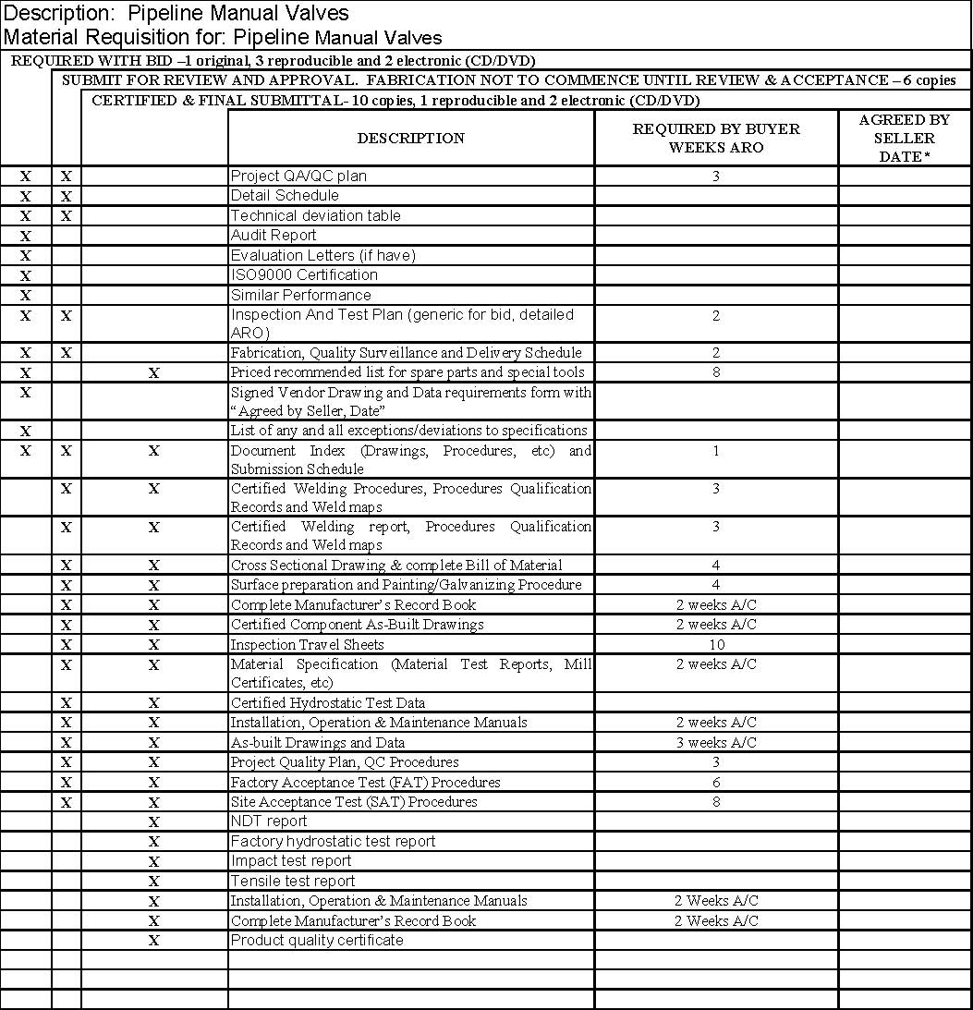

A/C – After Completion ARO – After receipt of Order *Seller to complete and return with bid

Notes: •

Vendor shall submit all deliverables within the period as indicated; •

All the documents shall be in English language; •

Final certified drawings and documents shall be submitted within two weeks of fabrication and testing completion; •

Vendor shall submit all the documents & drawings required along with their bid without which the offer will be deemed incomplete & liable for rejection.

Certified correct data and drawings are required within two (2) weeks after return of “For Approval” data and drawings;

All data and drawings are required by final invoice, if not a “Vendor Data Retention” will be held back until receipt of data and drawings;

Reduced size reproducible A3 (or by varied length). Reproducible copies required if larger than 11” X 17” (A3);

Cost of above prints must be included in the quotation;

All drawings must show equipment tag numbers and P.O. numbers. Faxed documents must be followed by originals. Final drawings must be certified.

All drawings must show Company / EPC Contractor name, Project Title, Drawing number, Revision number.

All deliverables shall be submitted by official Transmittals;

Submit all documents via courier service;

The submitted documents shall be accurate, checked and signed by responsible Engineer(s).

Marked “X” means applicable.

**ATTACHMENT-B**

**TABLE OF COMPLIANCE**

The VENDOR shall submit the completed Table of Compliance, as a part of the technical offer. The VENDOR shall confirm compliance with each clause of this requisition/specification by writing, “yes” in the column headed “Compliance”. Where the VENDOR is unable to comply with a particular clause, the VENDOR shall write “no” in the column headed “Compliance” and shall describe the deviation with a full and complete justification in the appropriate adjacent cells, which may be extended on separate page(s) as required. Technical offers with an incomplete Table of Compliance will not be considered during technical evaluation.

|  |  |  |  |
| --- | --- | --- | --- |
| **Scope of Work Ref. Clause No.** | **Compliance (Yes/No)** | **Deviations** | **Justification / Remarks** |
| 1.0 |  |  |  |
| 1.1 |  |  |  |
| 1.2 |  |  |  |
| 2.0 |  |  |  |
| 2.1 |  |  |  |
| 2.2 |  |  |  |
| 2.3 |  |  |  |
| 3.0 |  |  |  |
| 3.1 |  |  |  |
| 3.2 |  |  |  |
| 4.0 |  |  |  |
| 4.1 |  |  |  |
| 4.2 |  |  |  |
| 4.3 |  |  |  |
| 4.4 |  |  |  |
| 4.5 |  |  |  |
| 4.6 |  |  |  |
| 4.7 |  |  |  |
| 4.8 |  |  |  |
| 4.9 |  |  |  |
| 4.10 |  |  |  |
| 5.0 |  |  |  |
| 5.1 |  |  |  |
| 5.2 |  |  |  |

|  |  |  |  |
| --- | --- | --- | --- |
| **Scope of Work Ref. Clause No.** | **Compliance (Yes/No)** | **Deviations** | **Justification / Remarks** |
| 6.0 |  |  |  |
| 7.0 |  |  |  |
| 7.1 |  |  |  |
| 7.2 |  |  |  |
| 7.3 |  |  |  |
| 8.0 |  |  |  |
| 9.0 |  |  |  |
| 10.0 |  |  |  |
| 10.1 |  |  |  |
| 10.2 |  |  |  |
| 10.3 |  |  |  |
| 10.4 |  |  |  |
| 10.5 |  |  |  |
| Attachment-A |  |  |  |
| Attachment-B |  |  |  |

**EXHIBIT 1.**

**APPLICABLE CODES AND STANDARD SPECIFICATION**

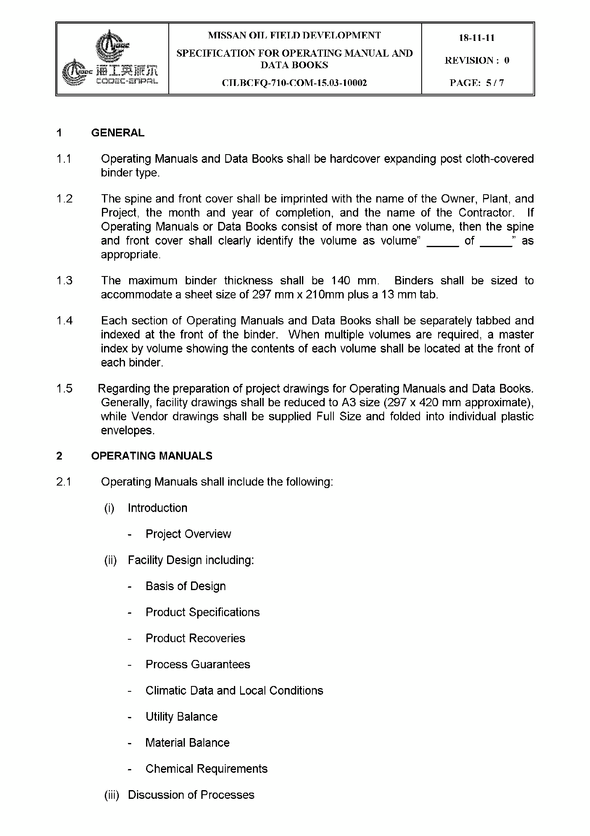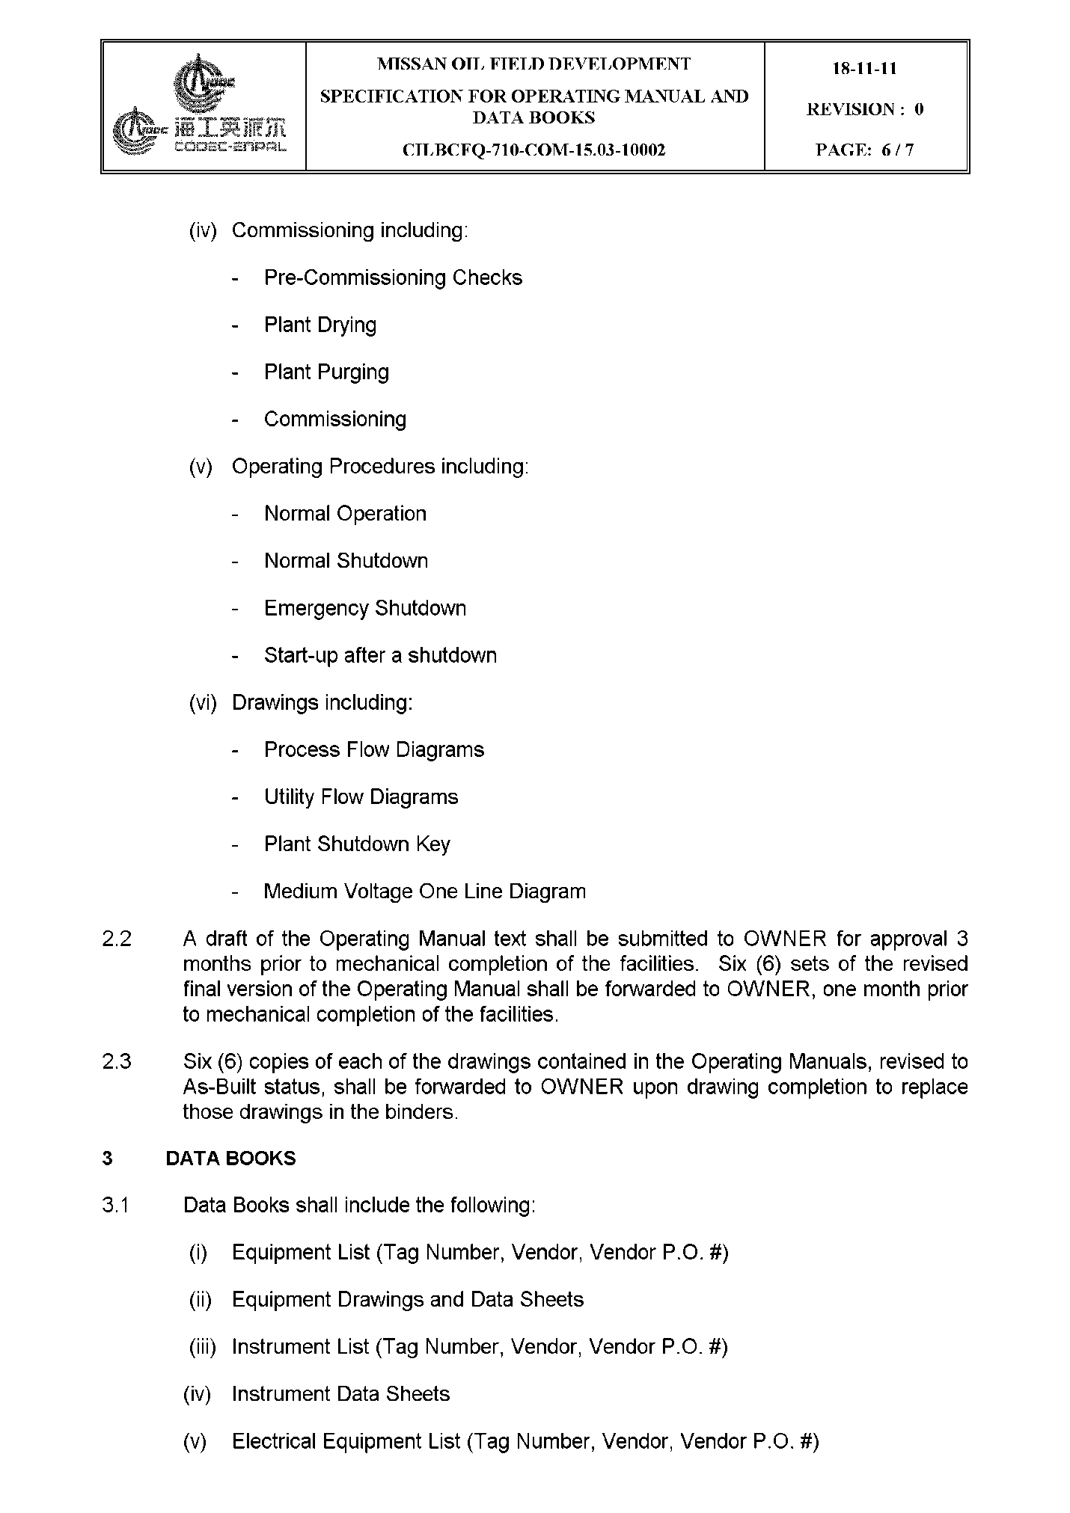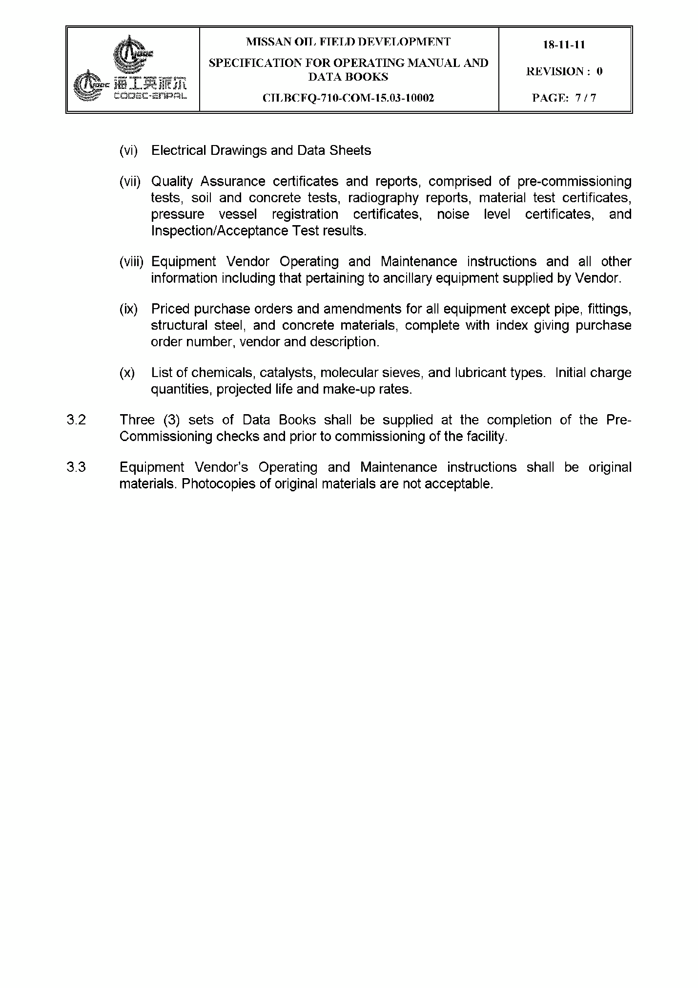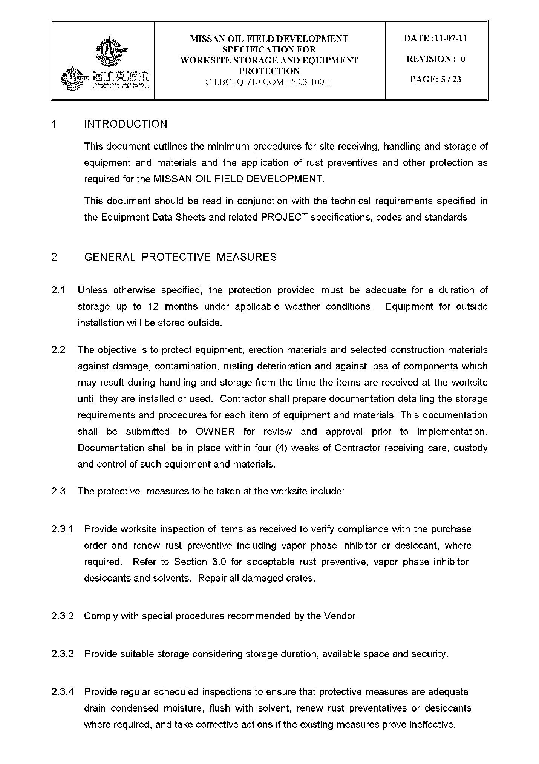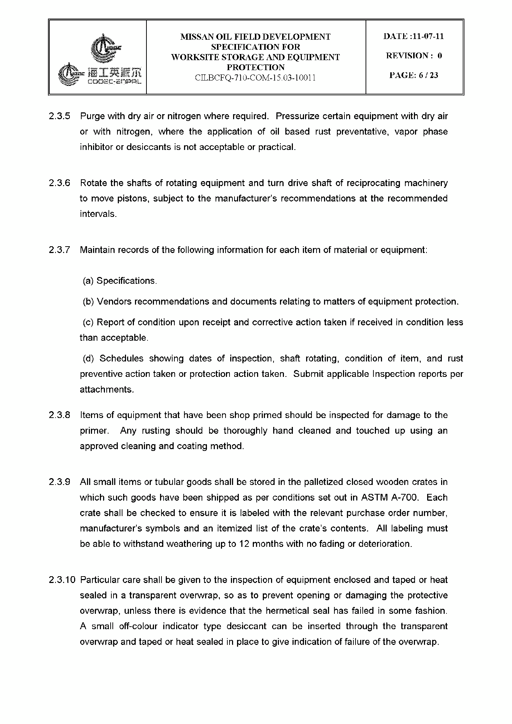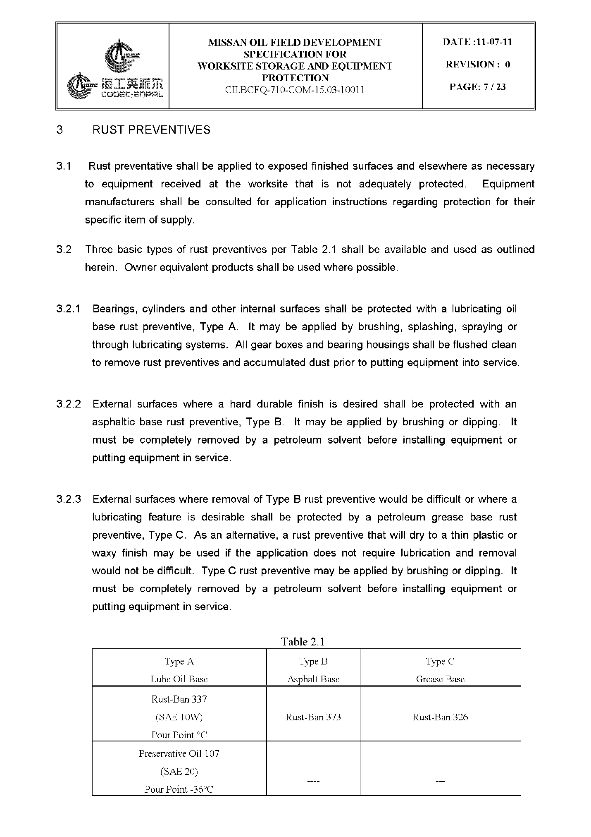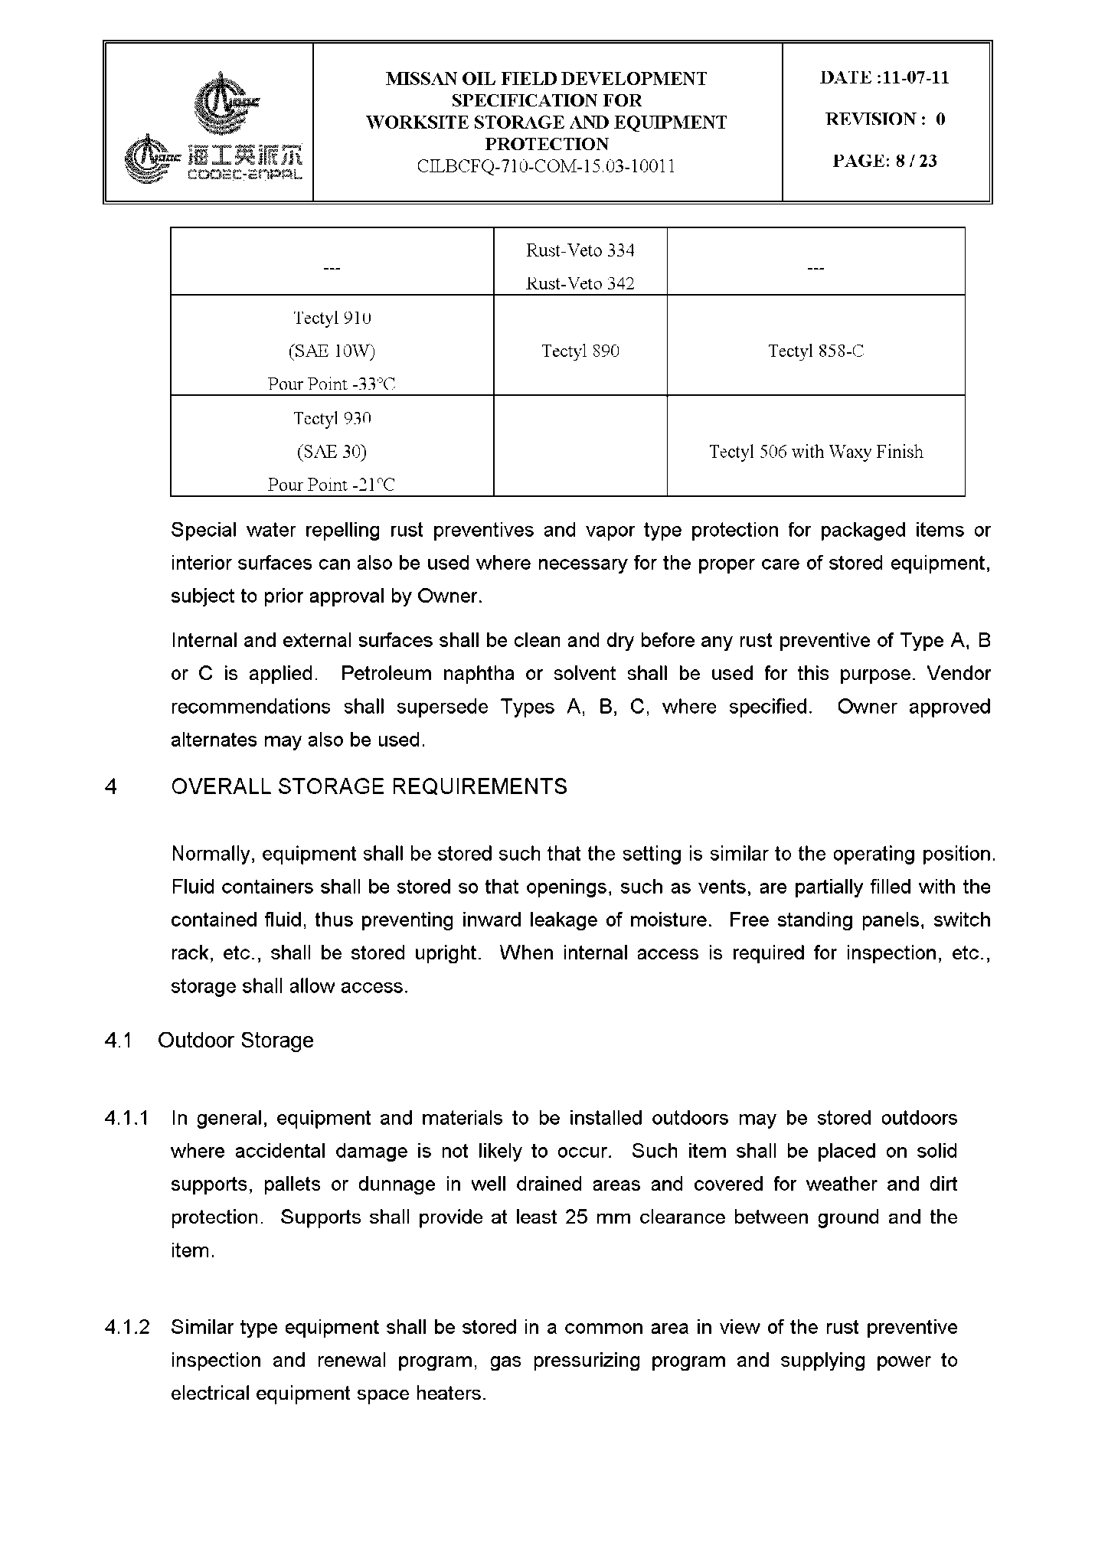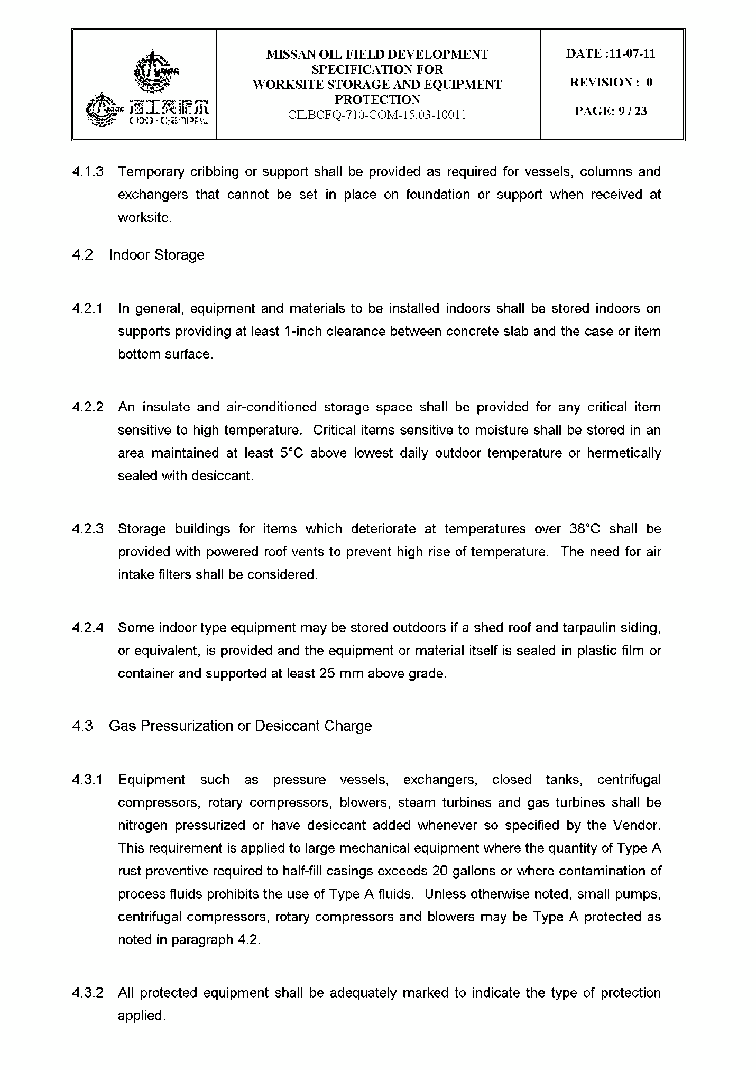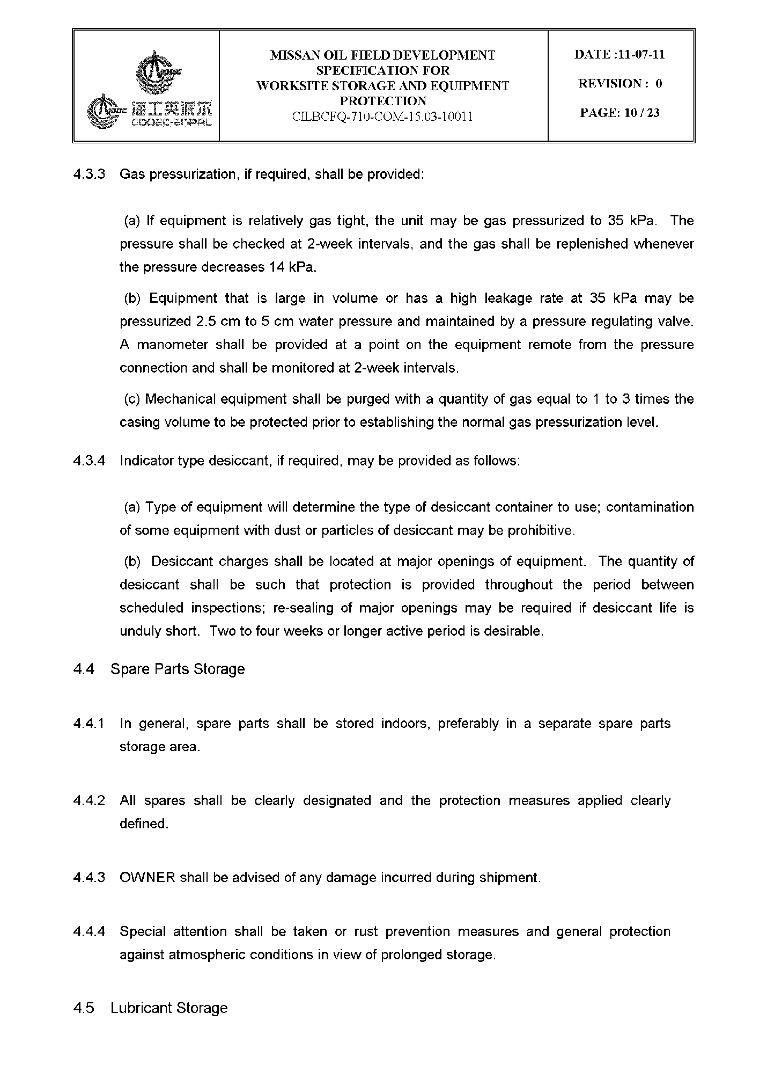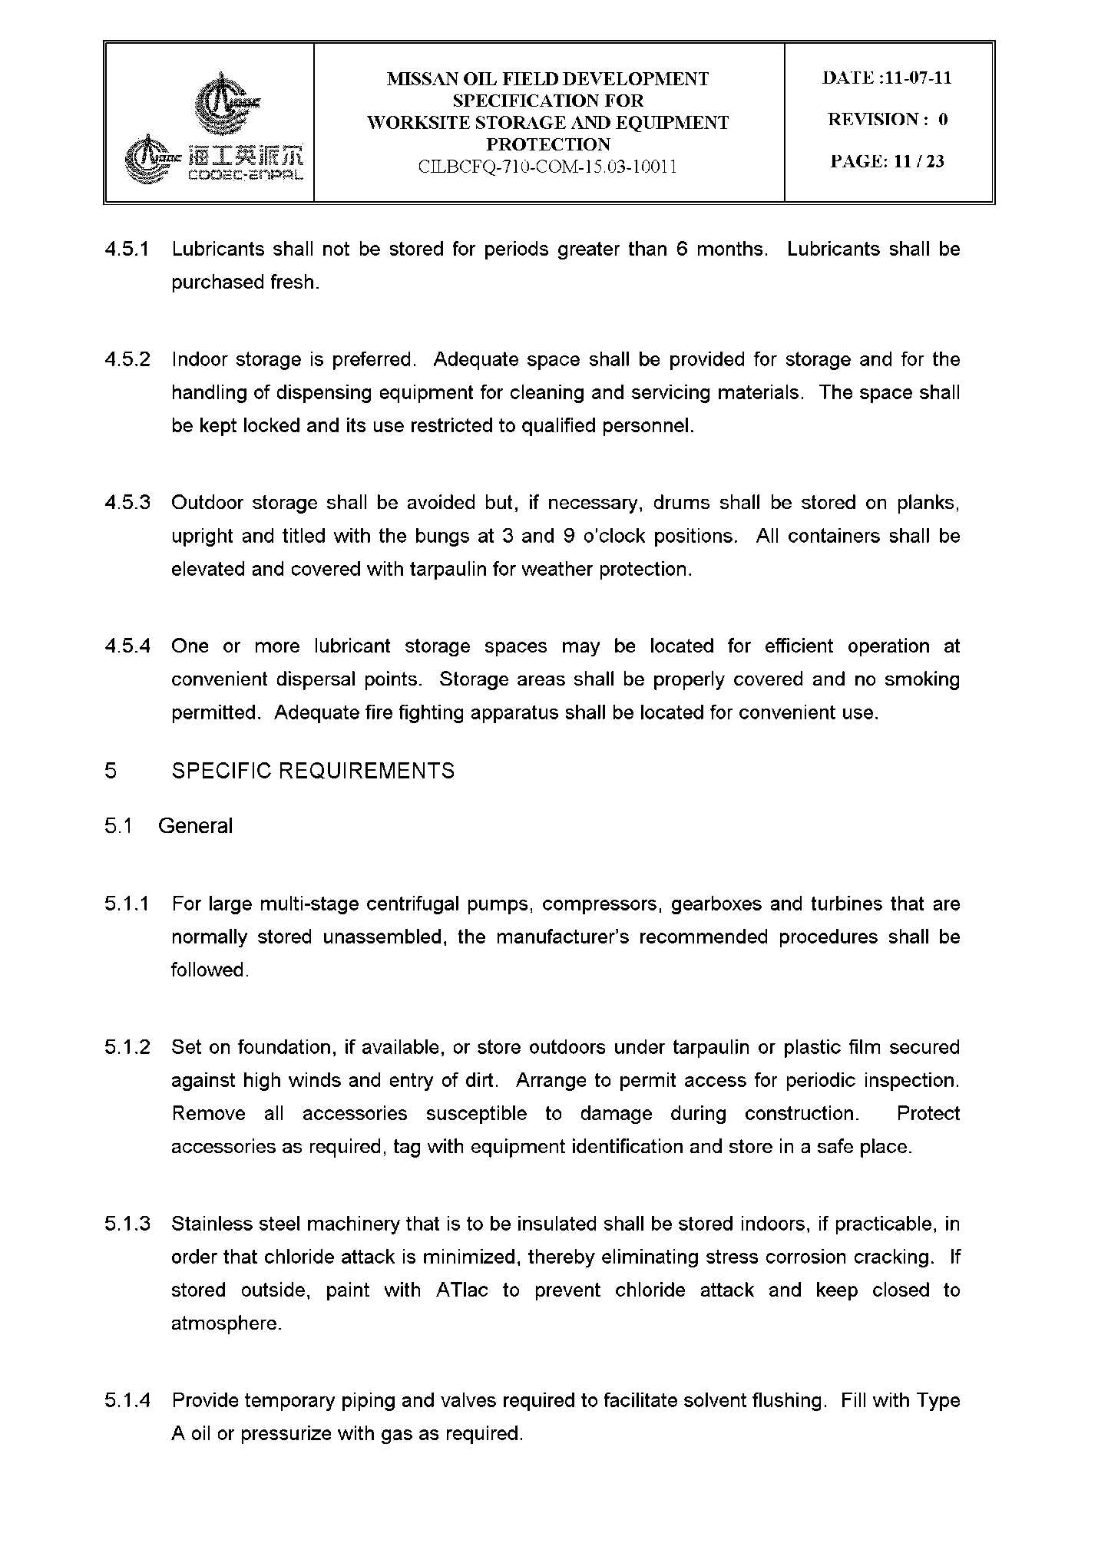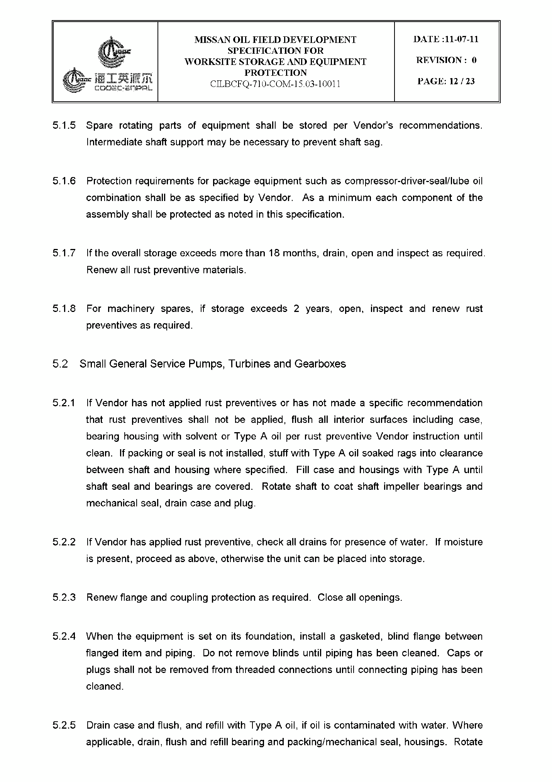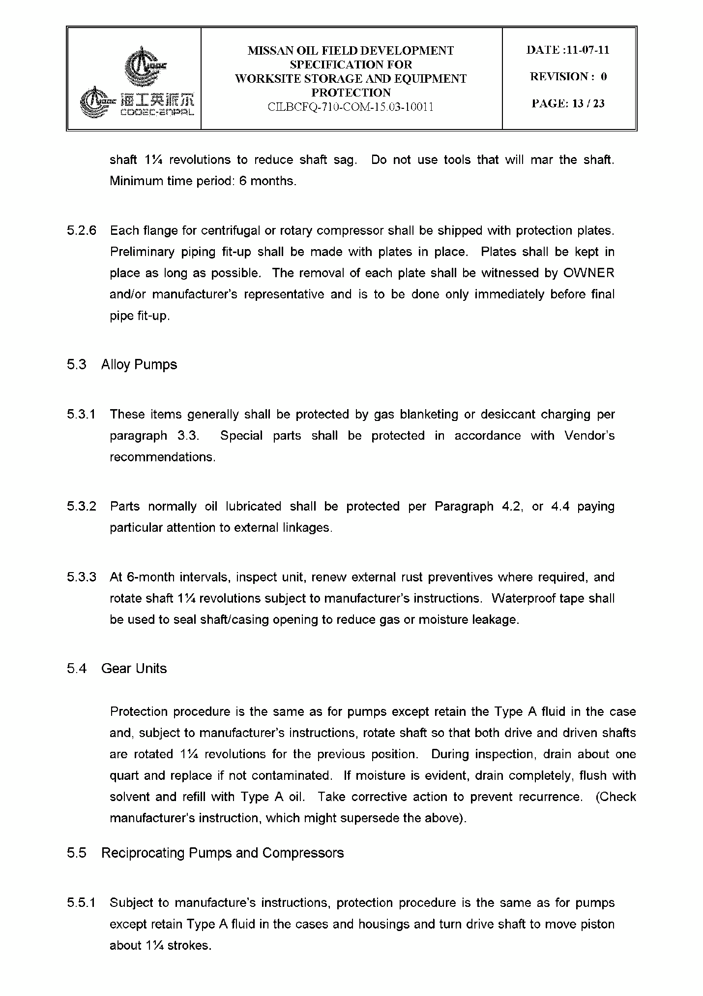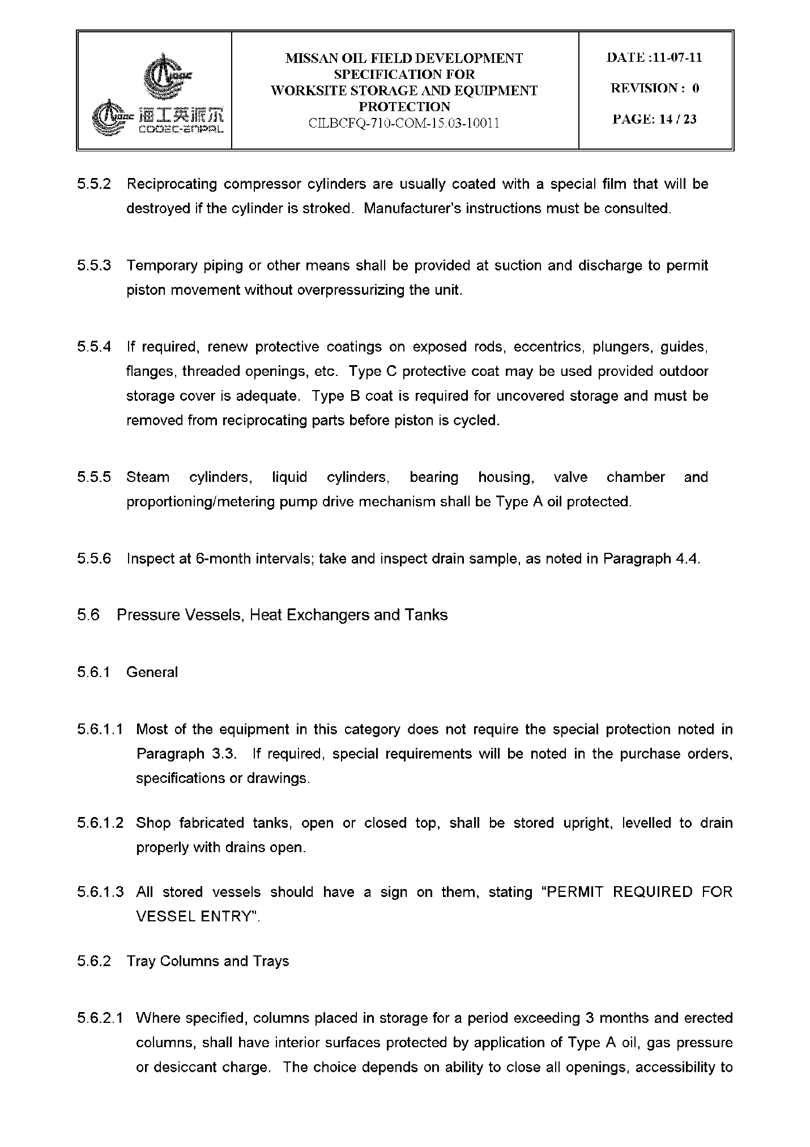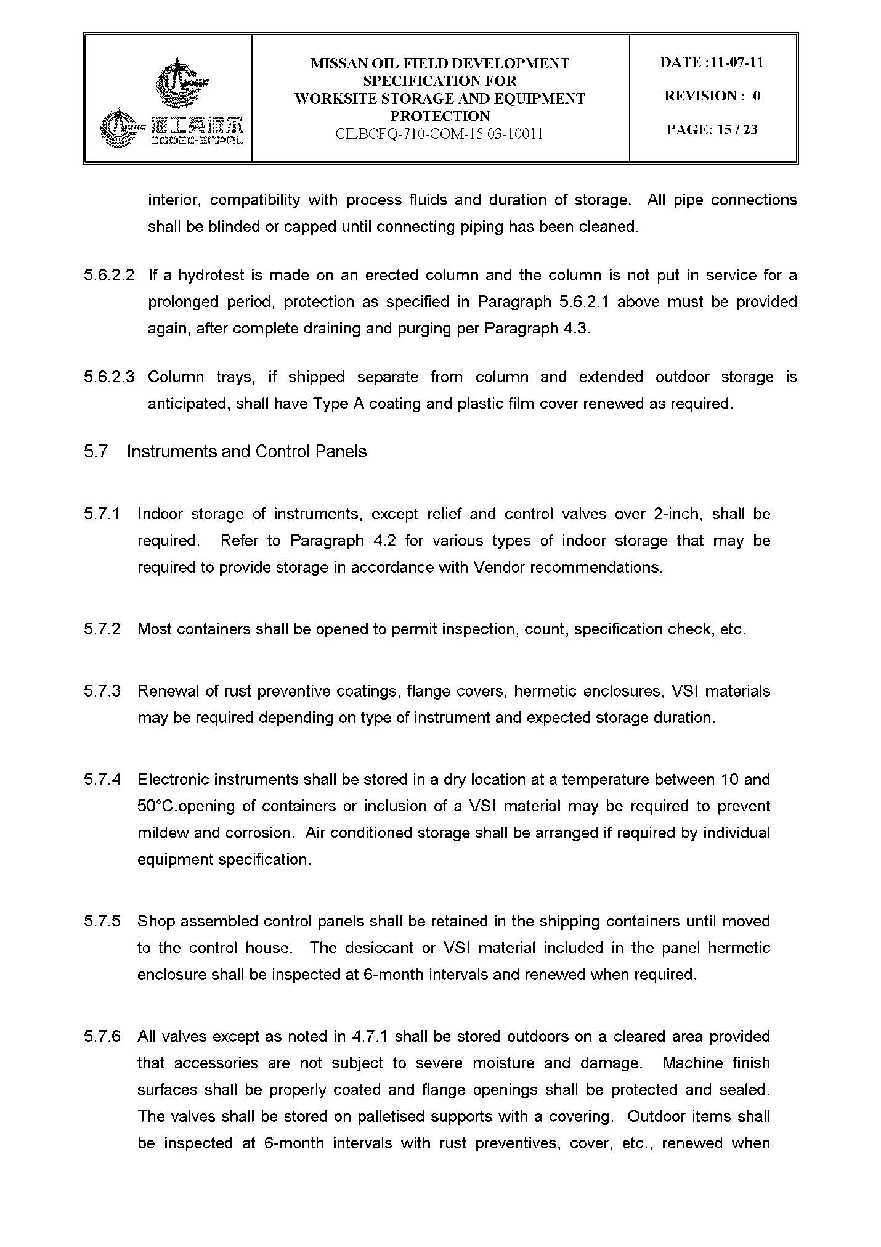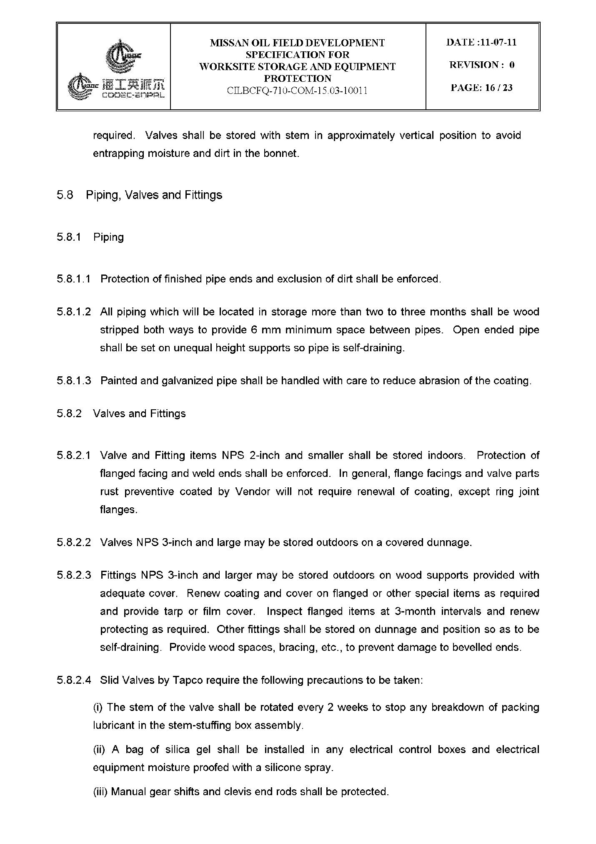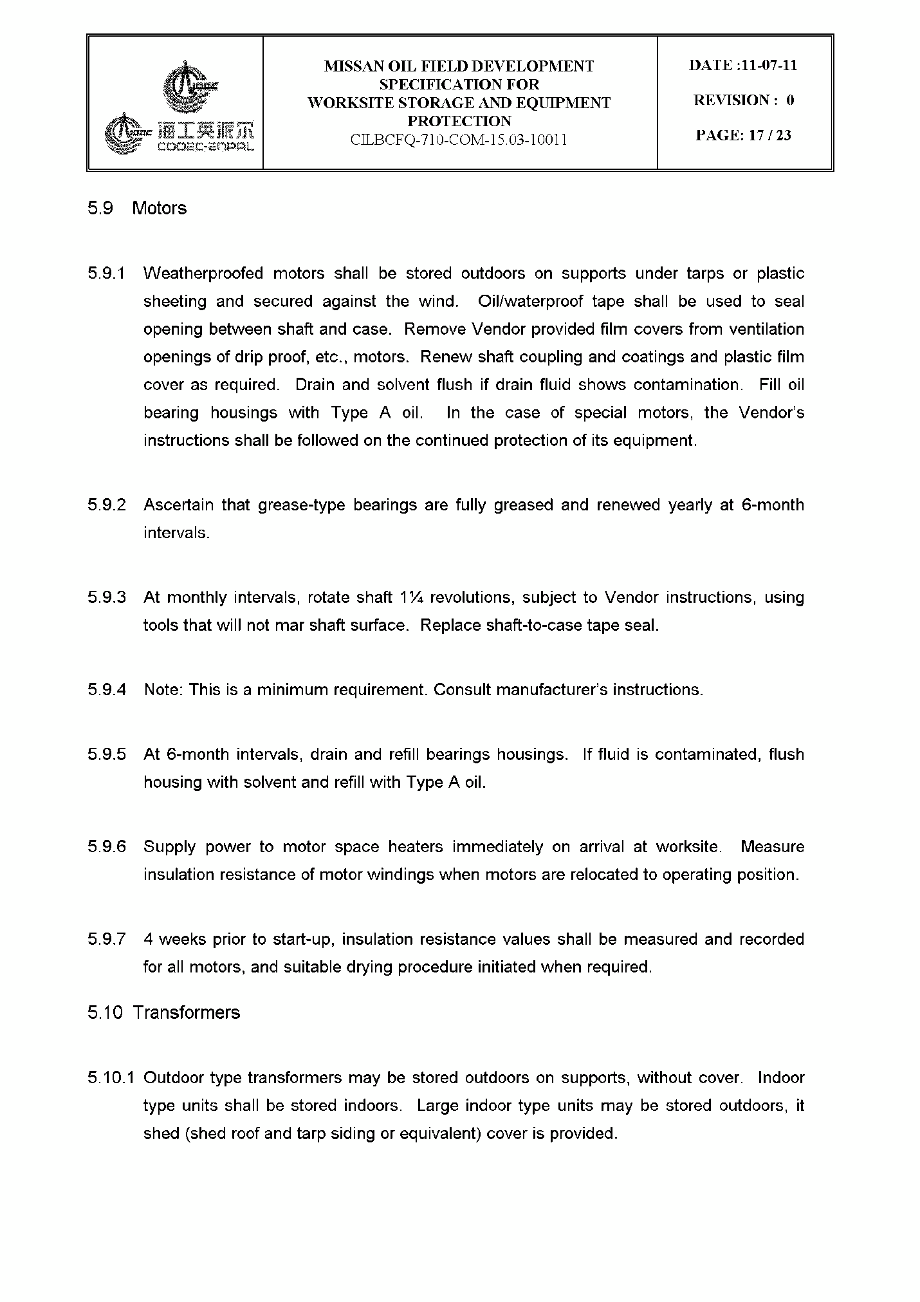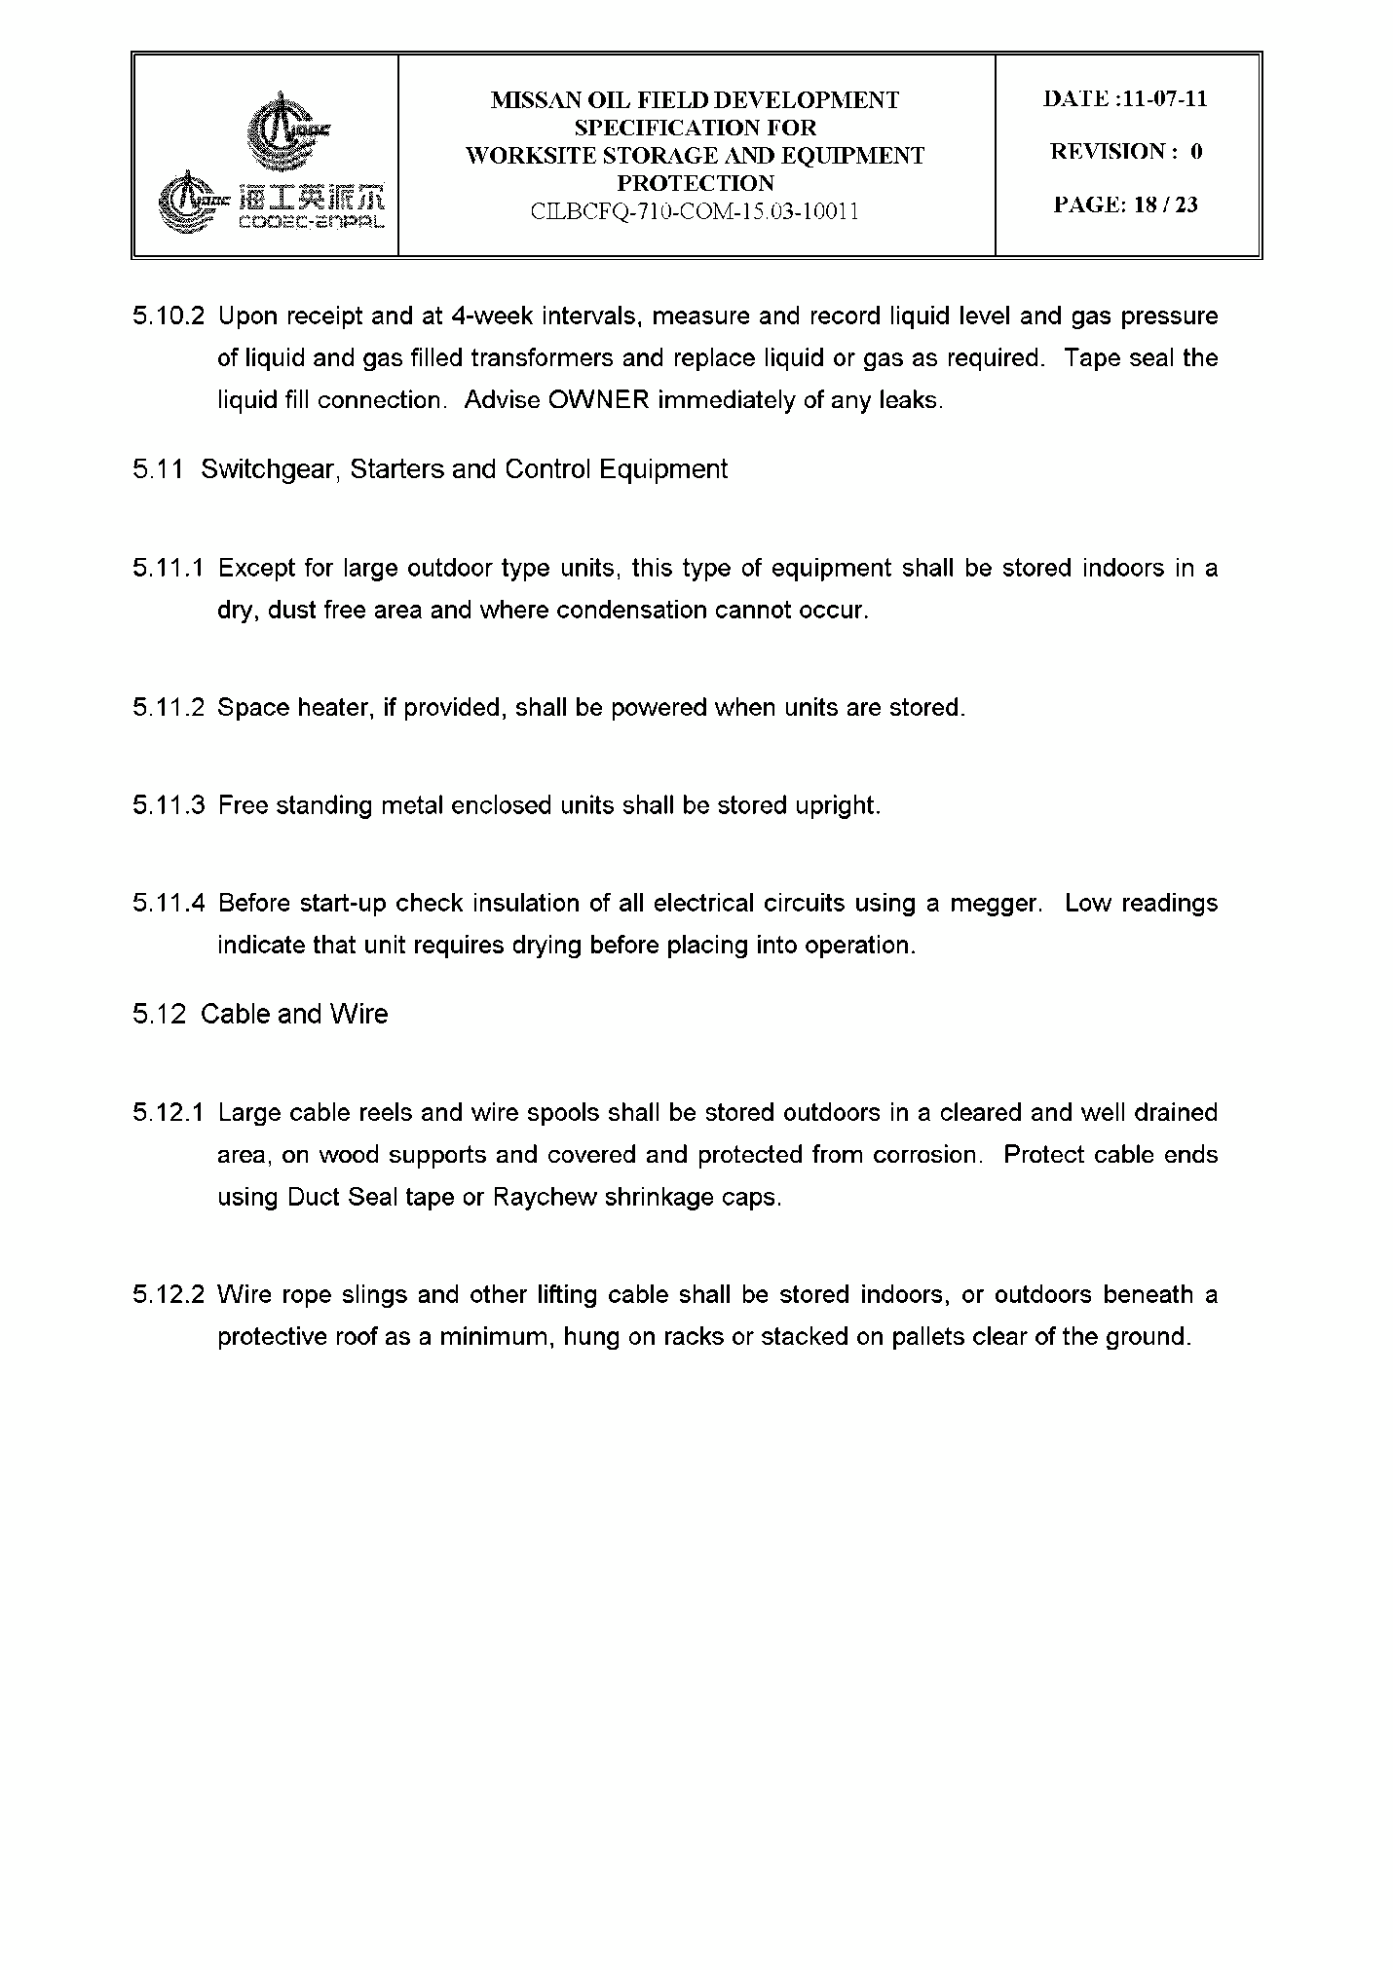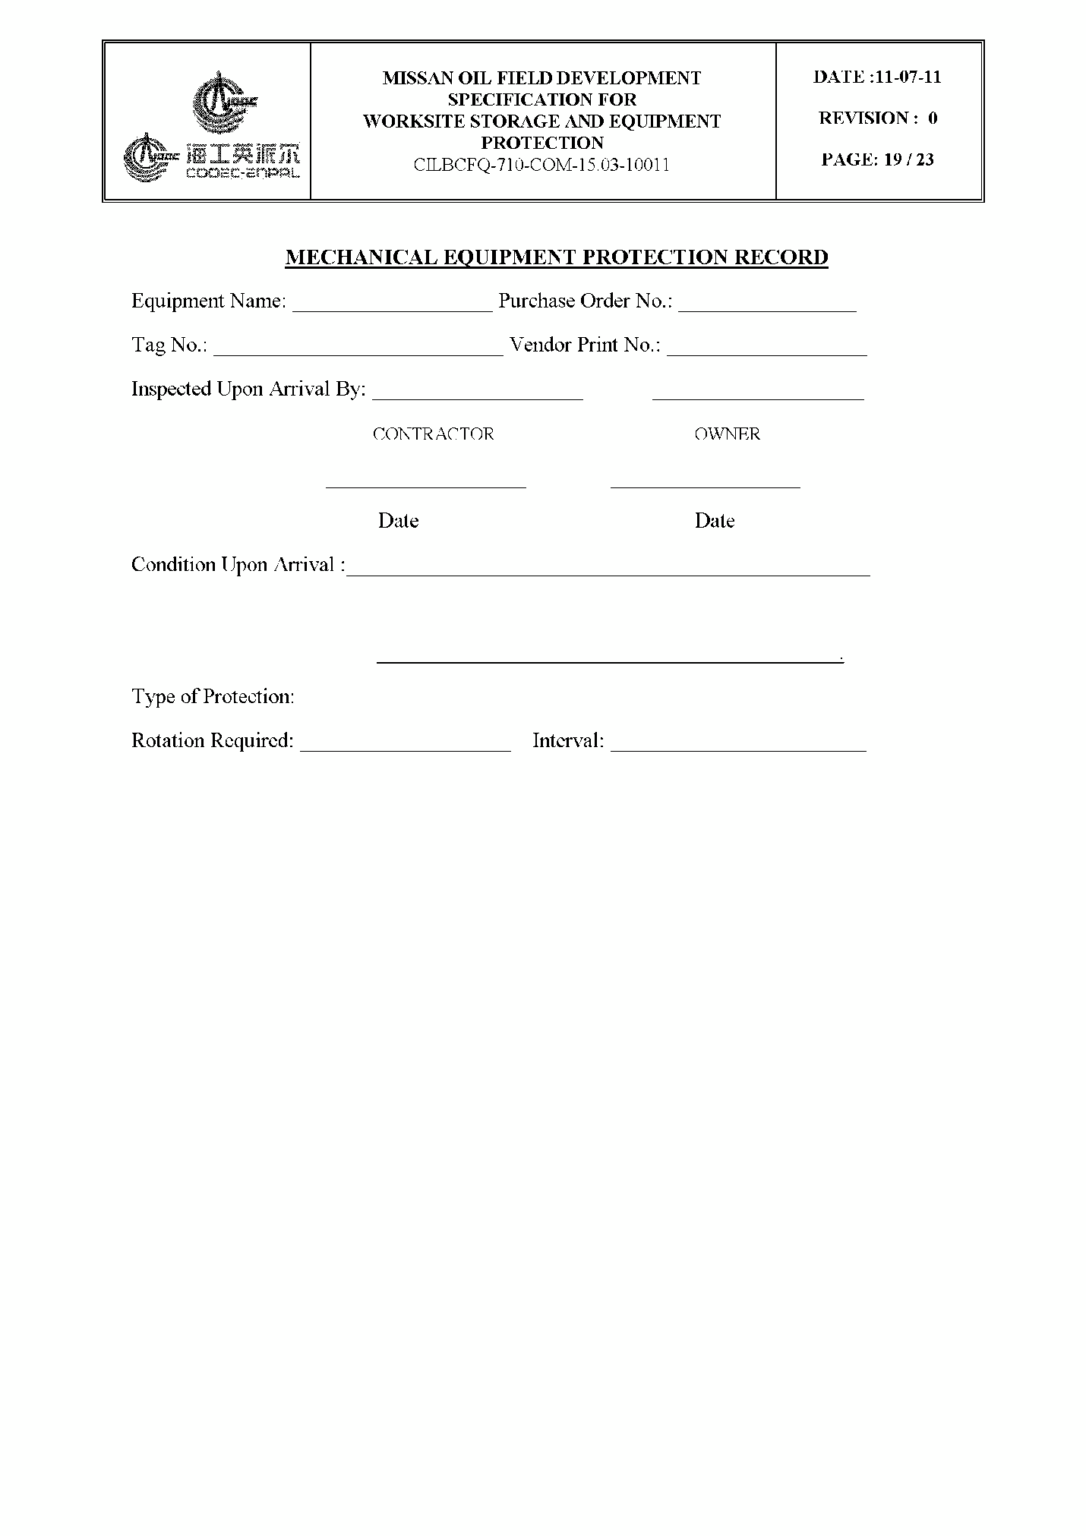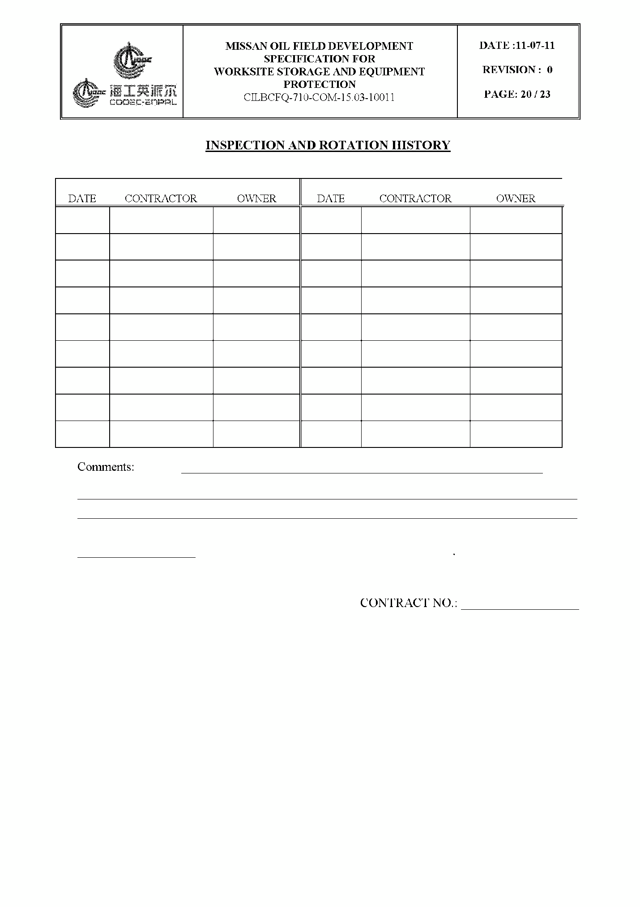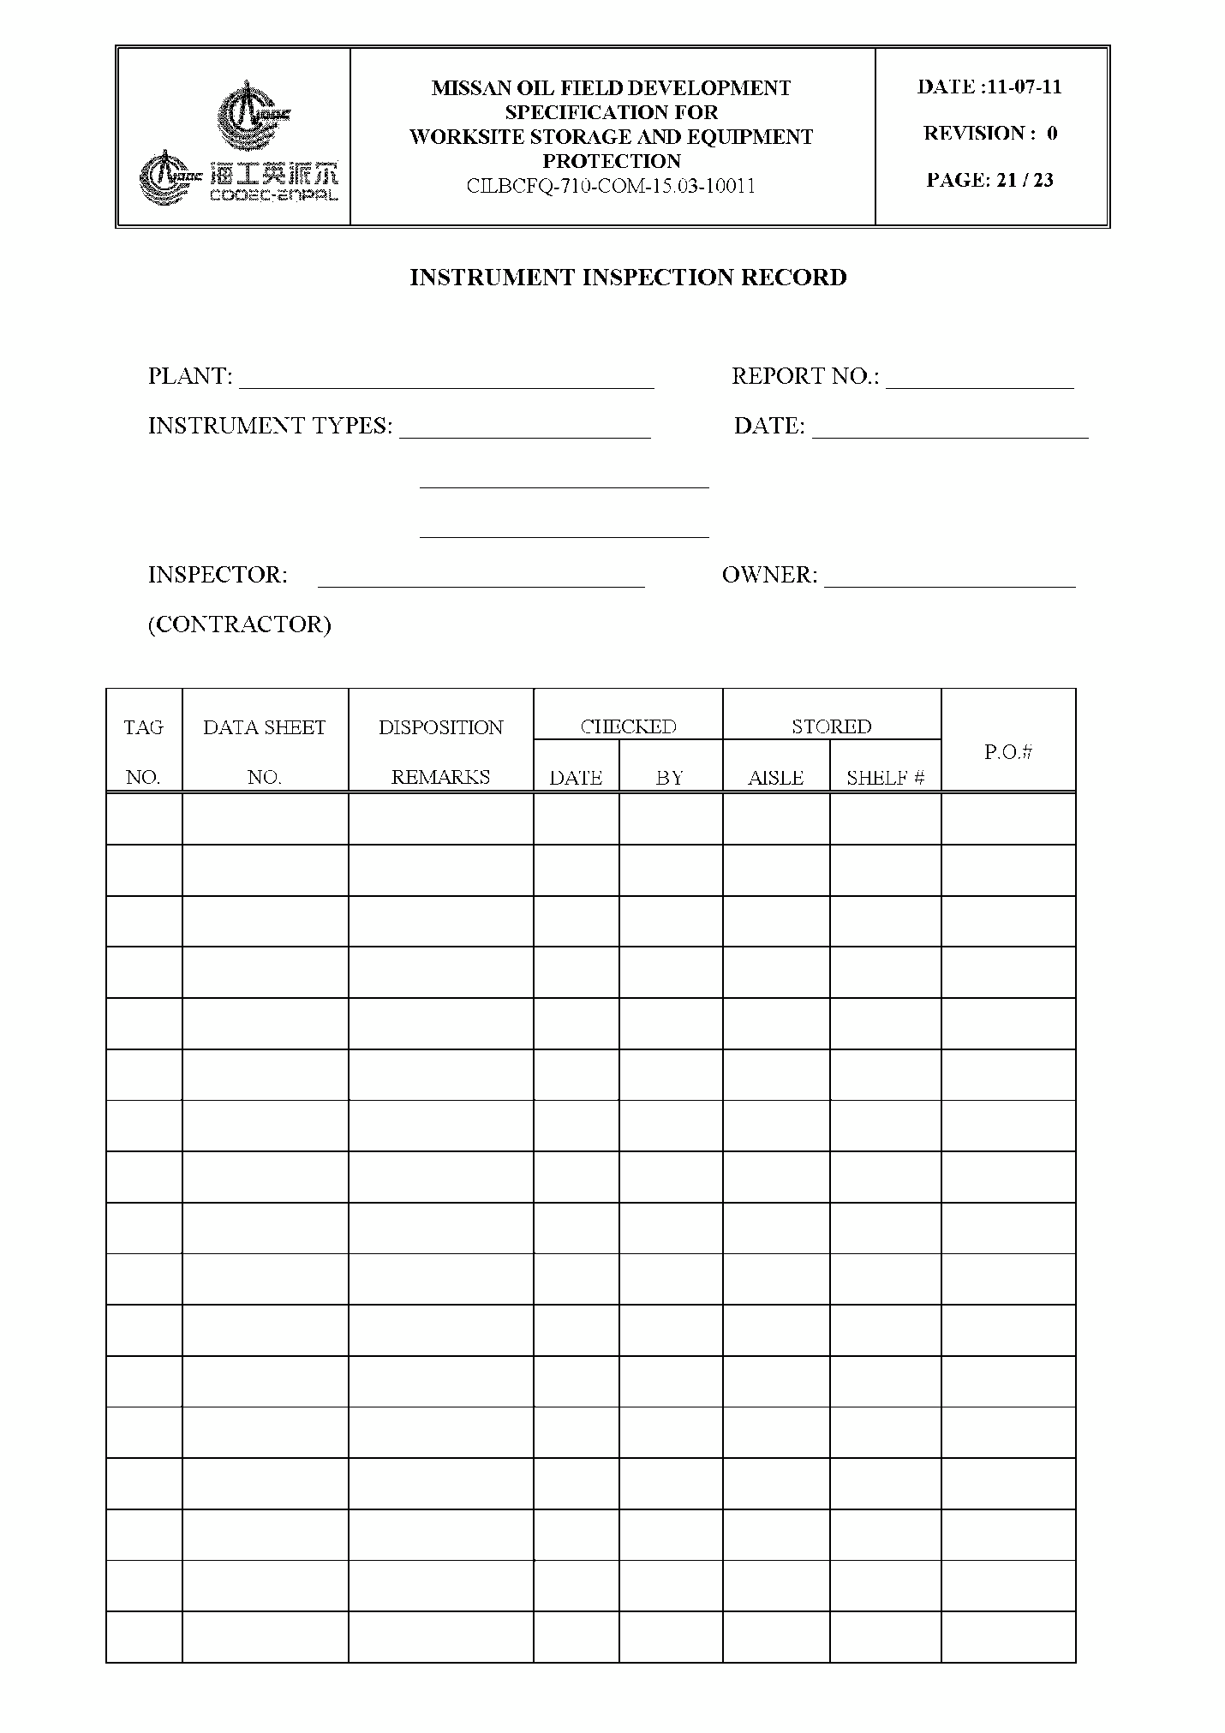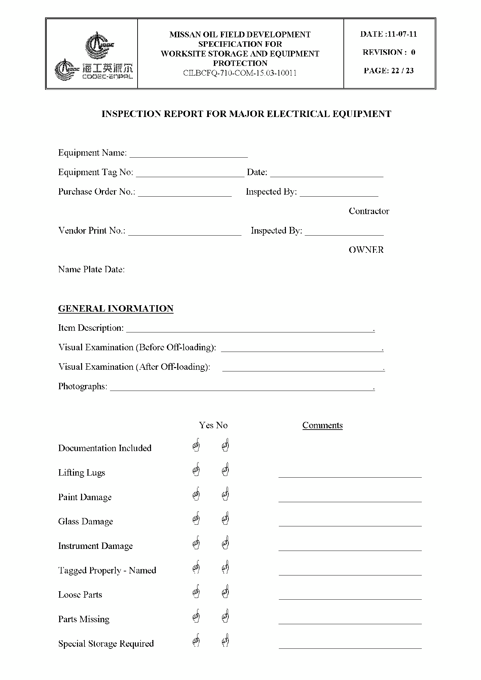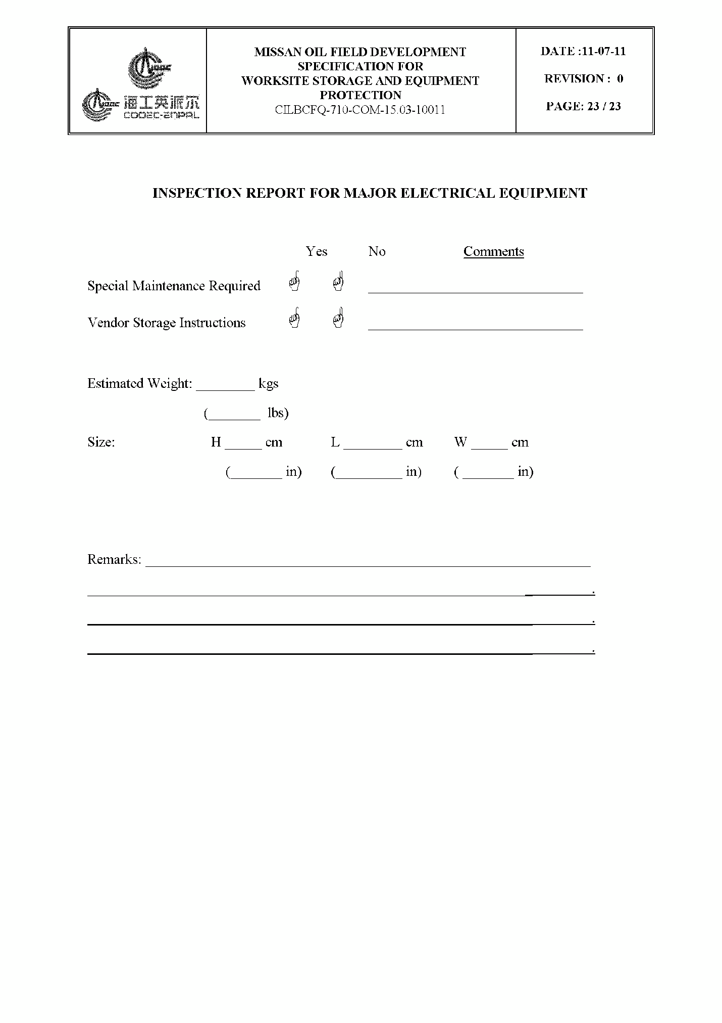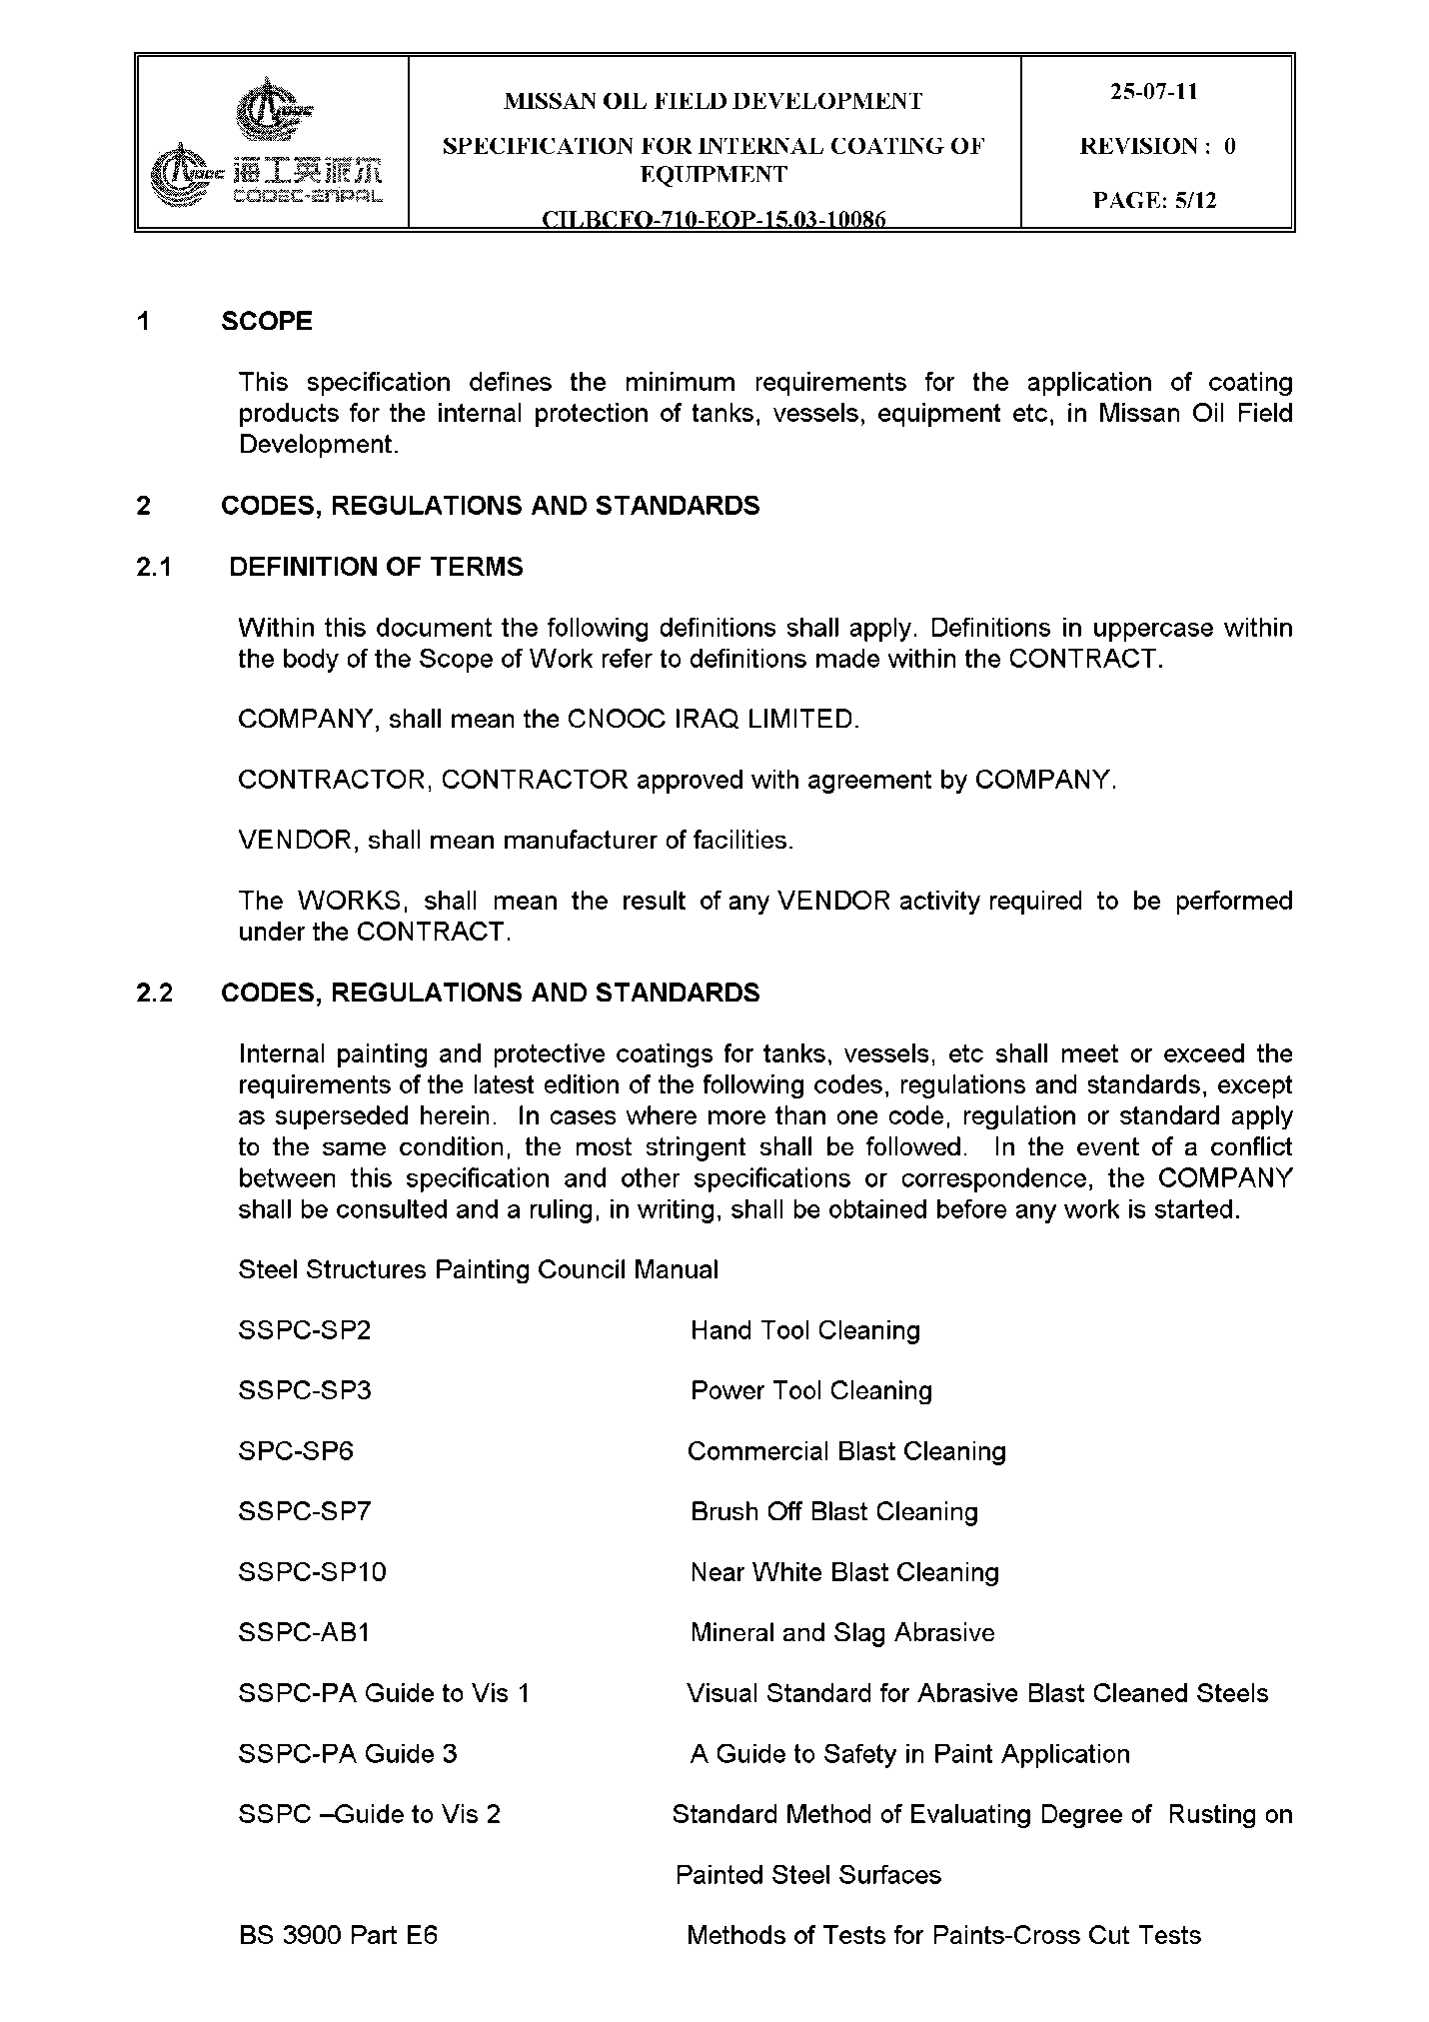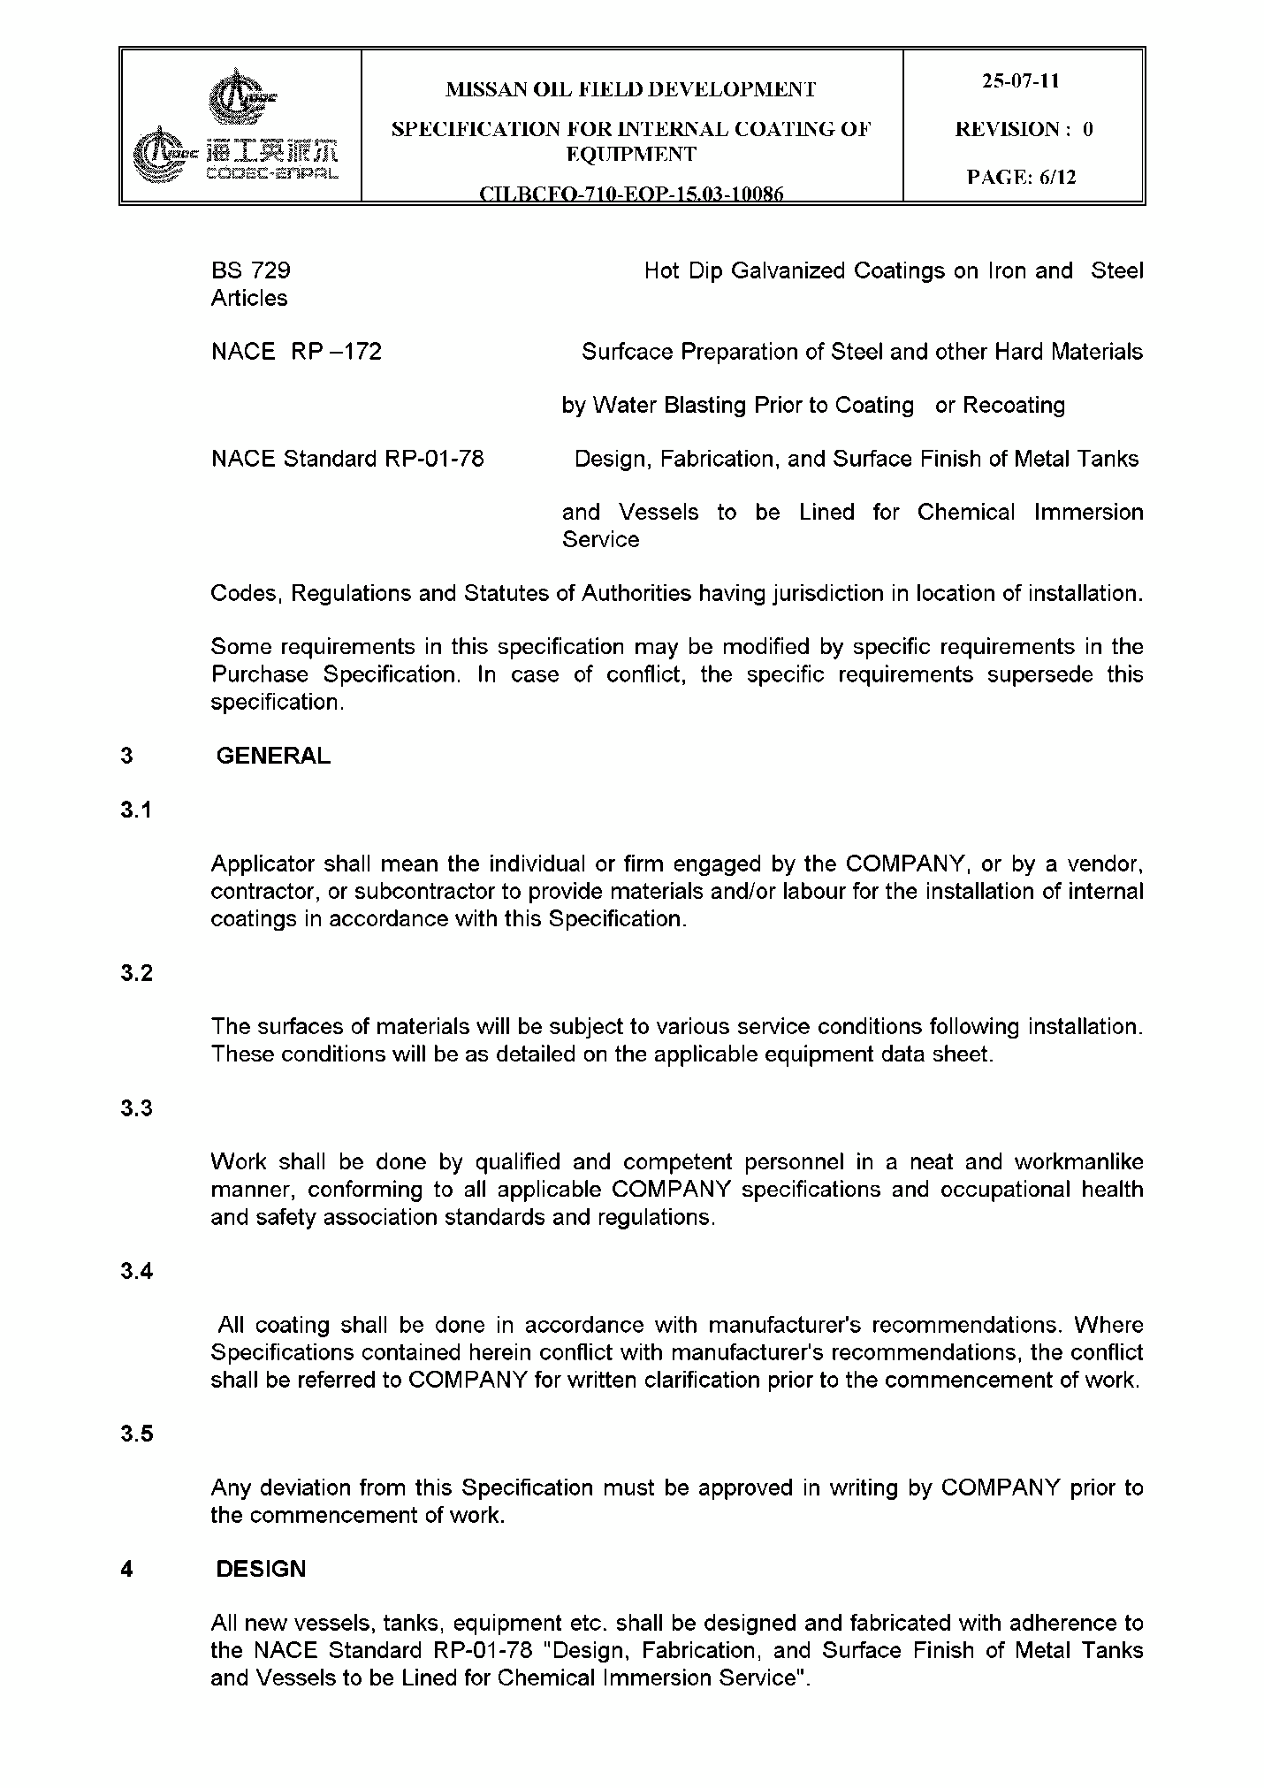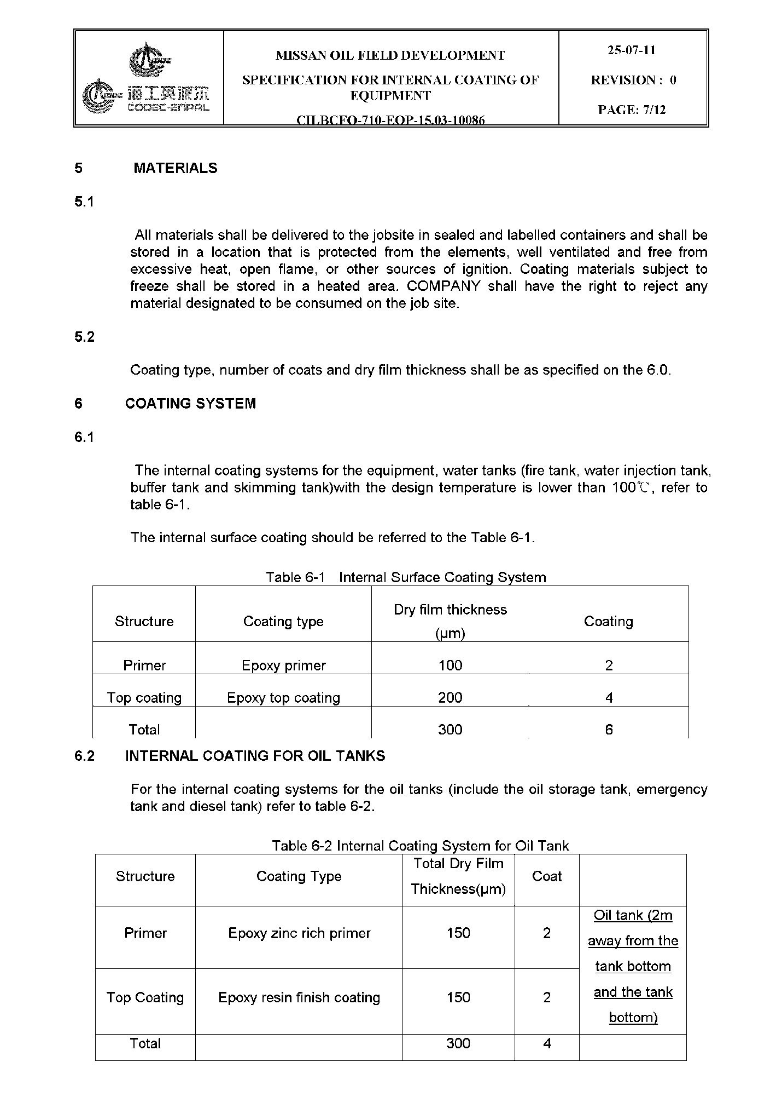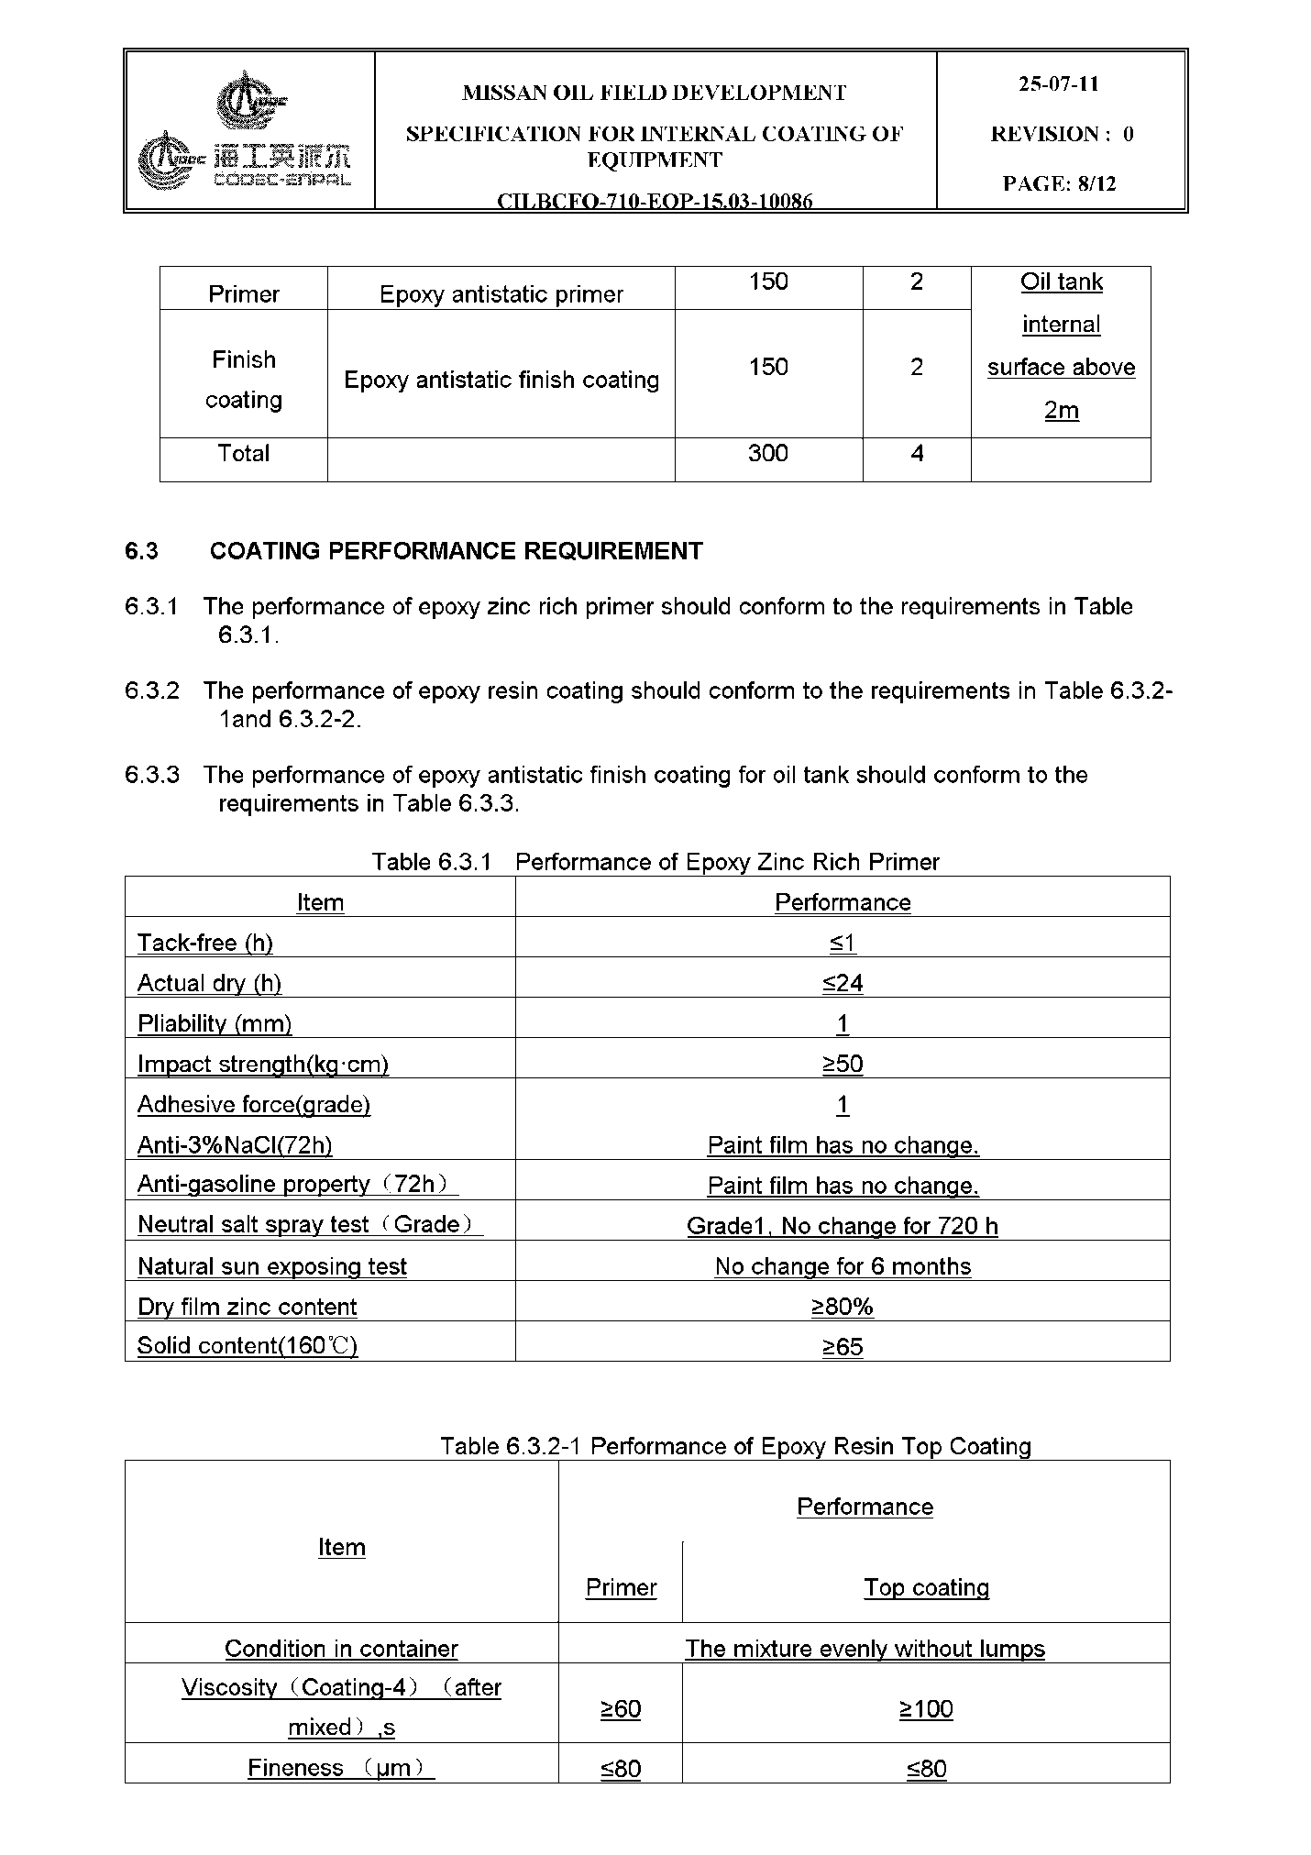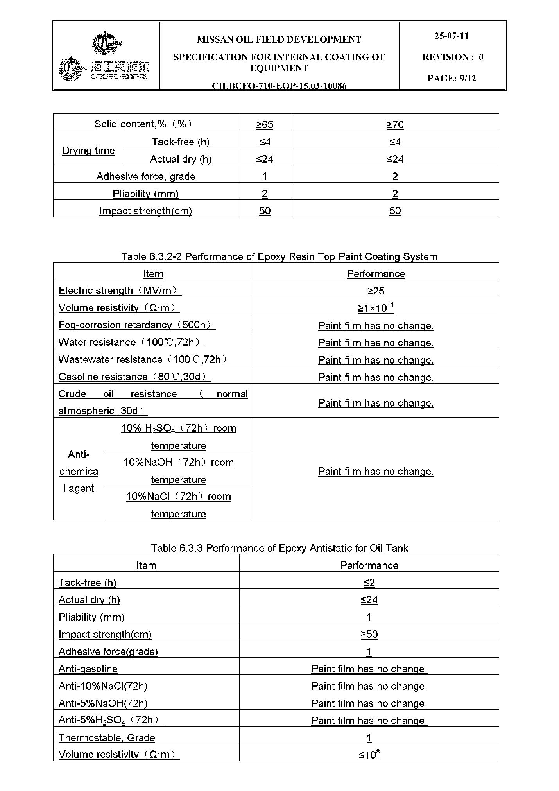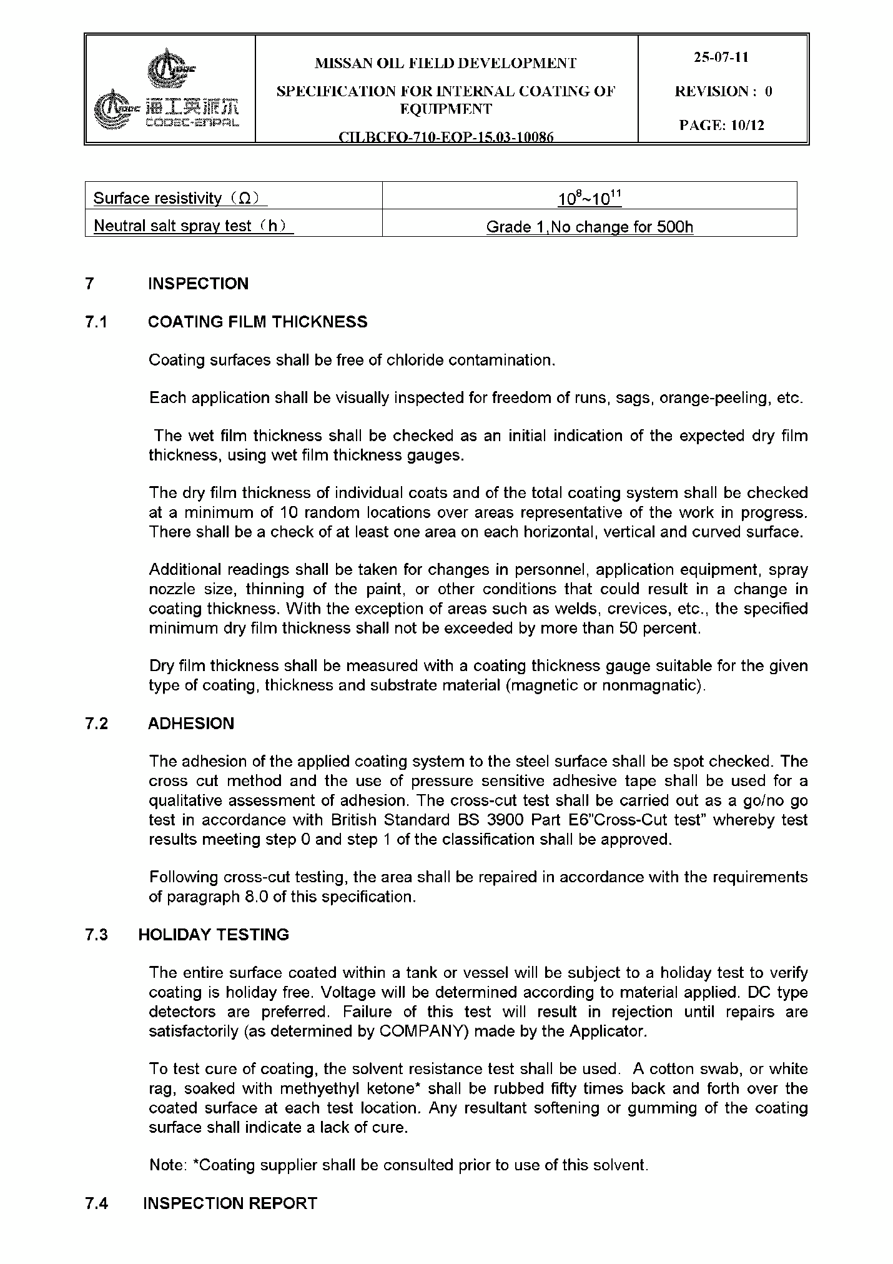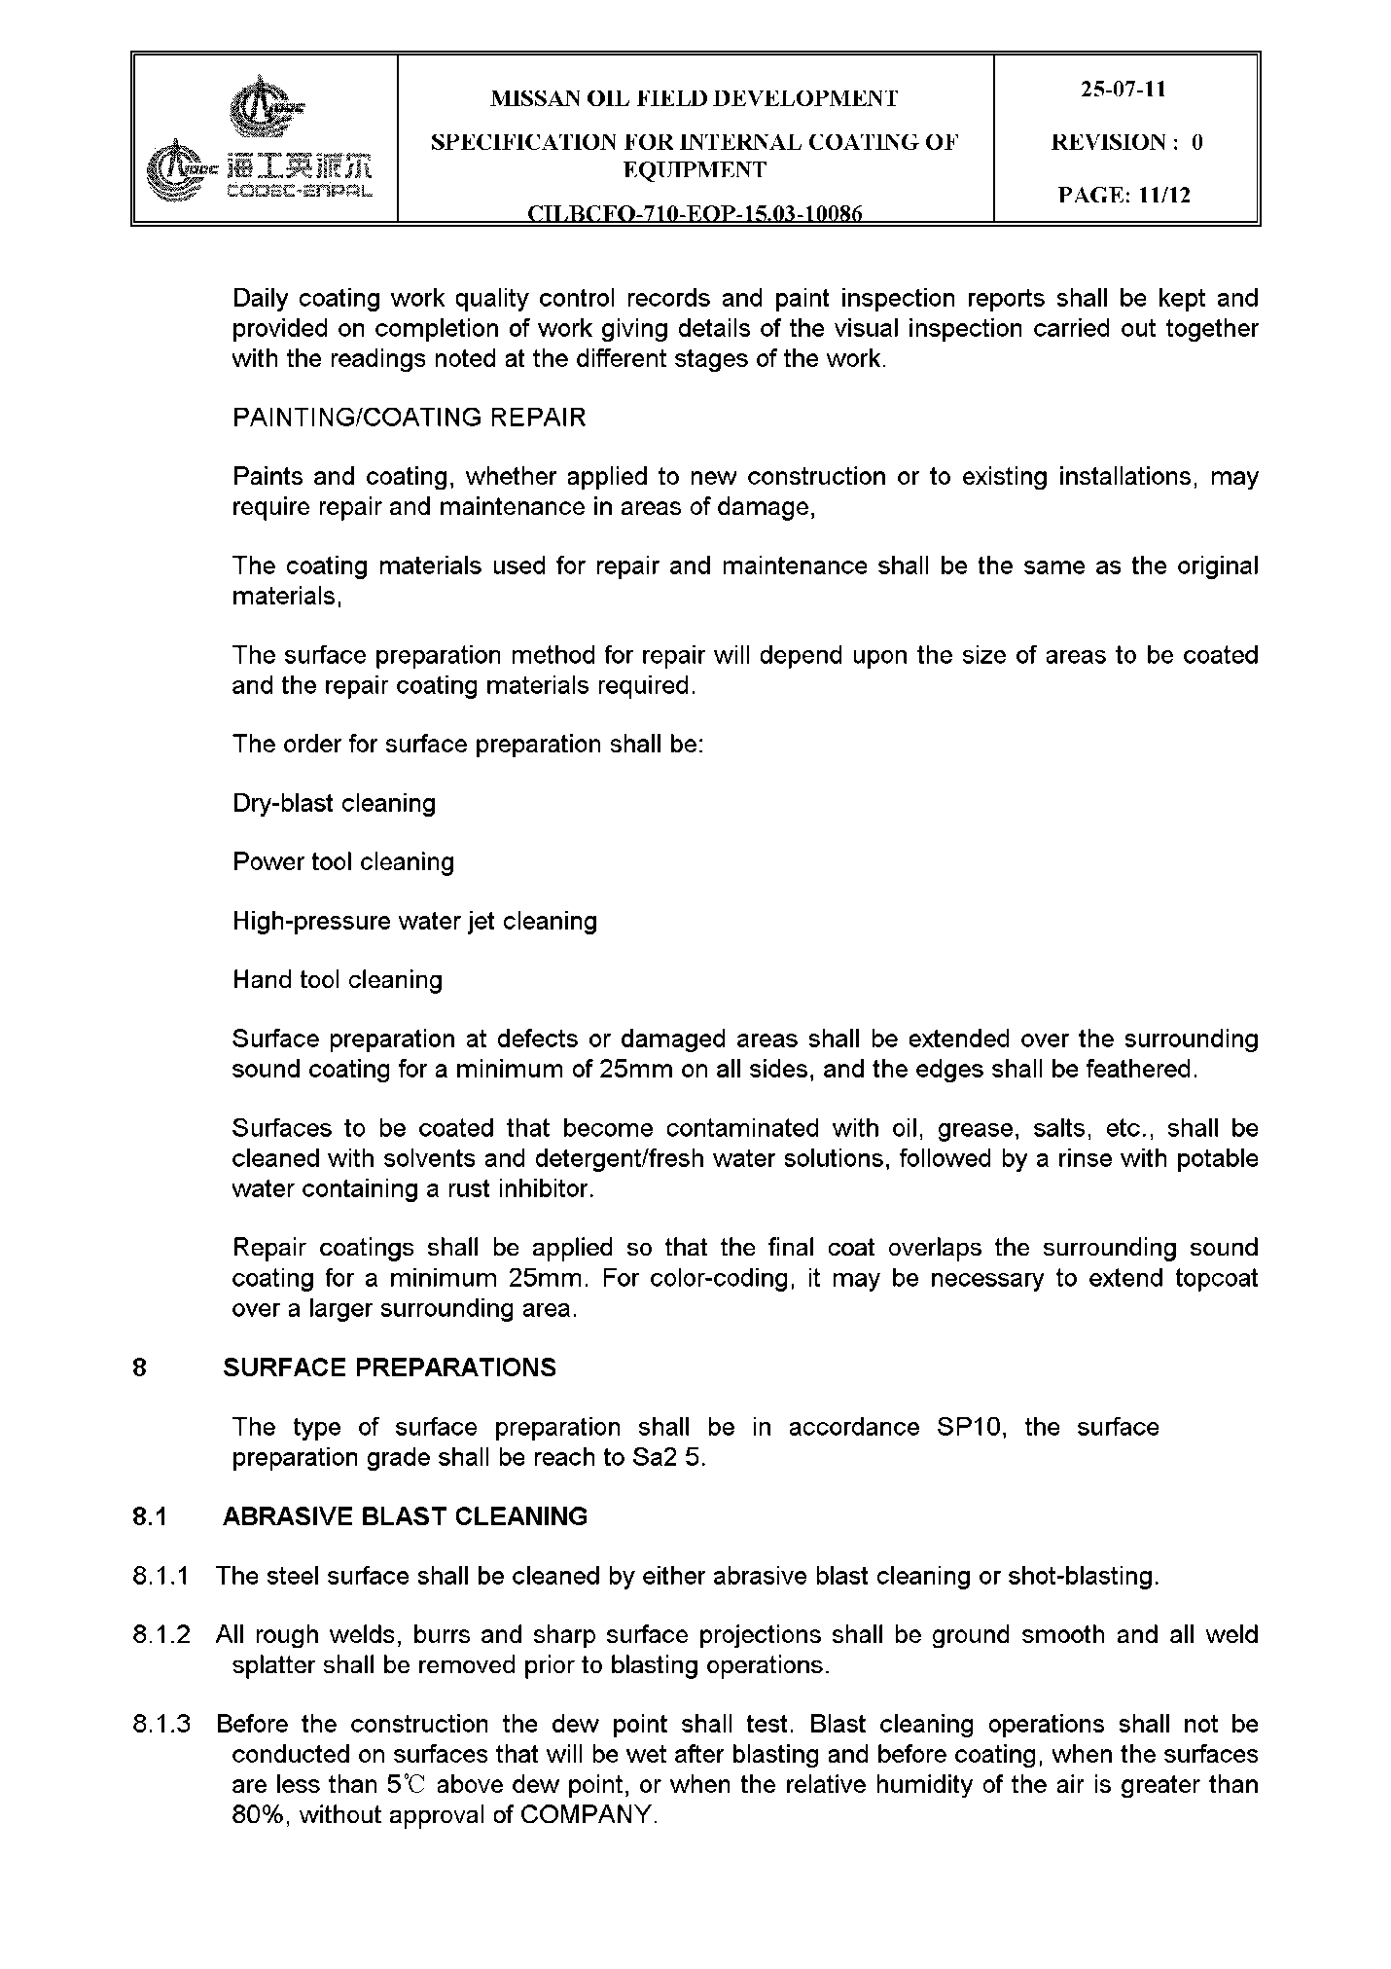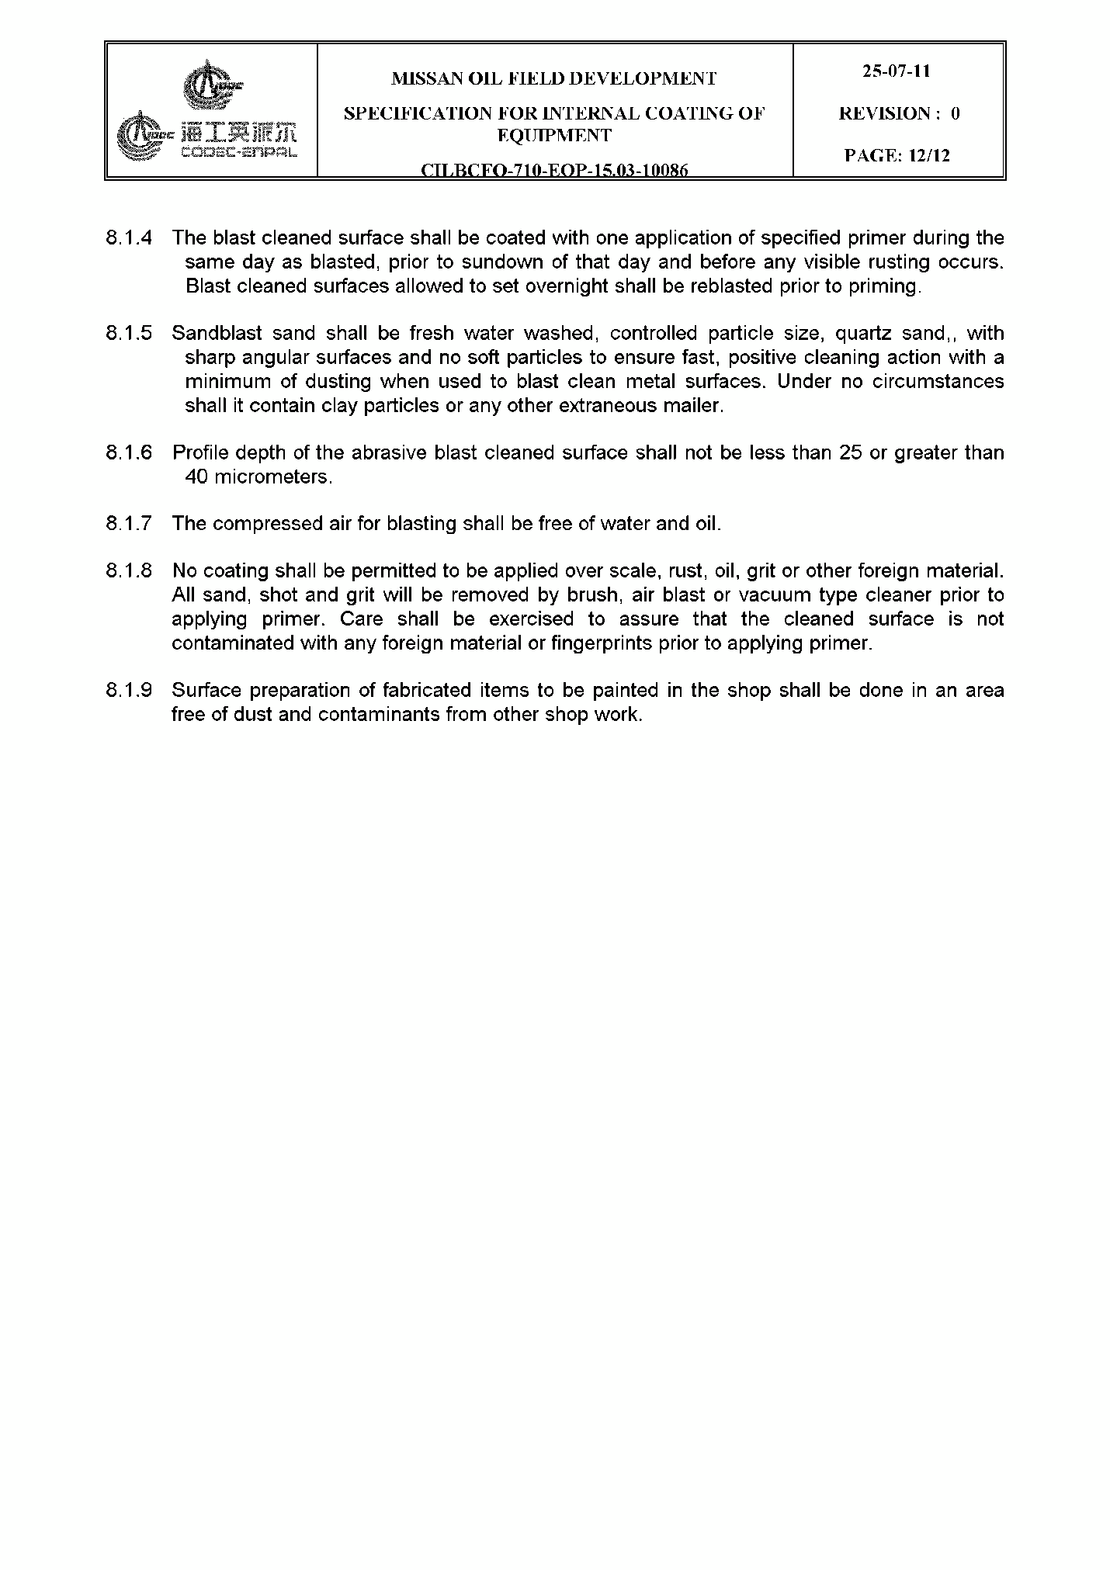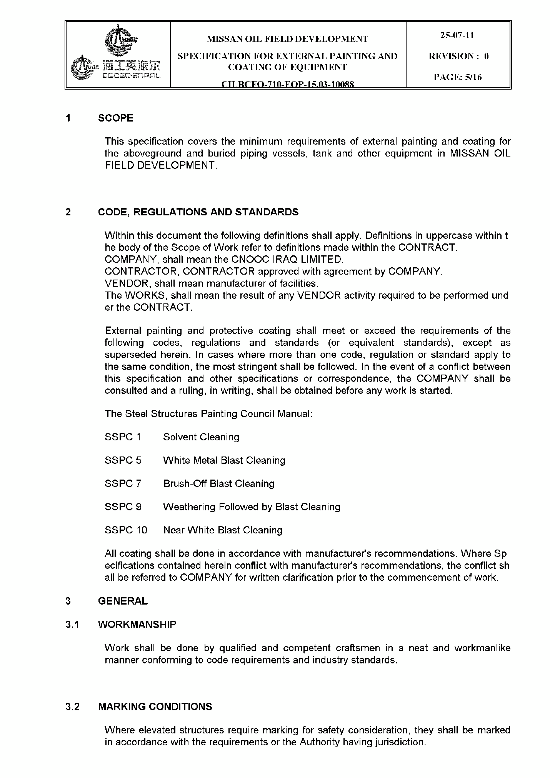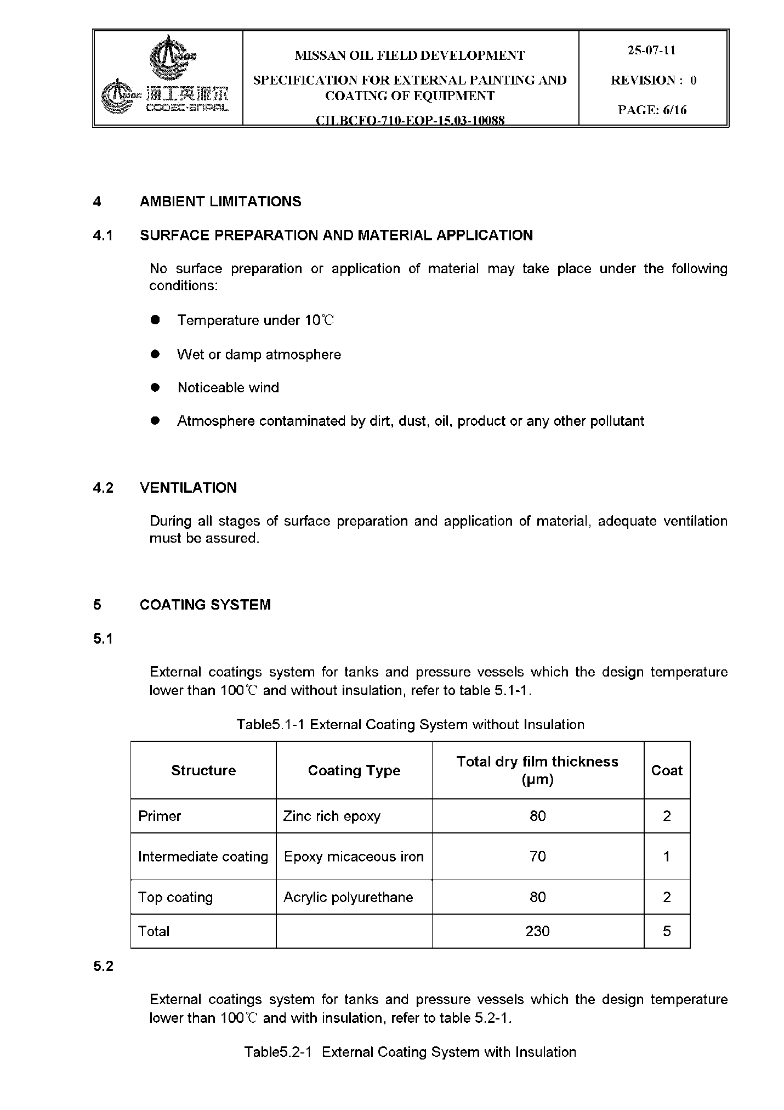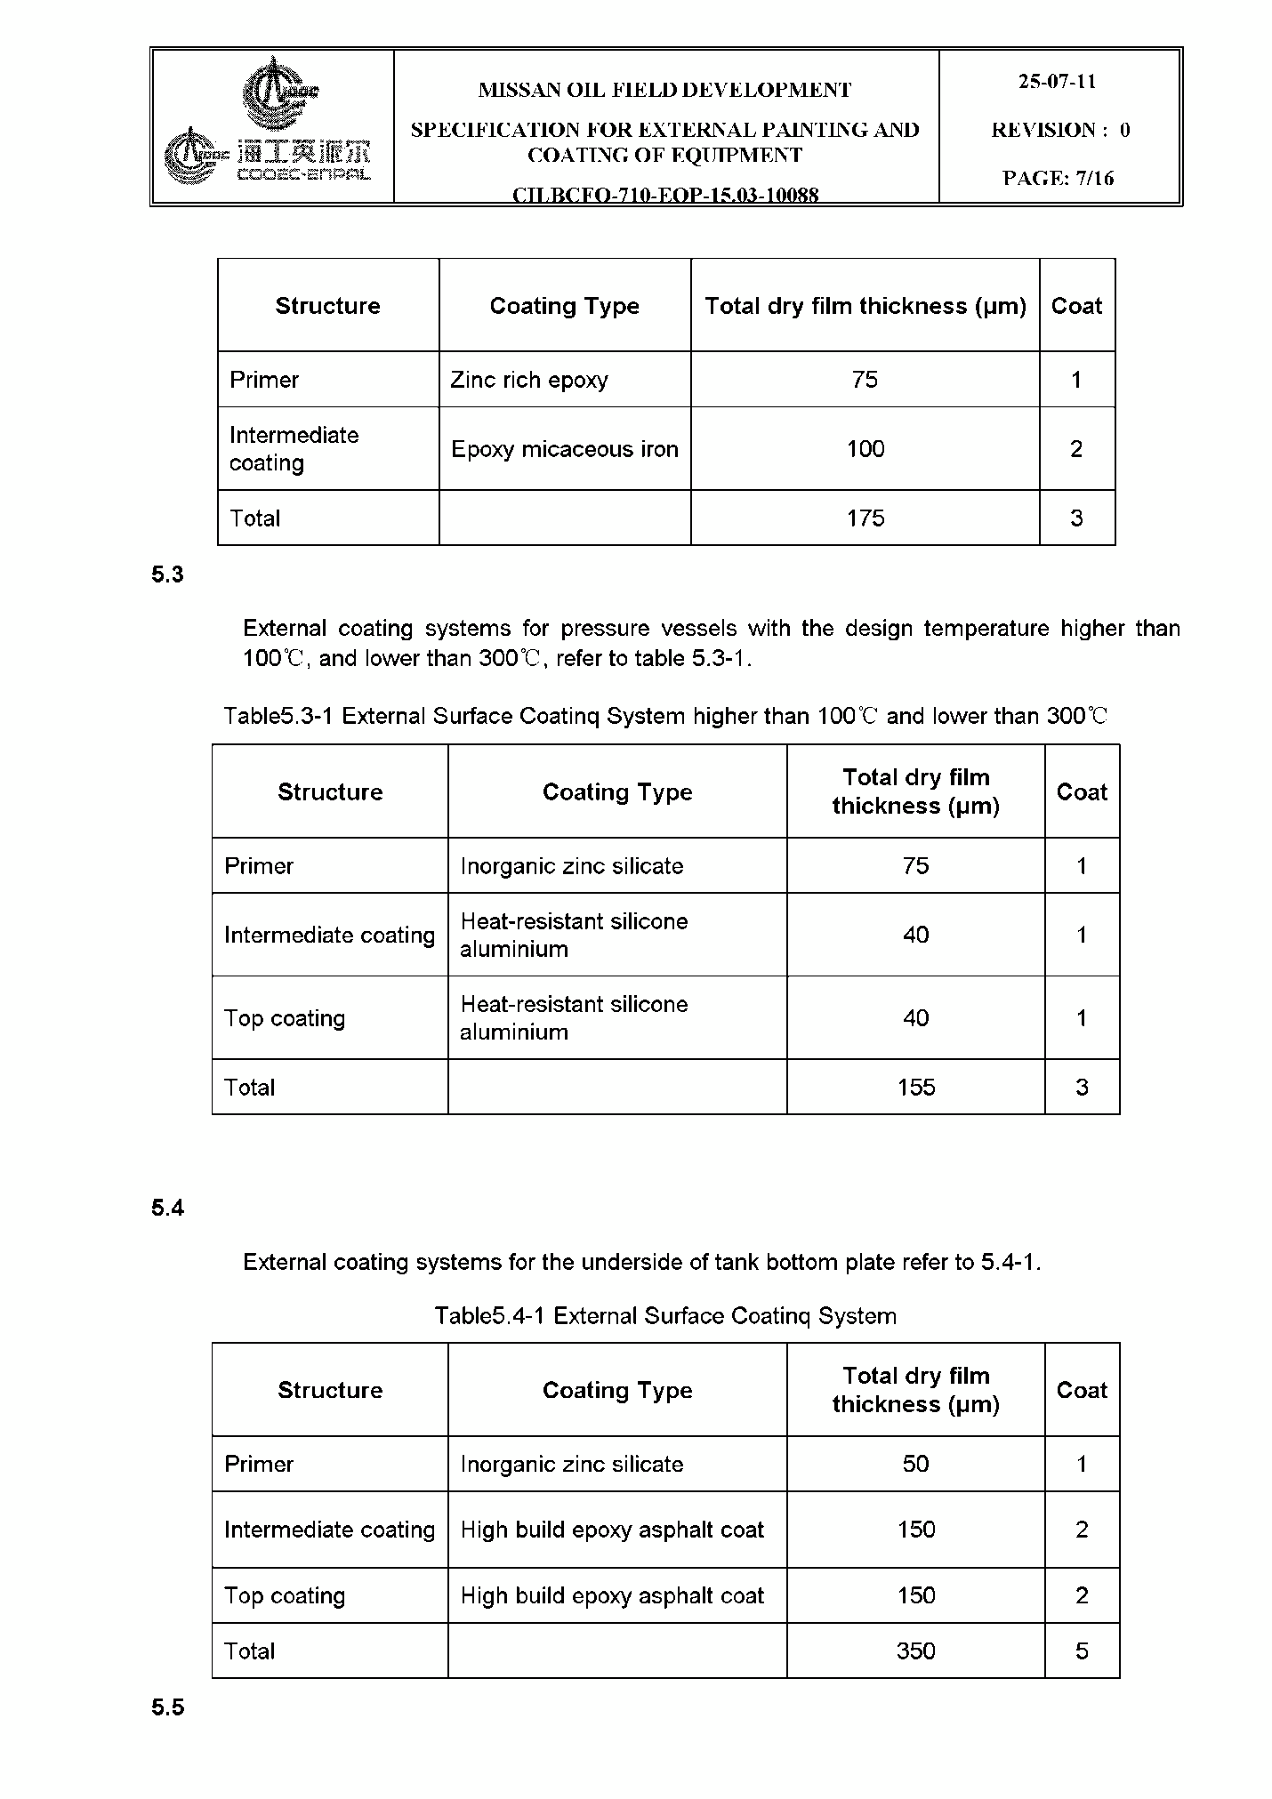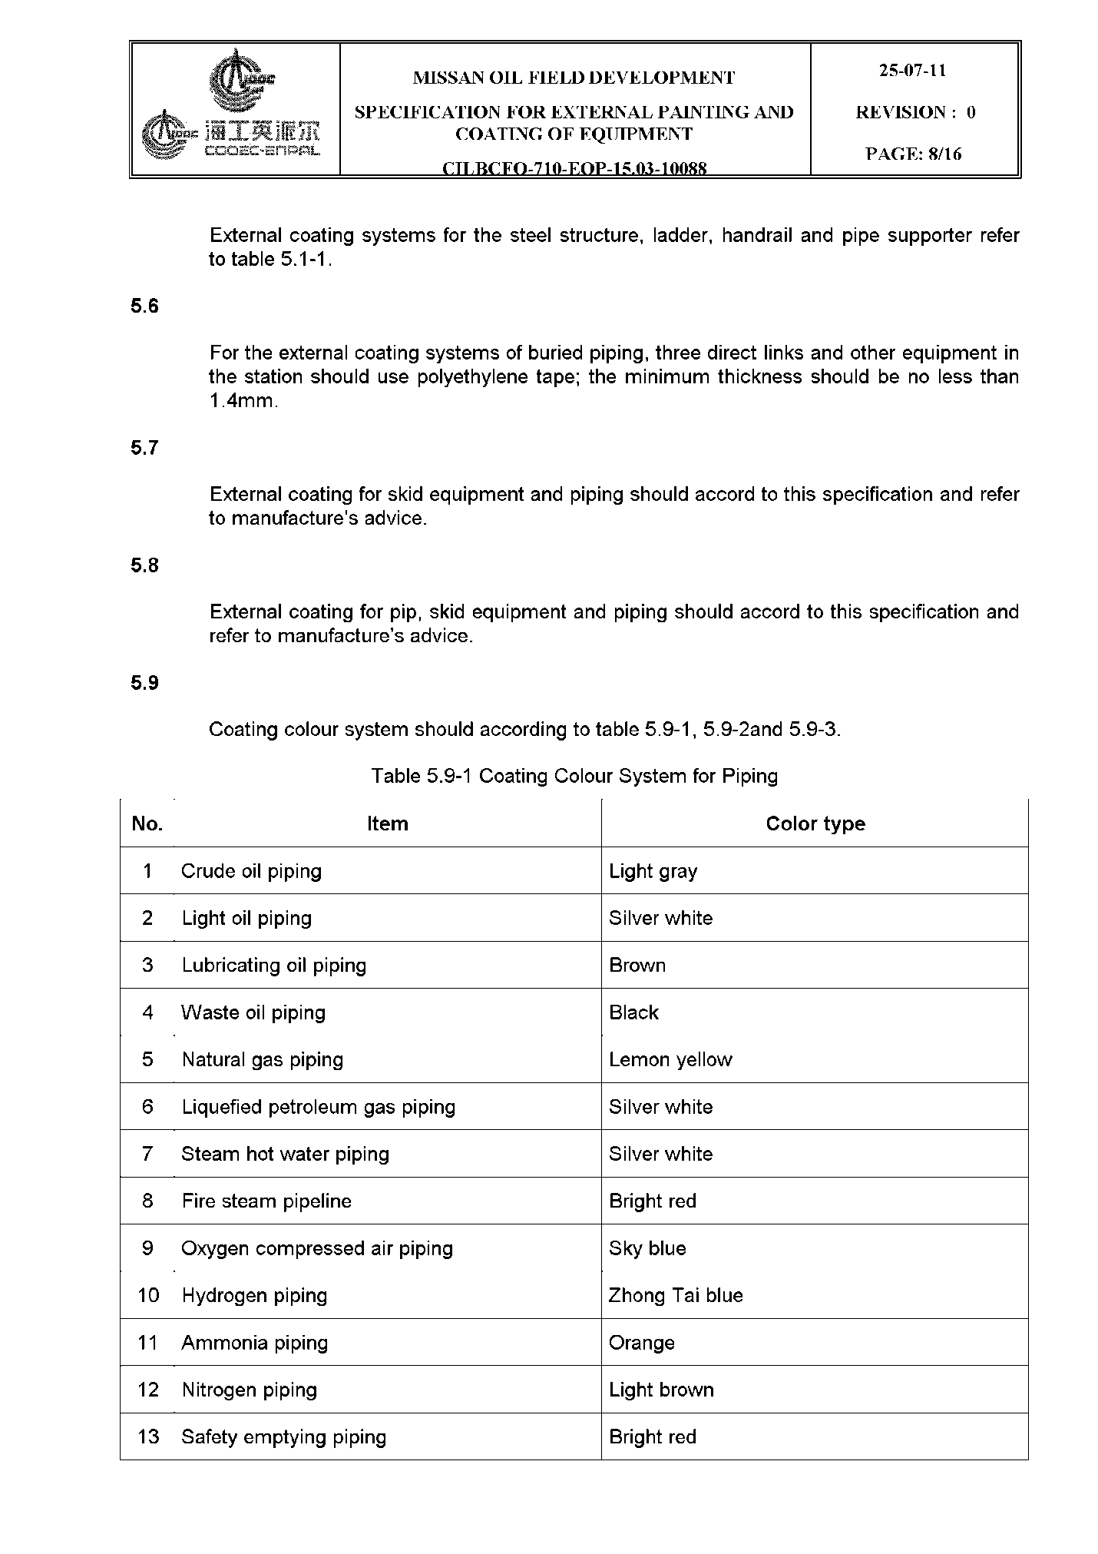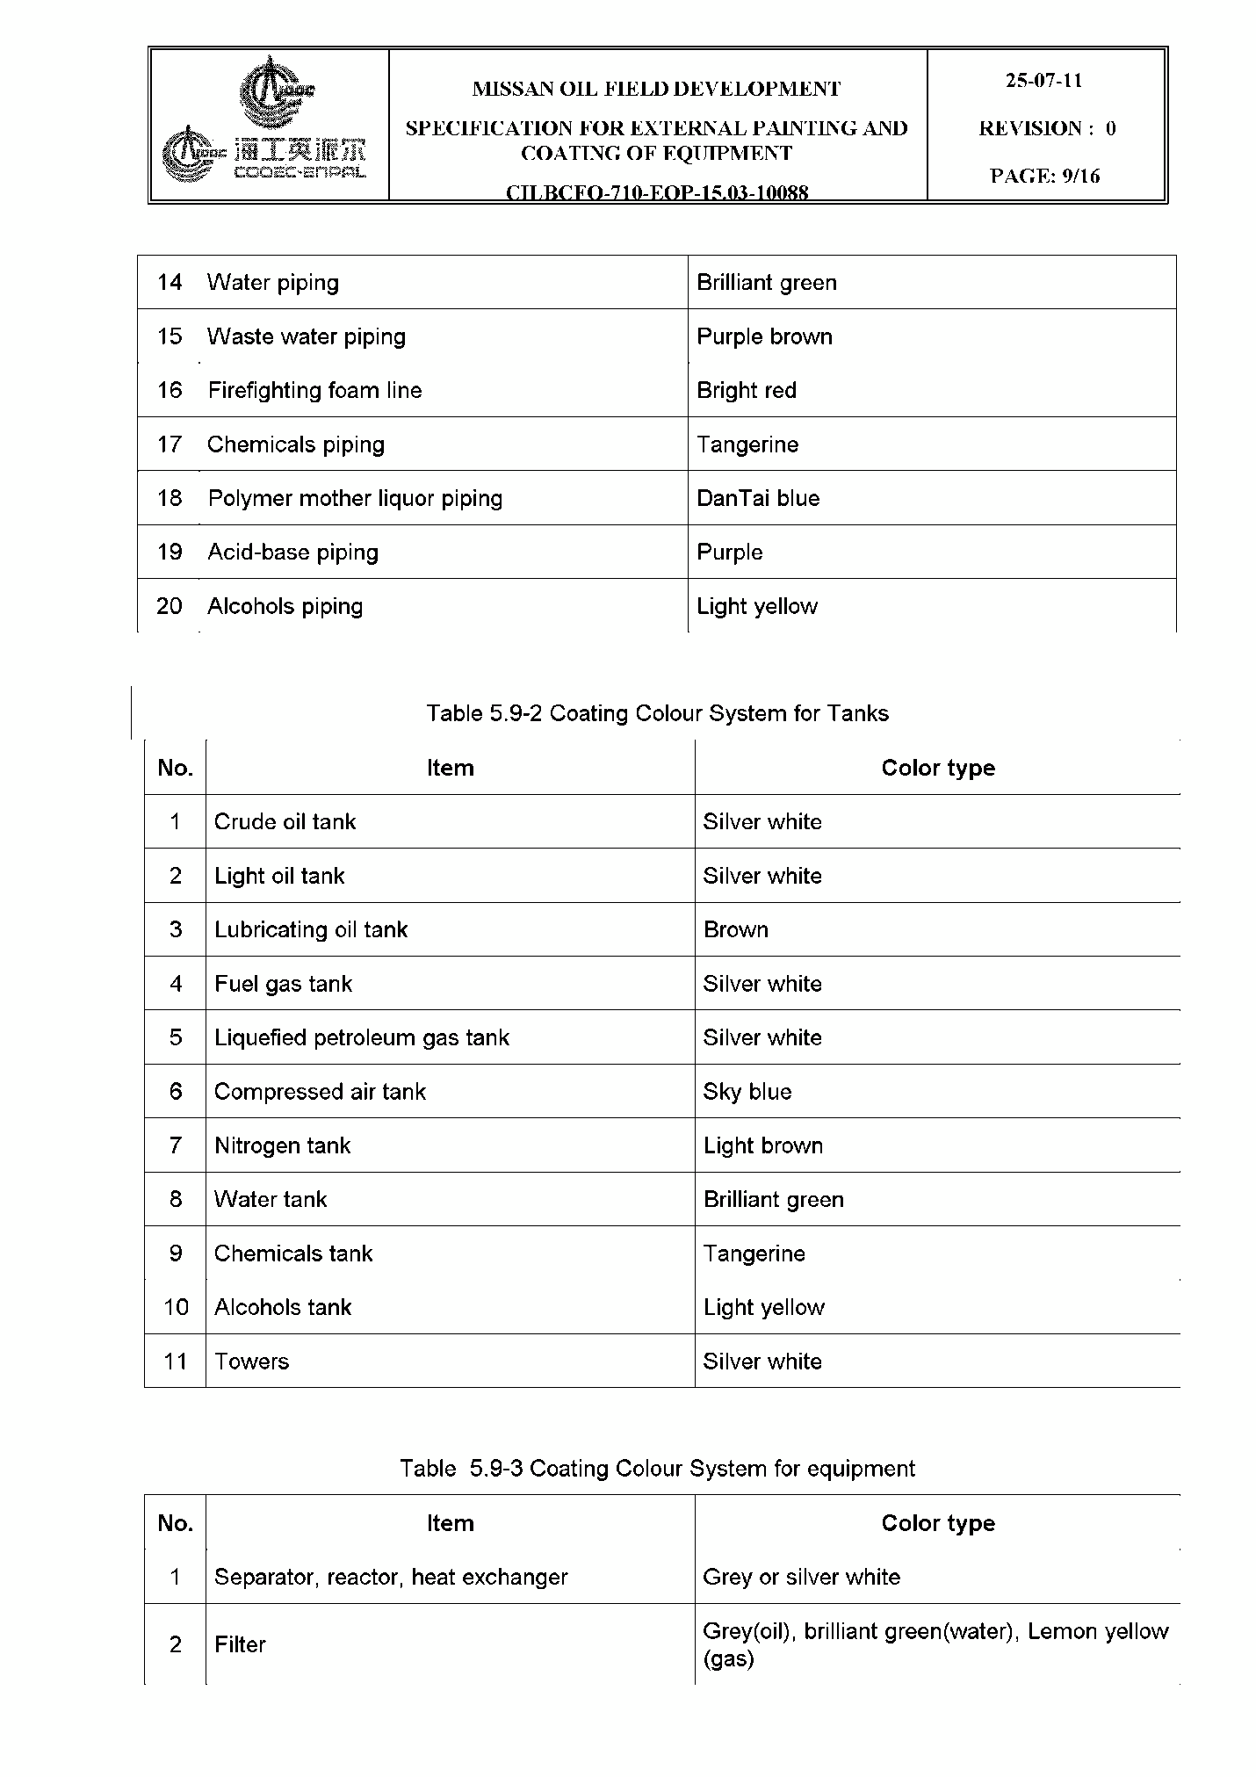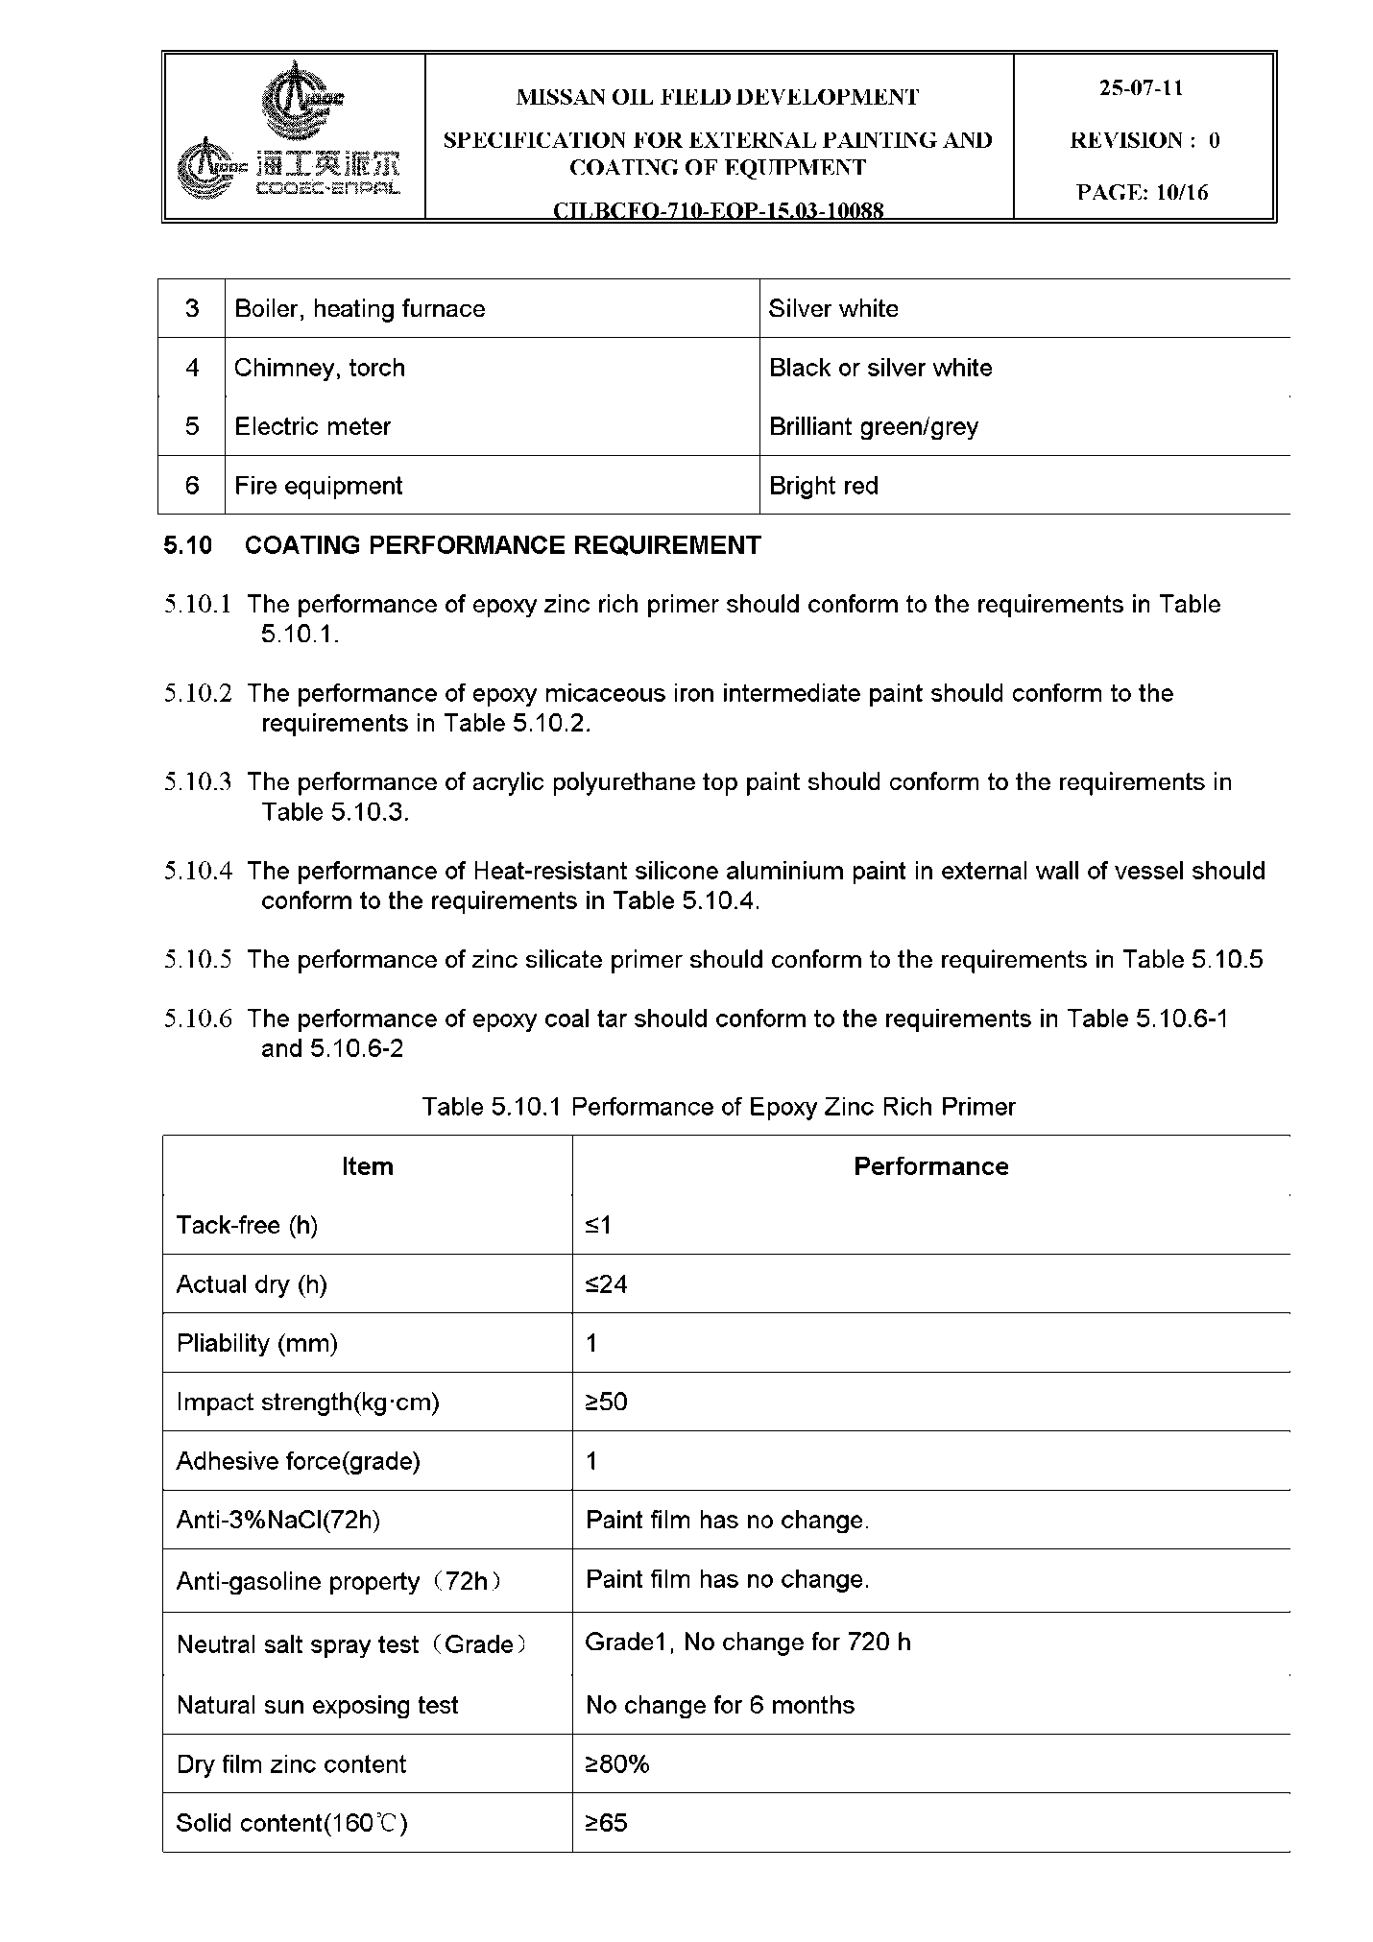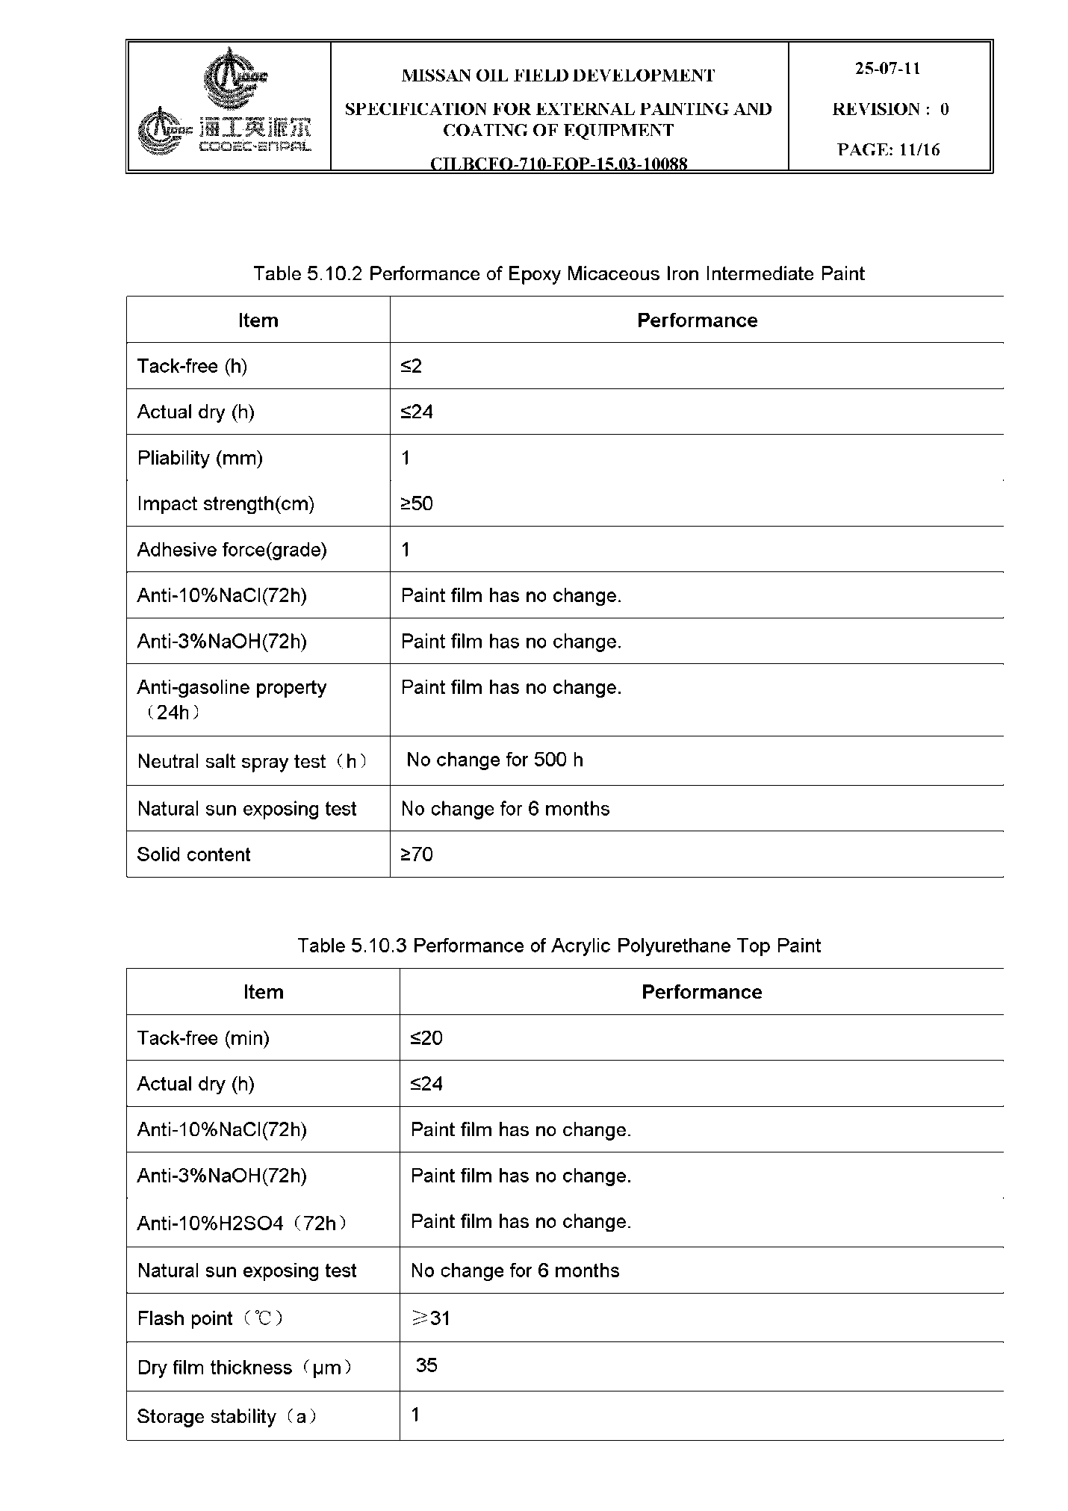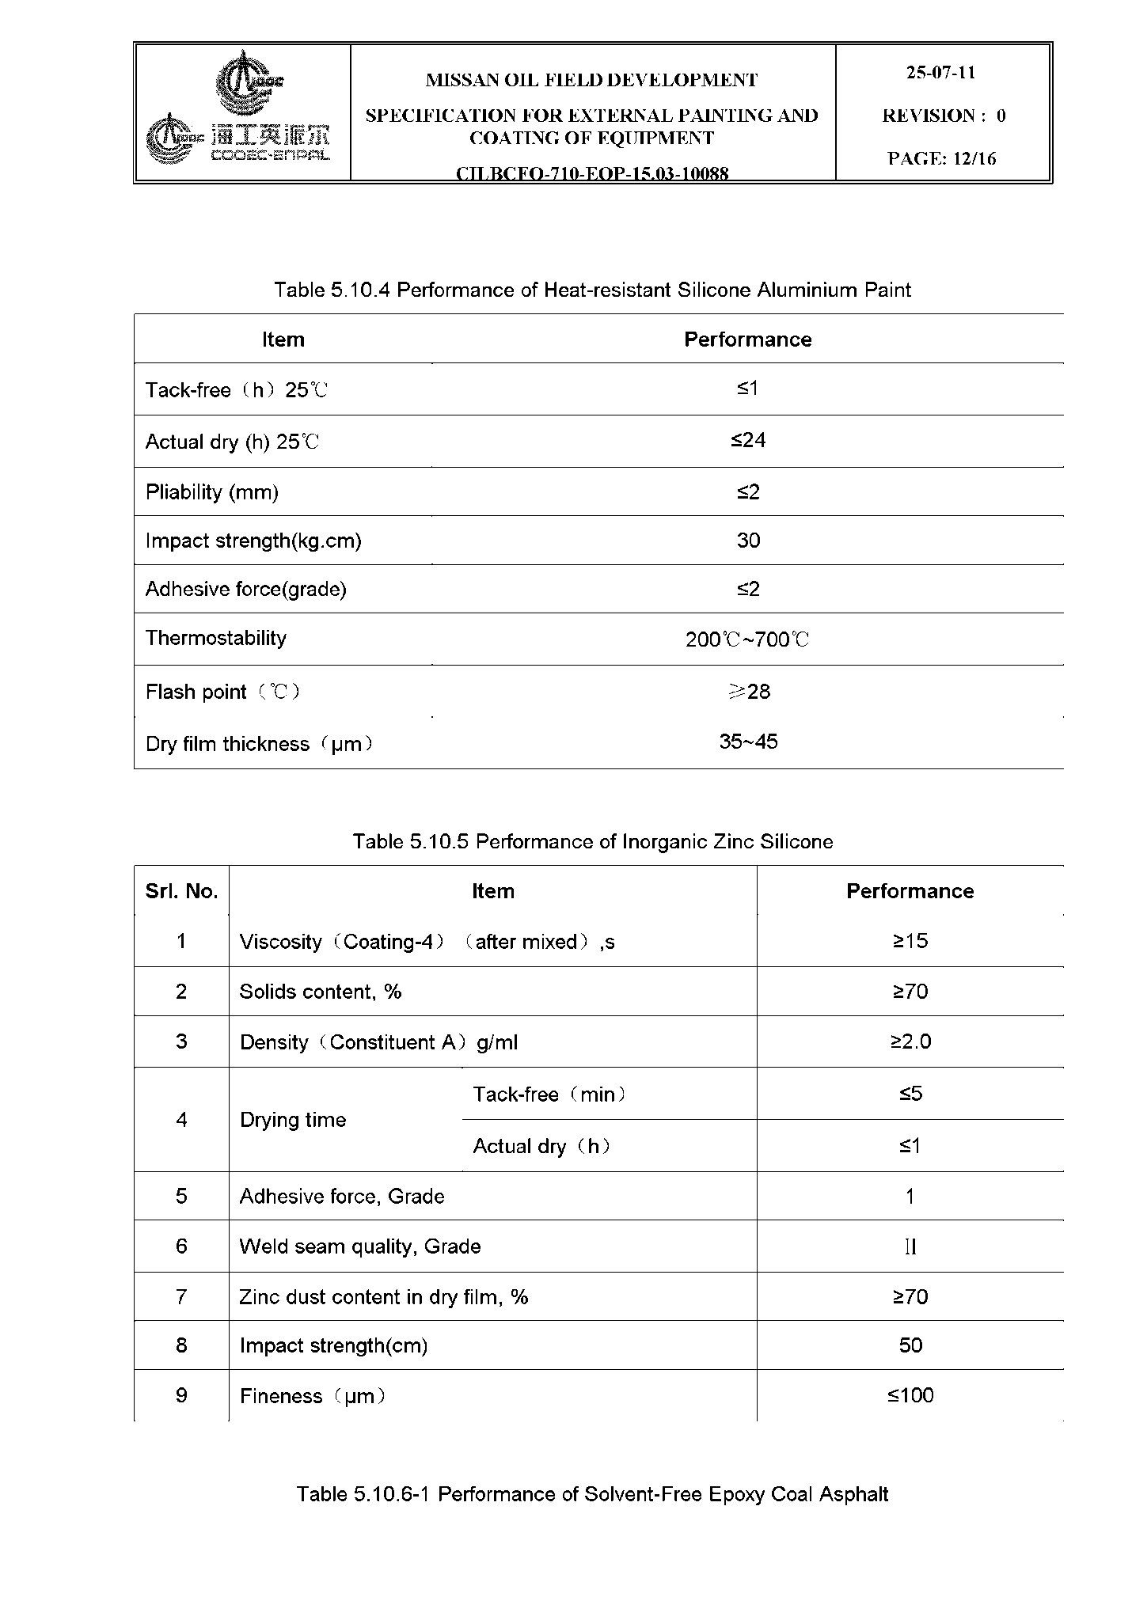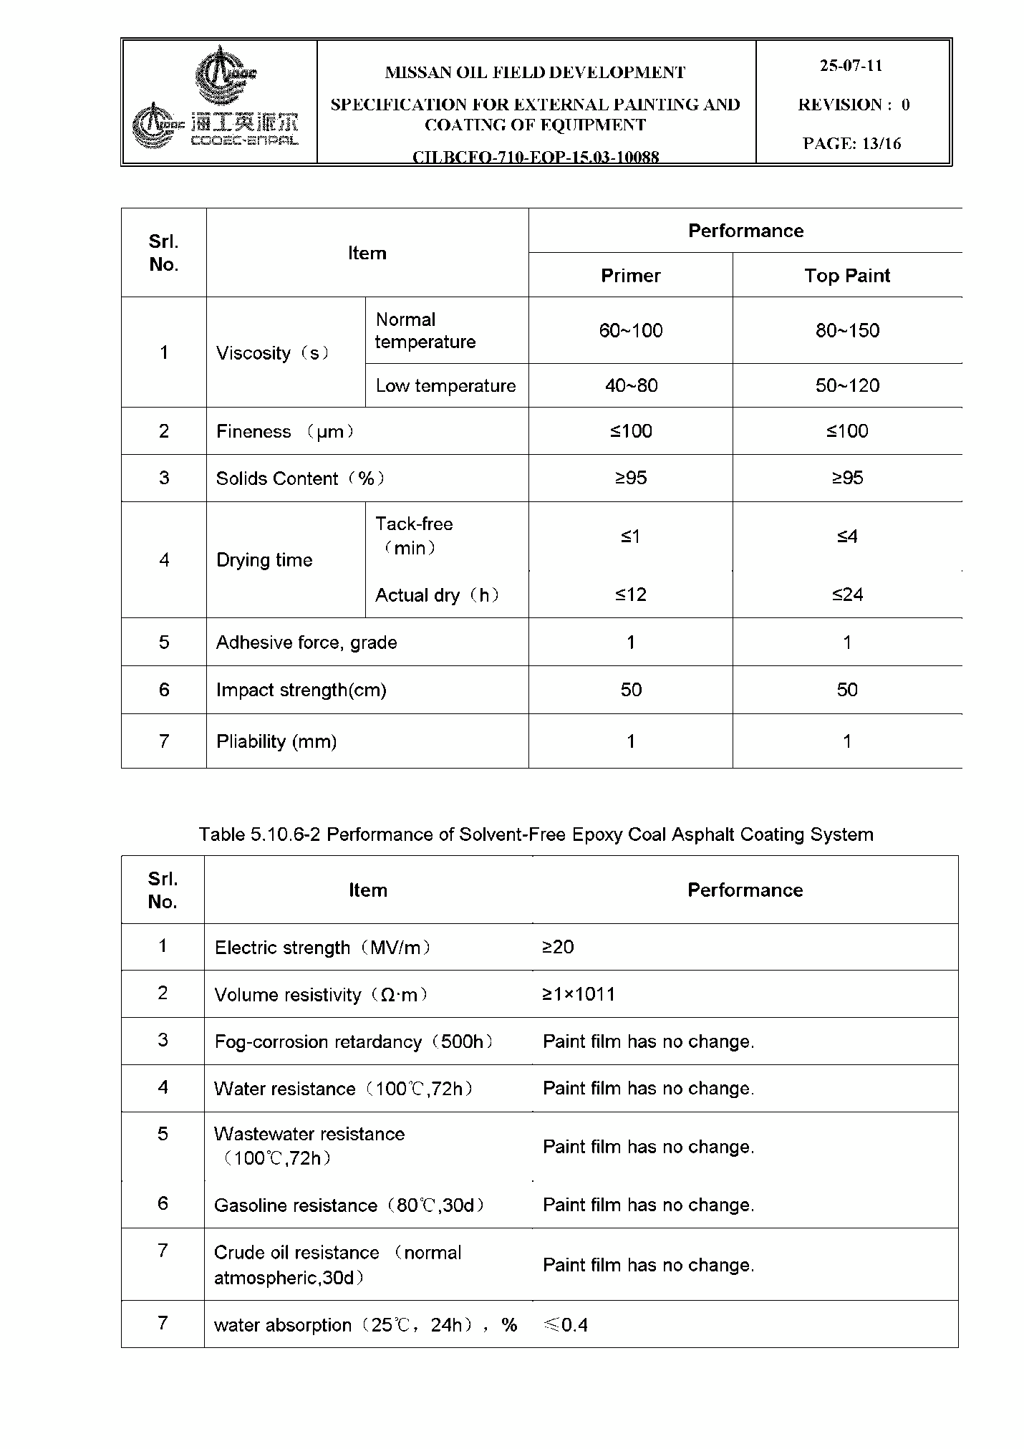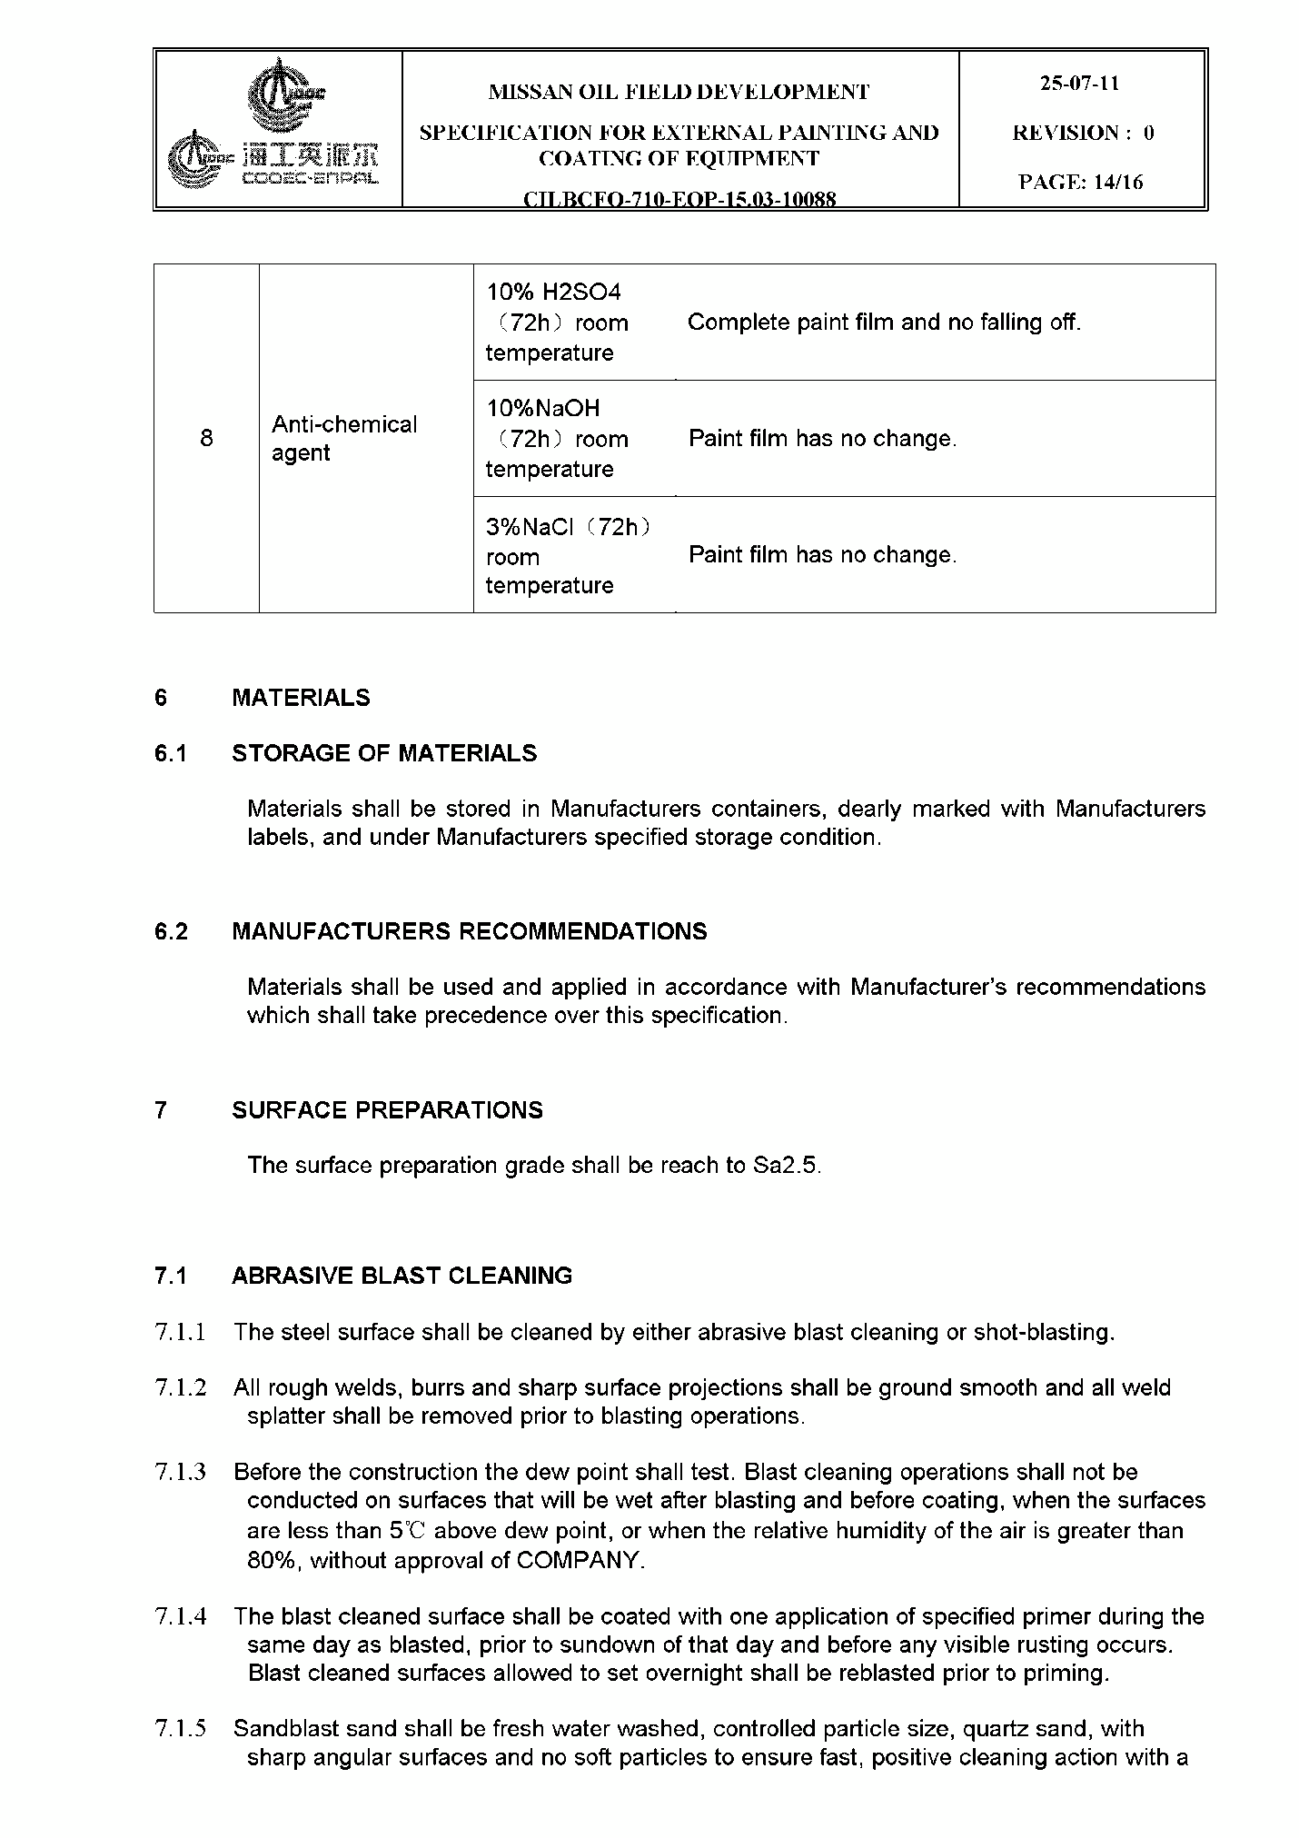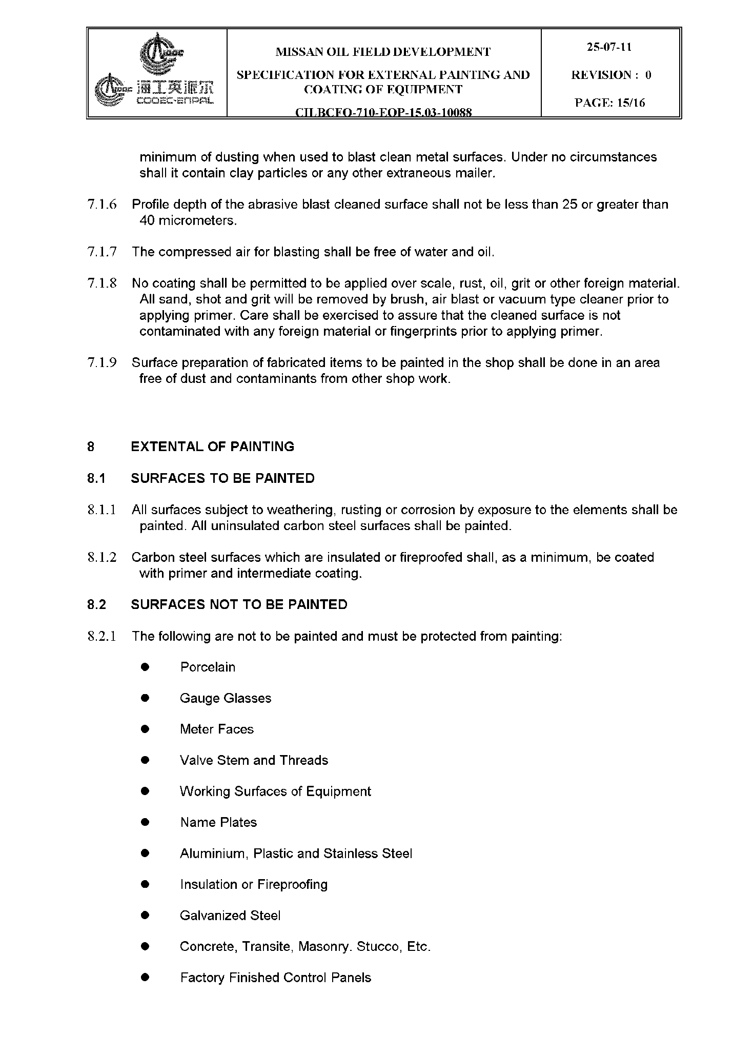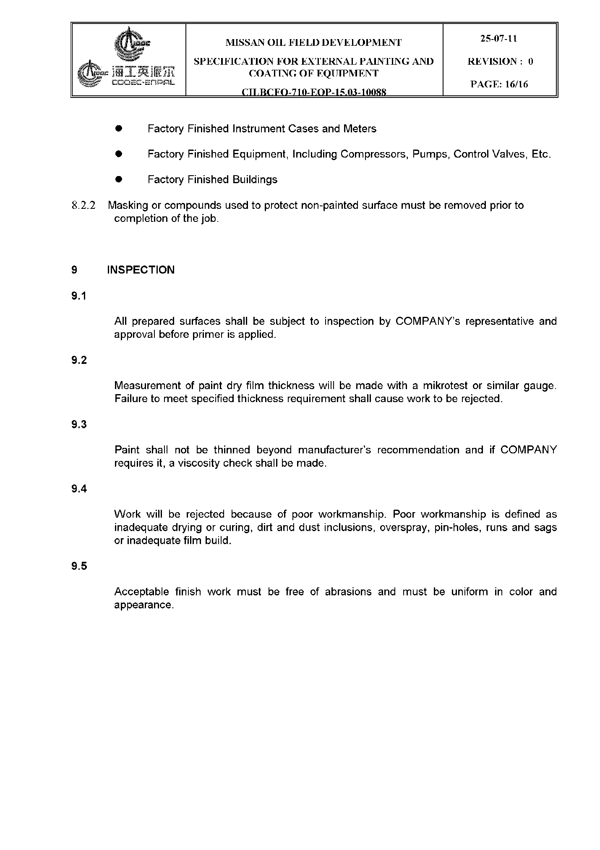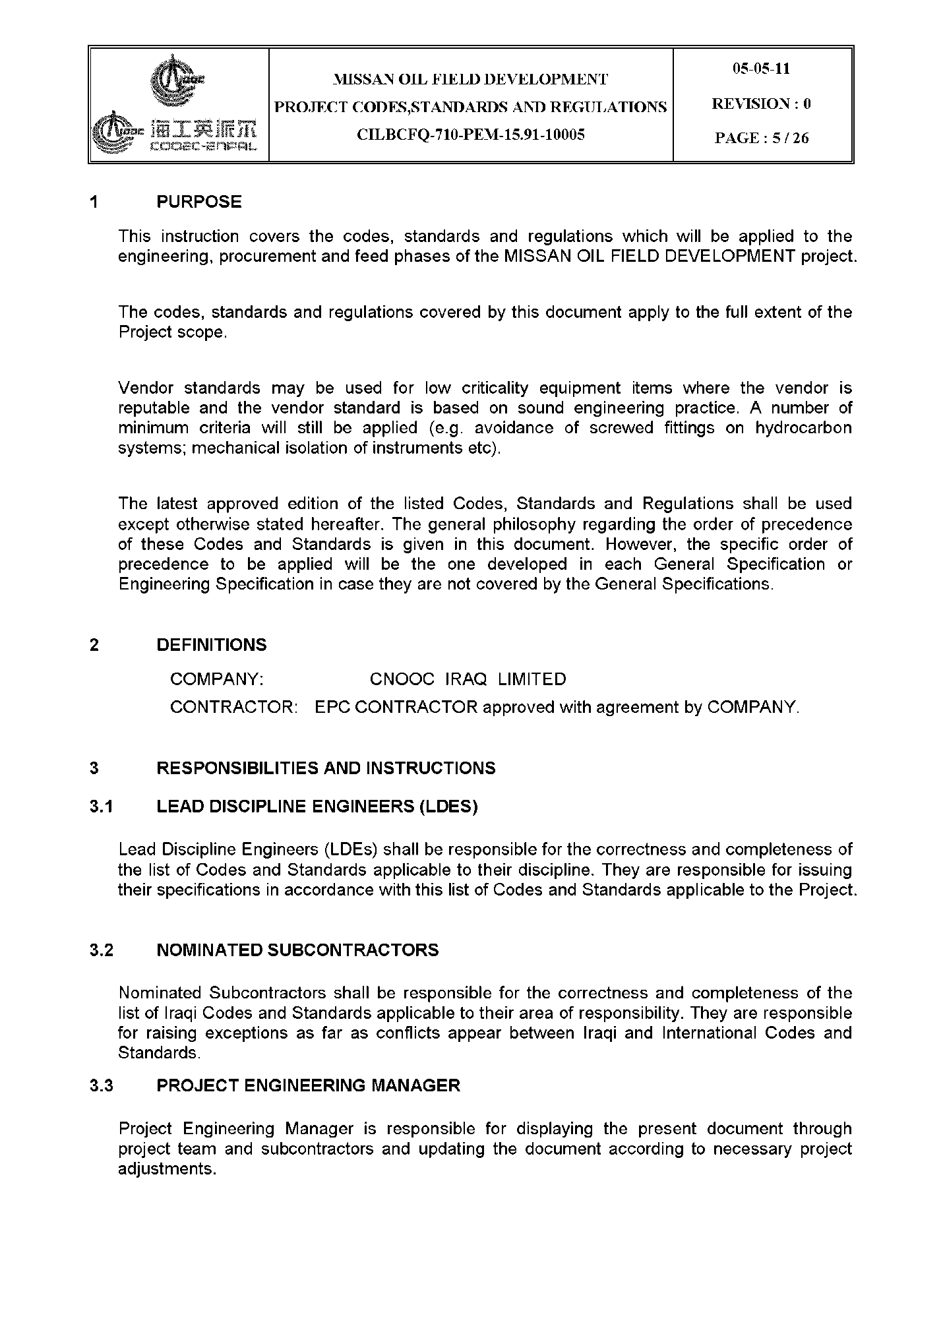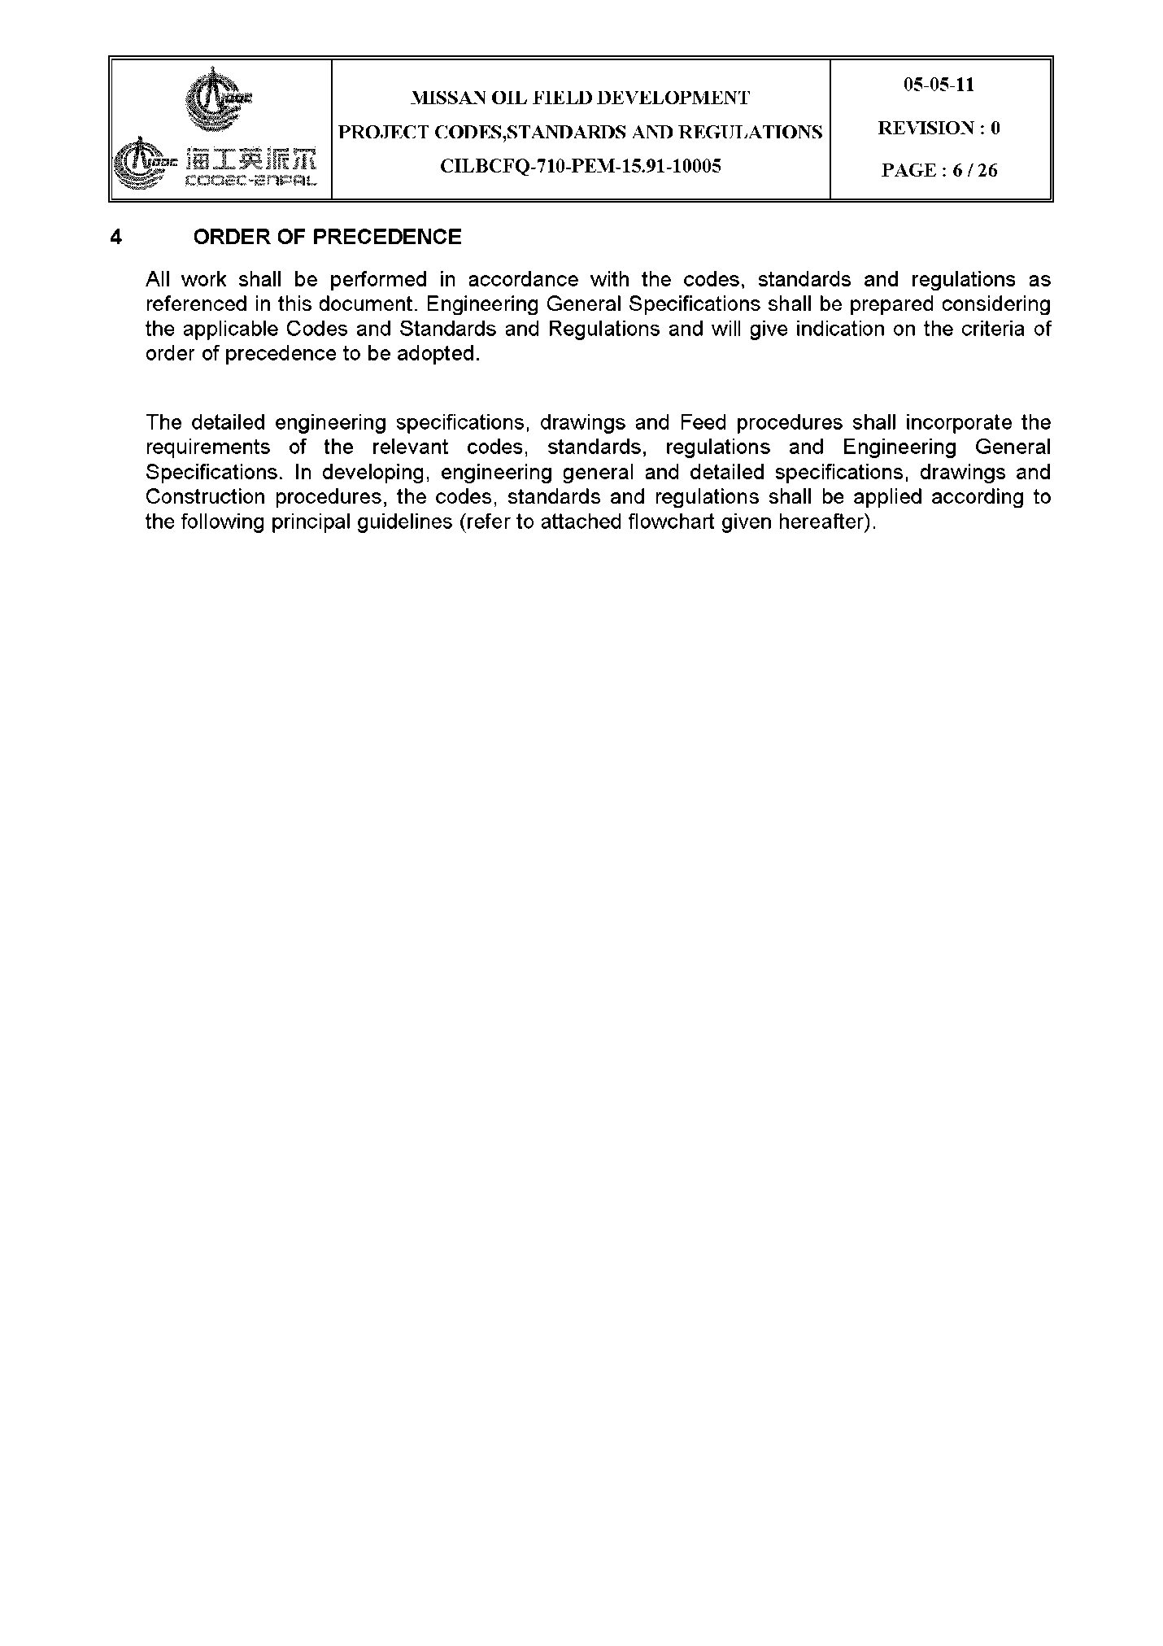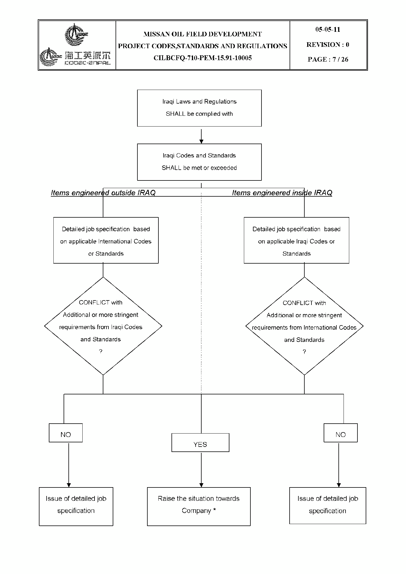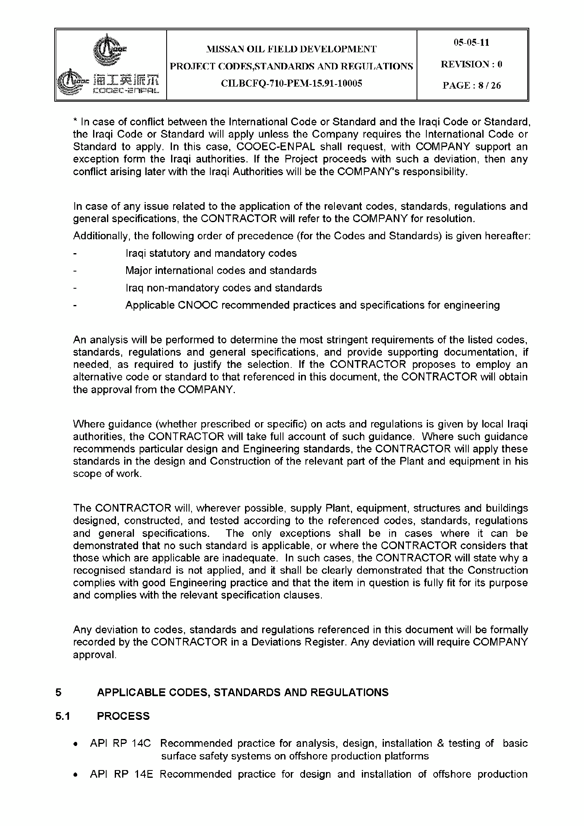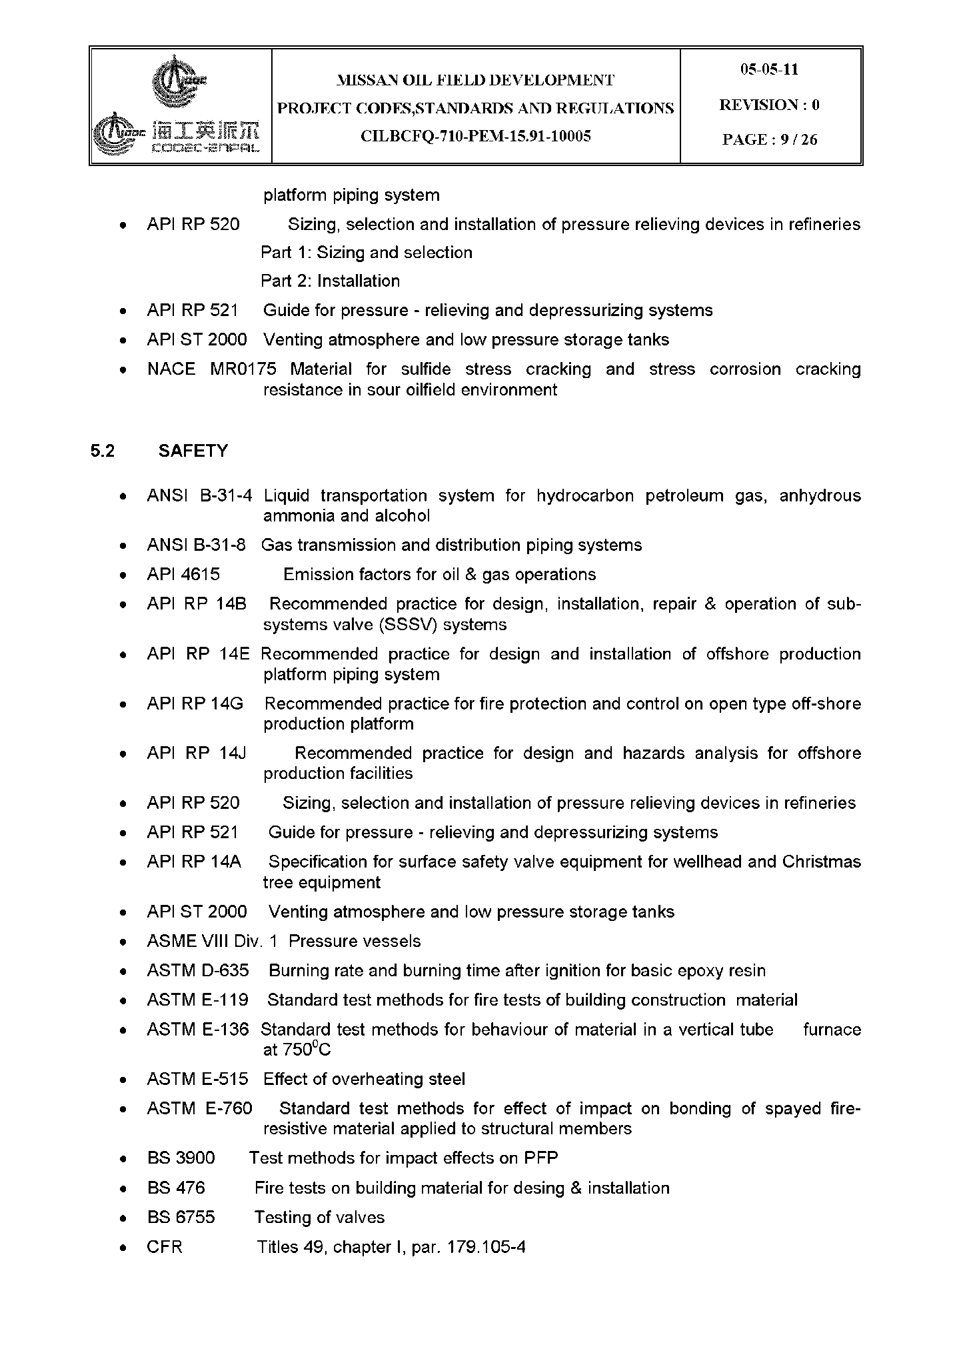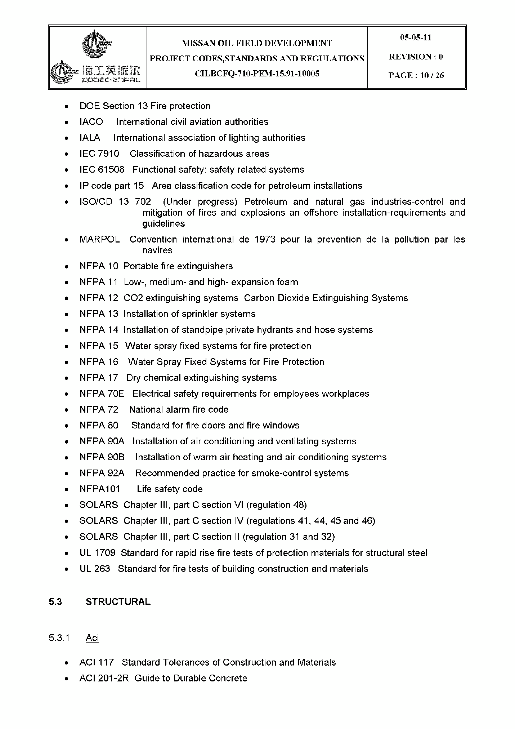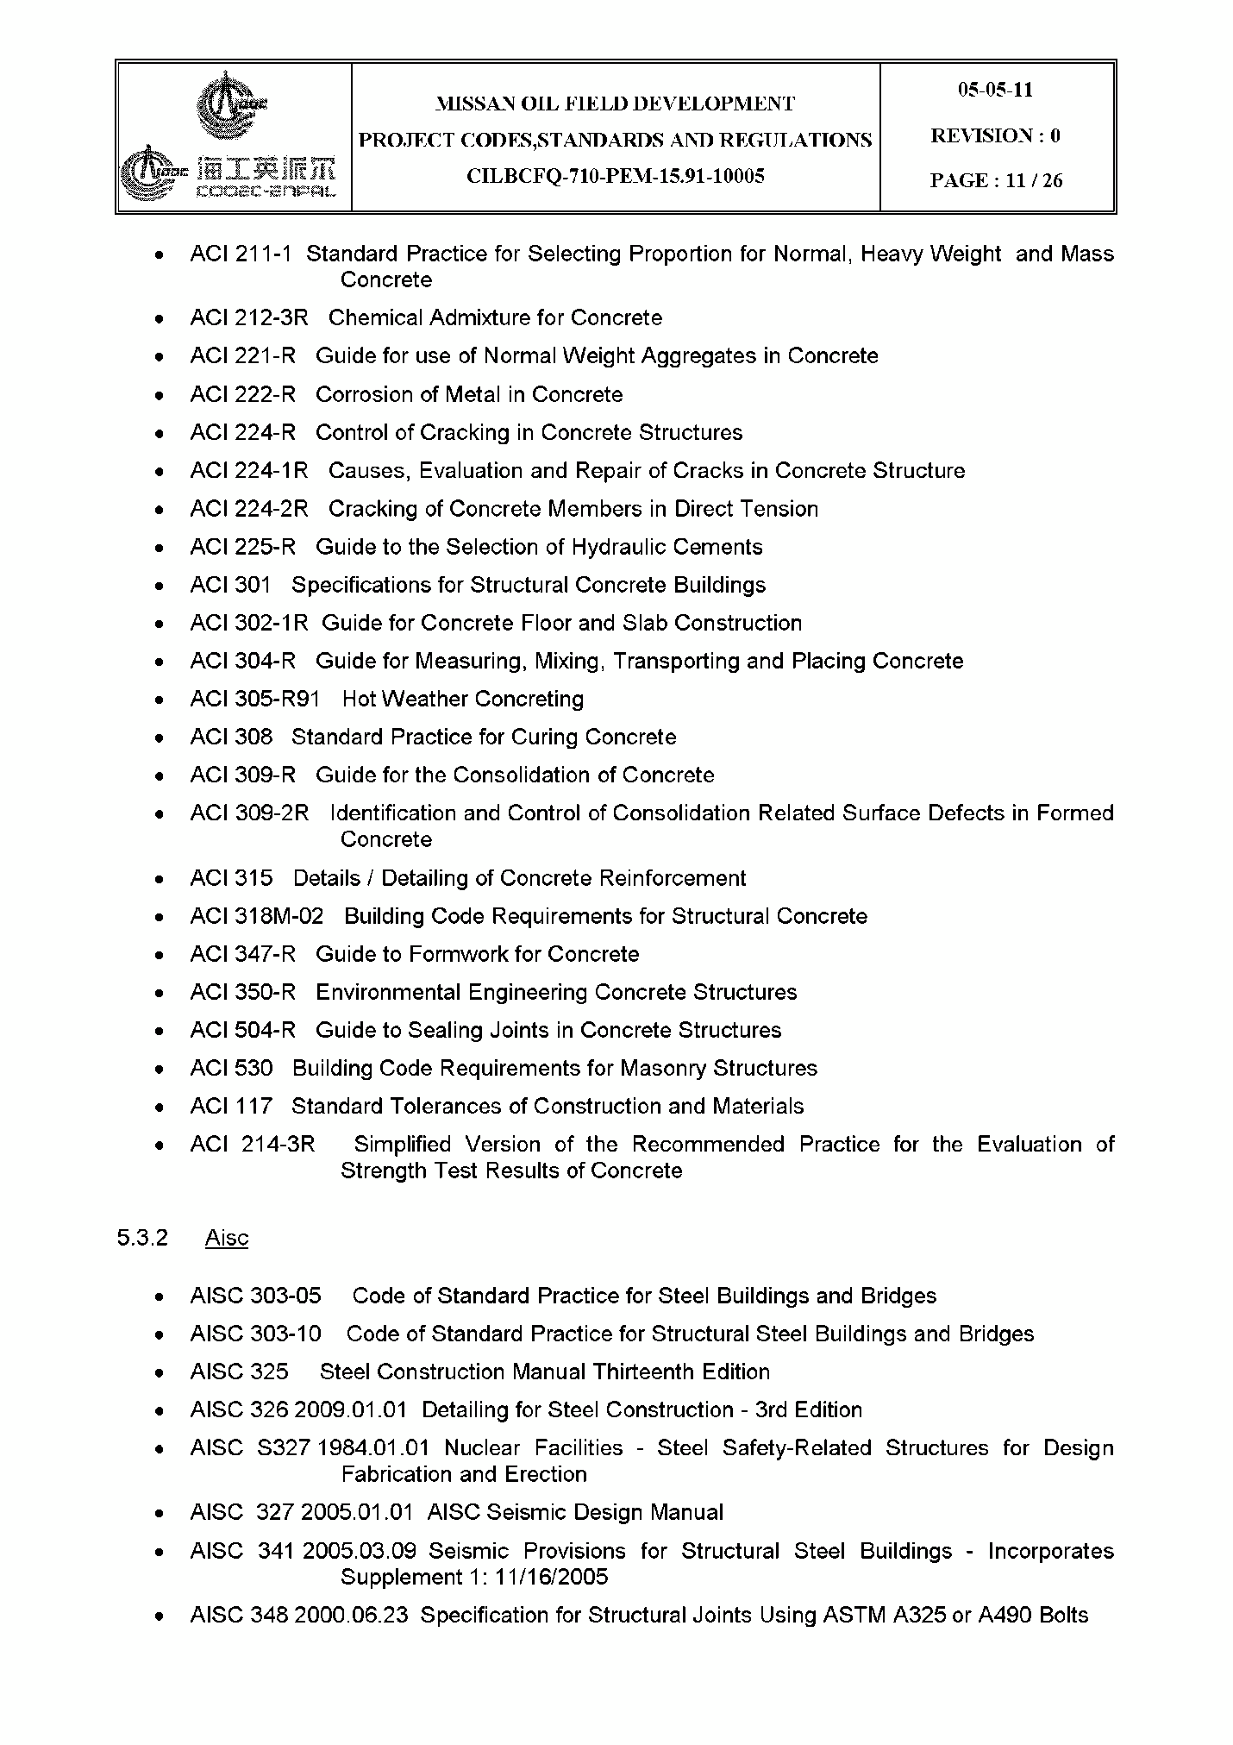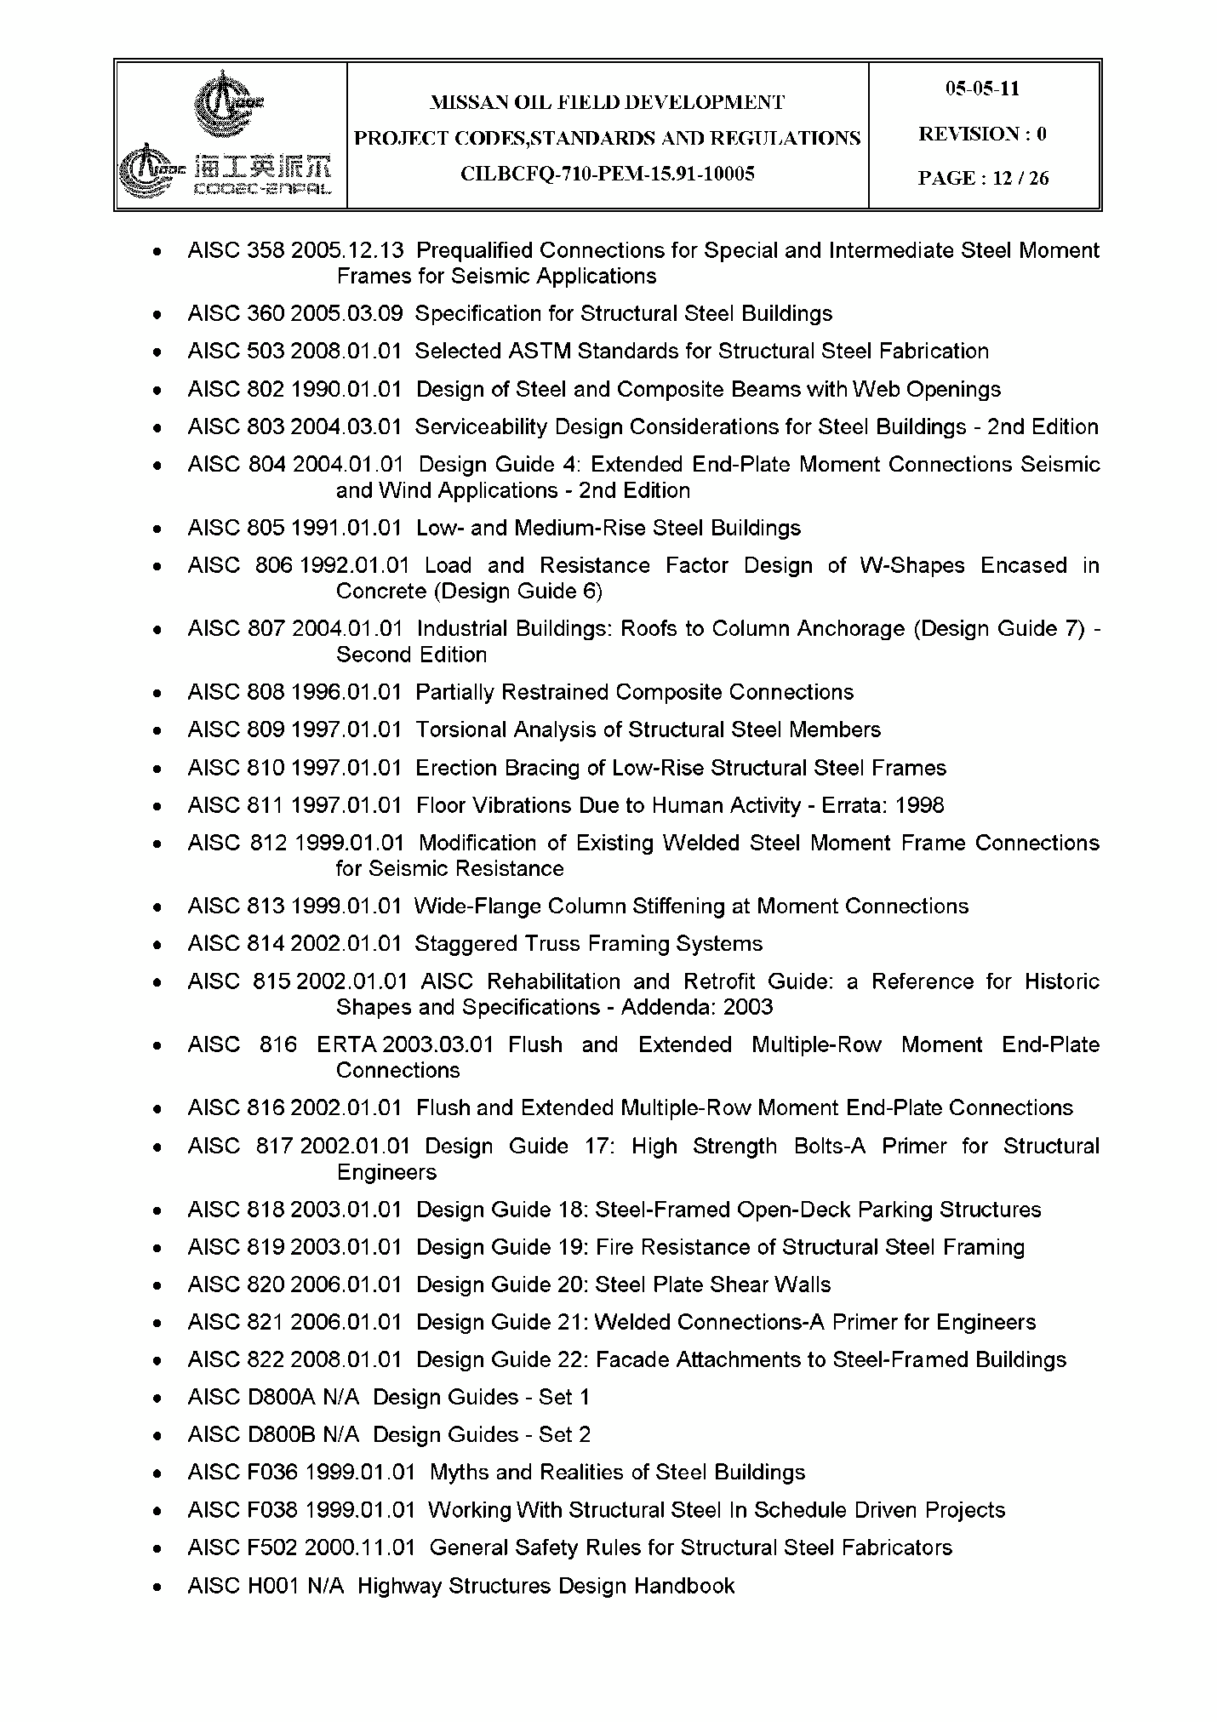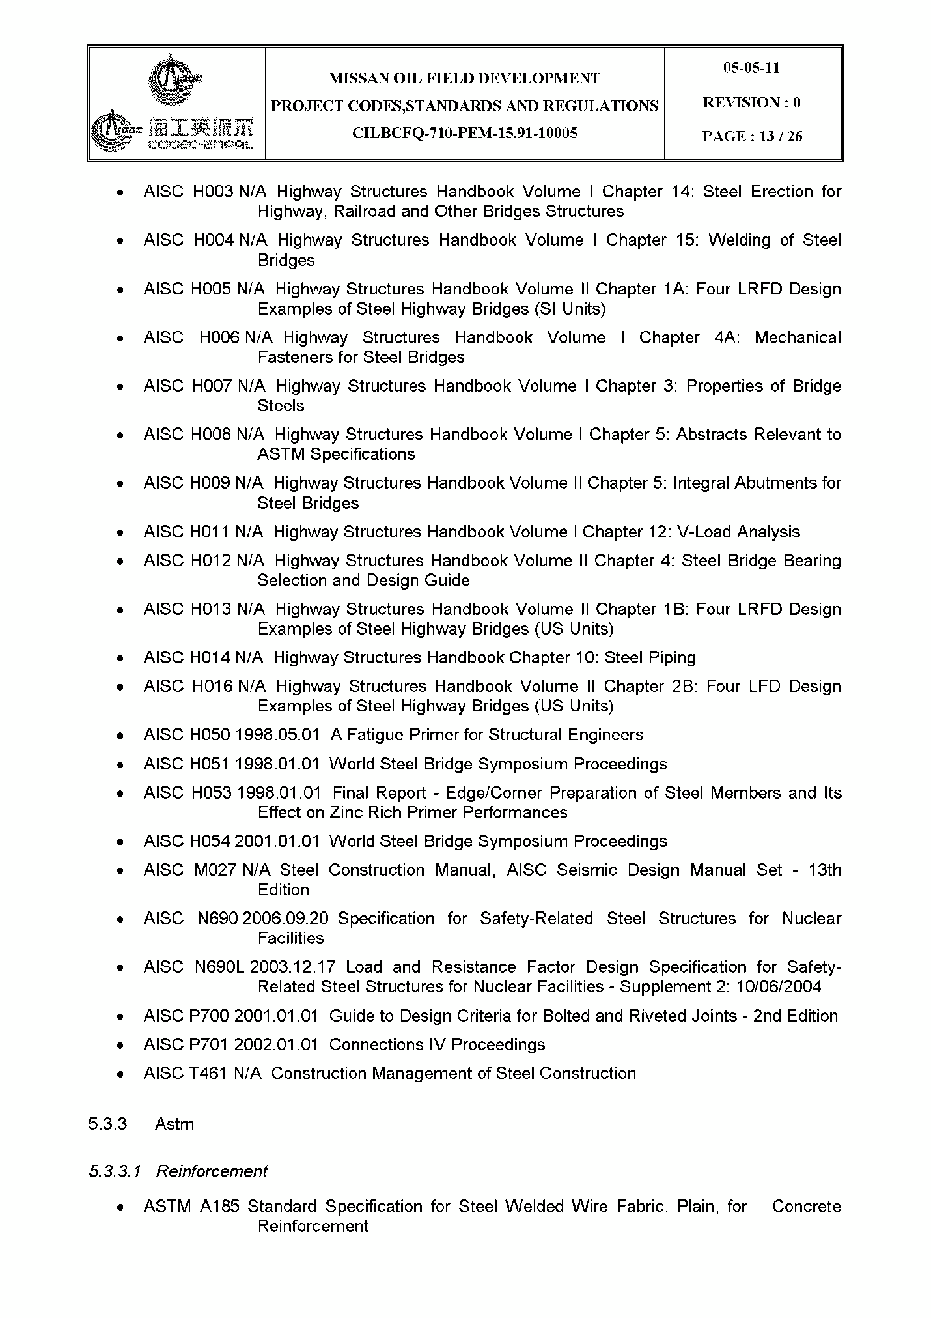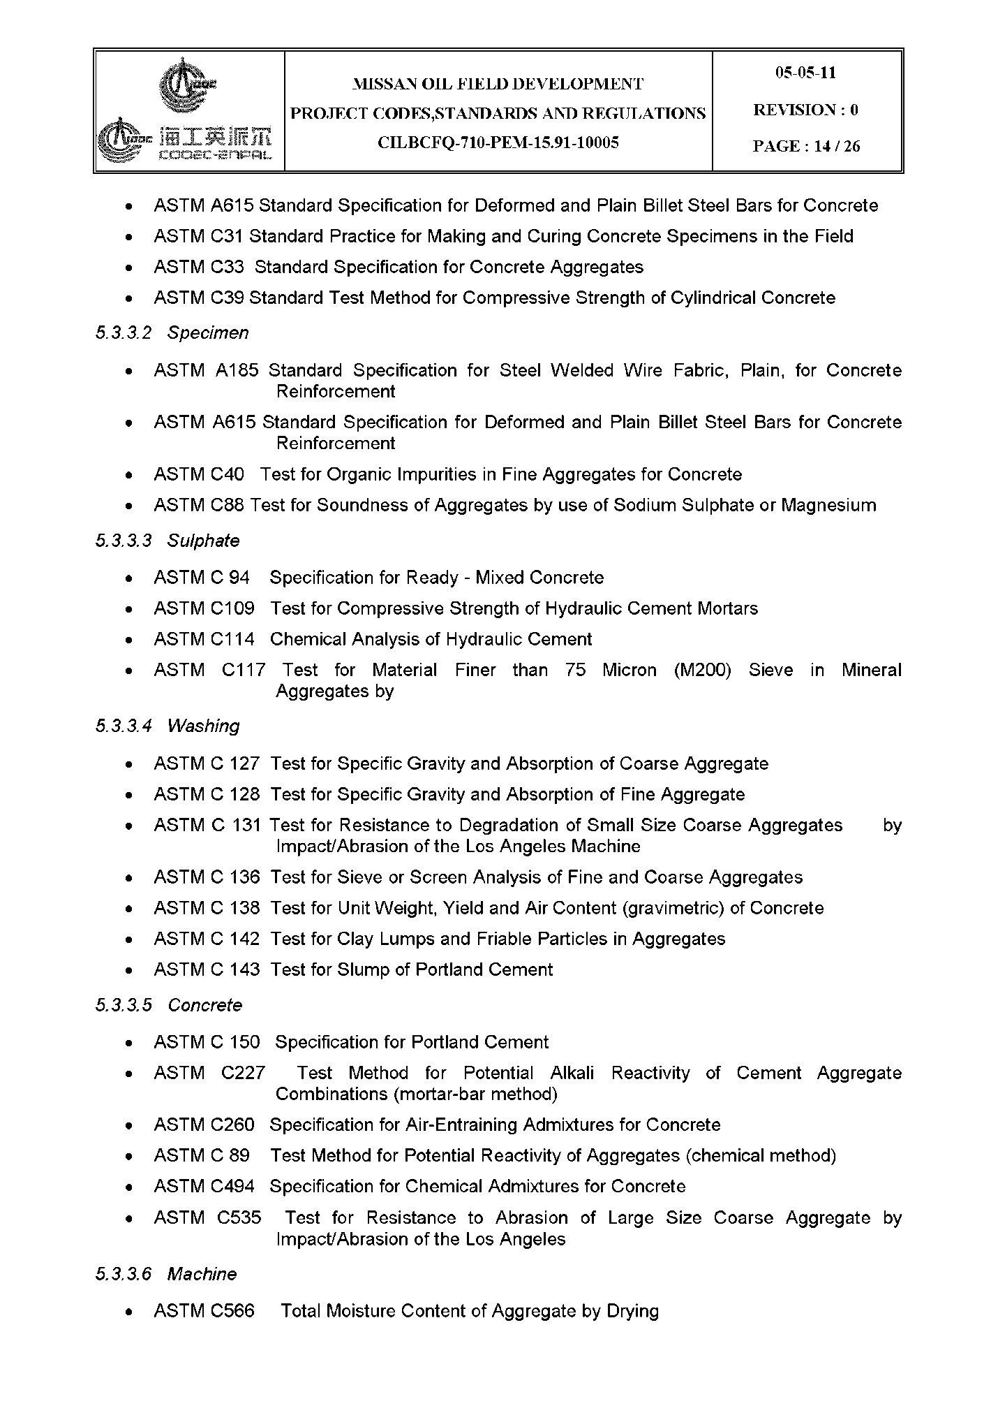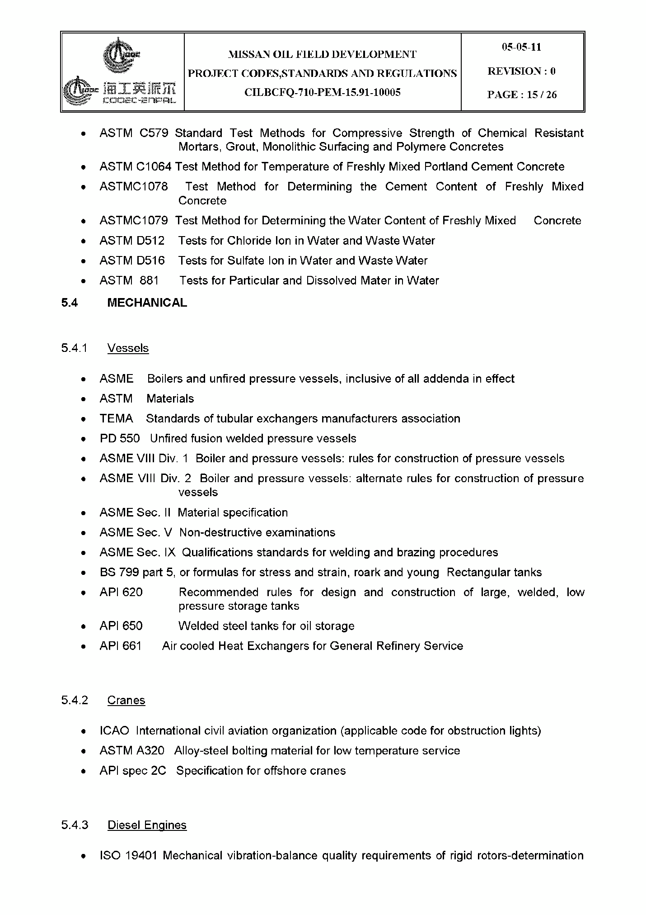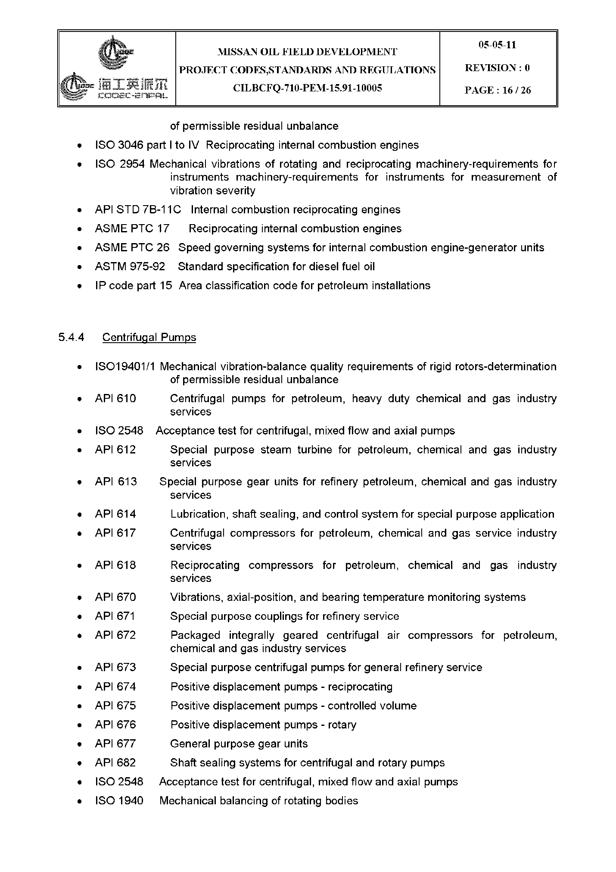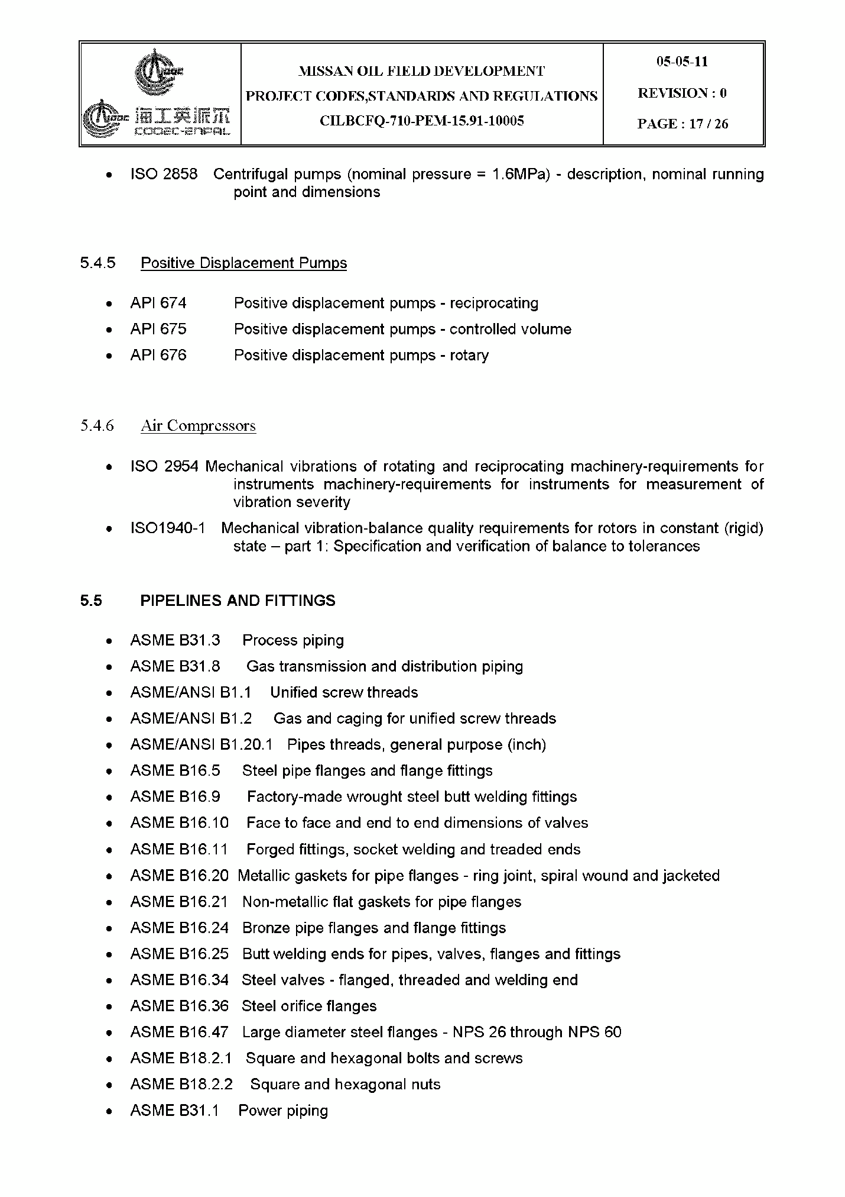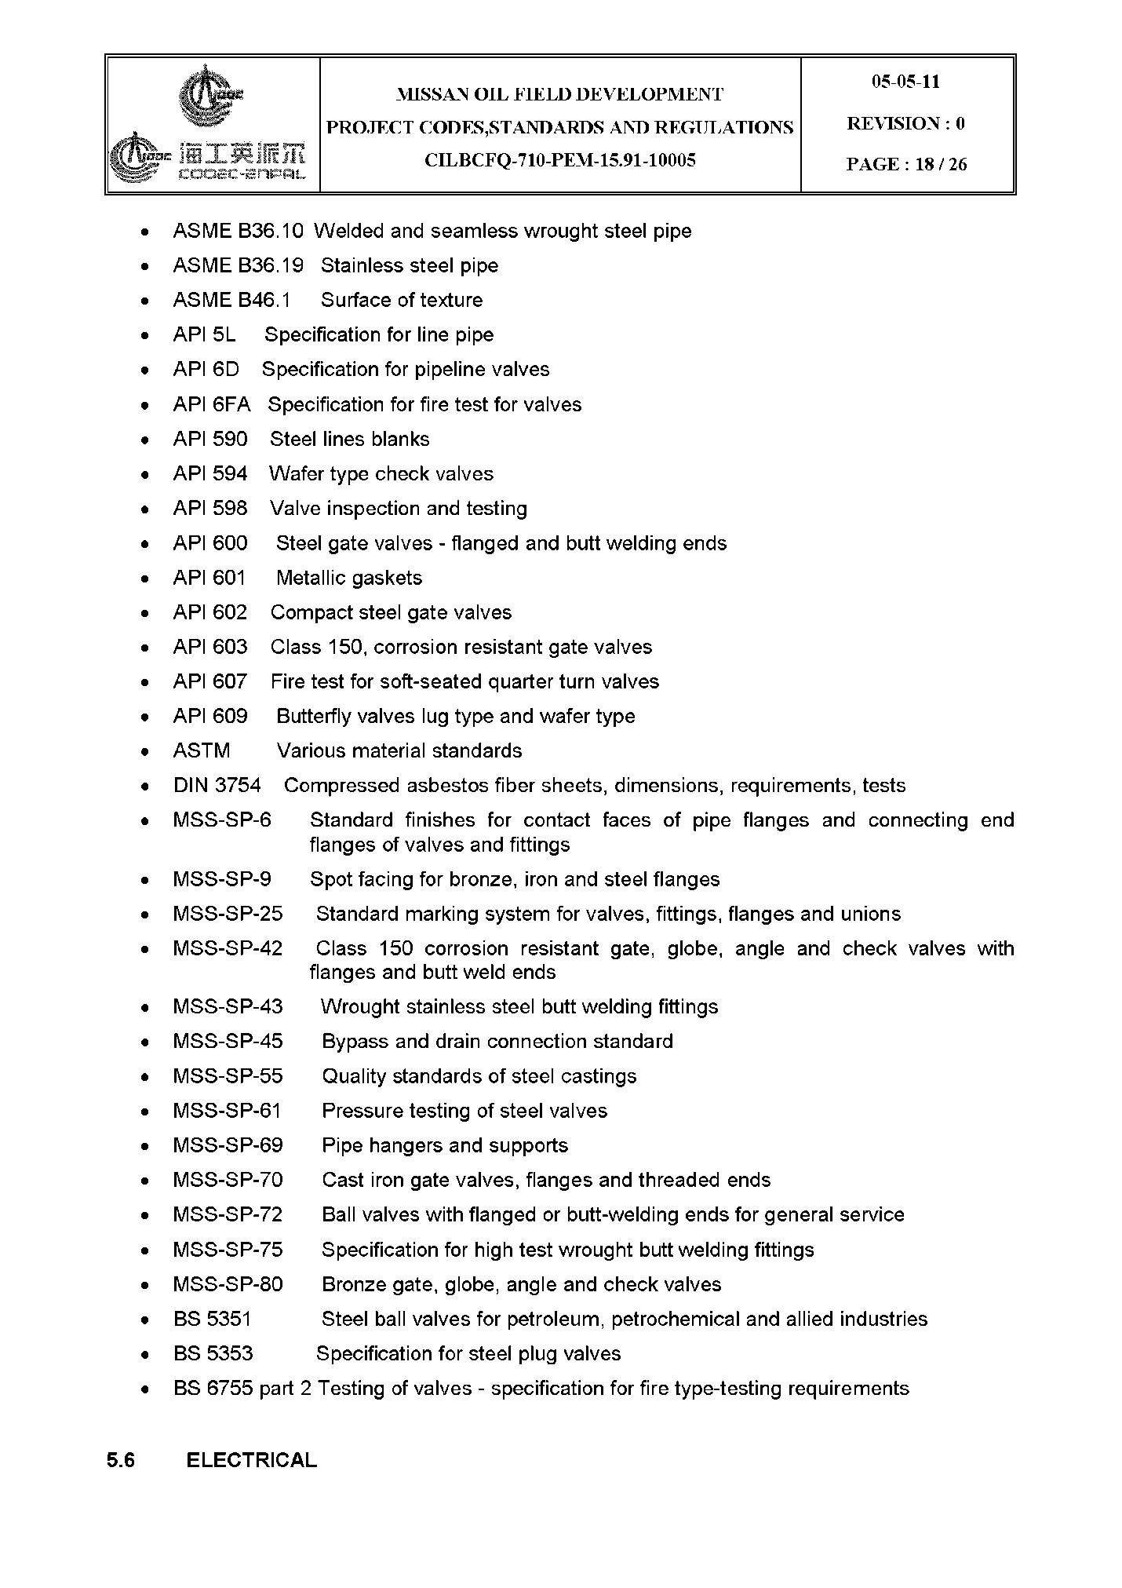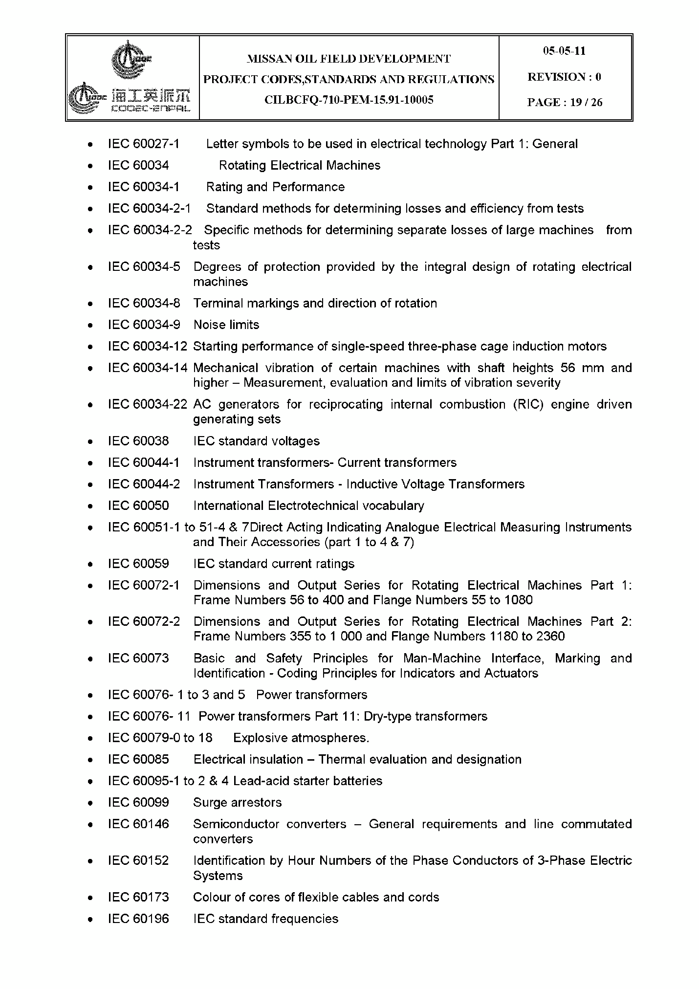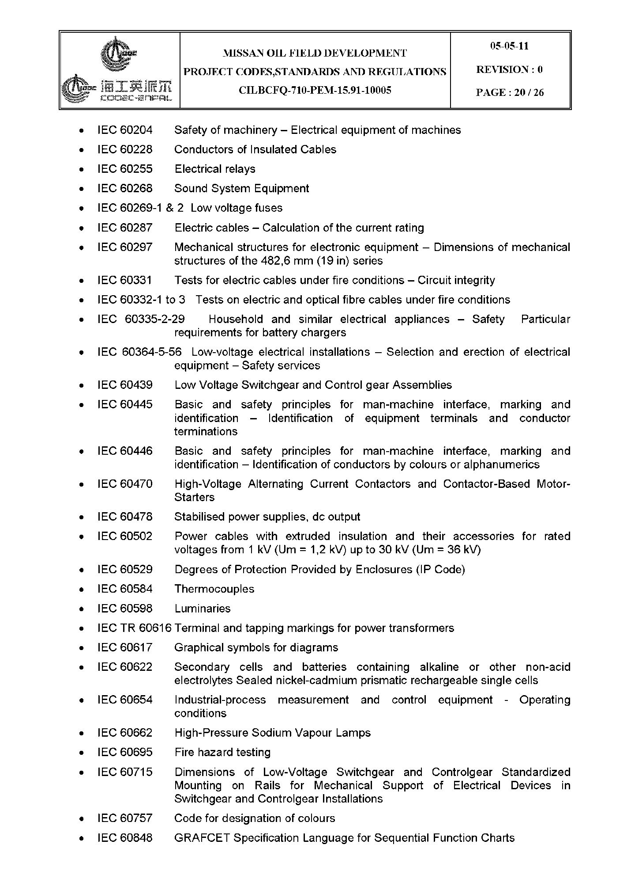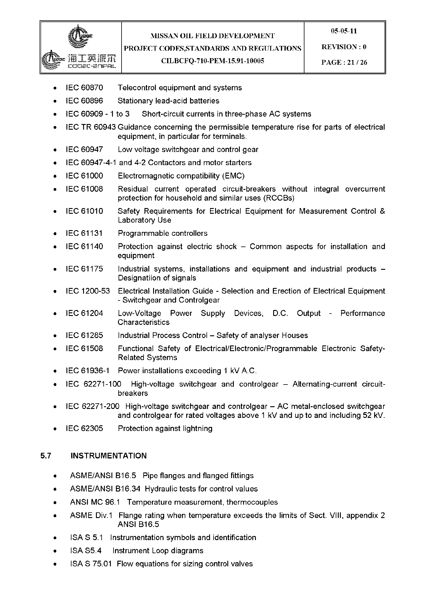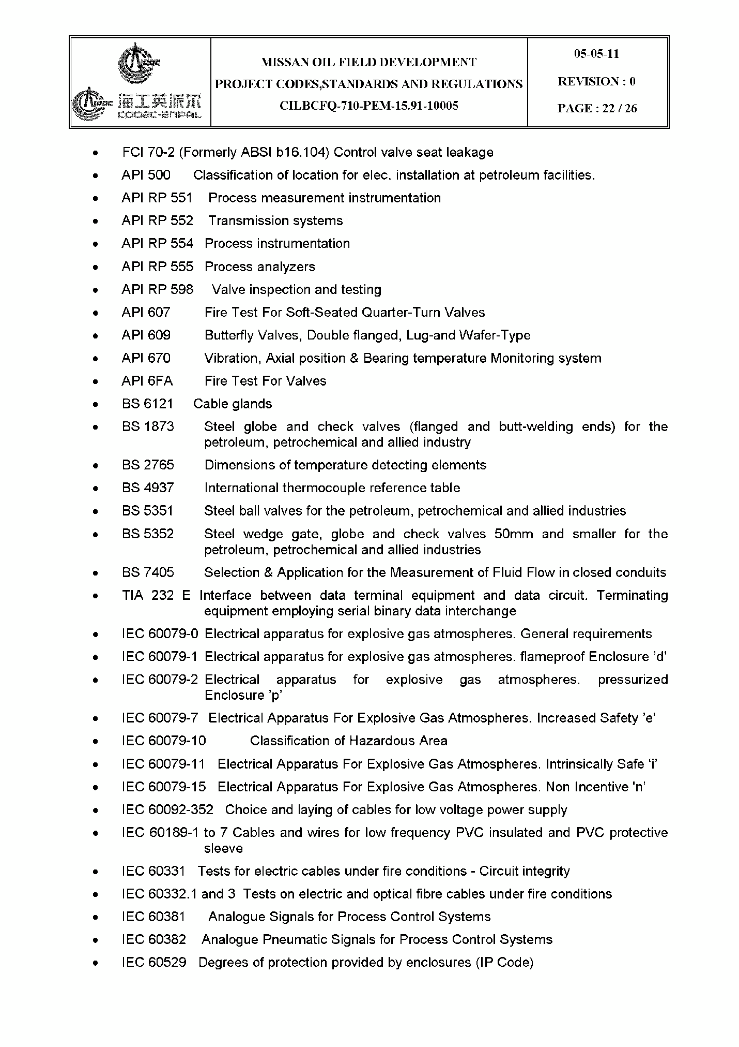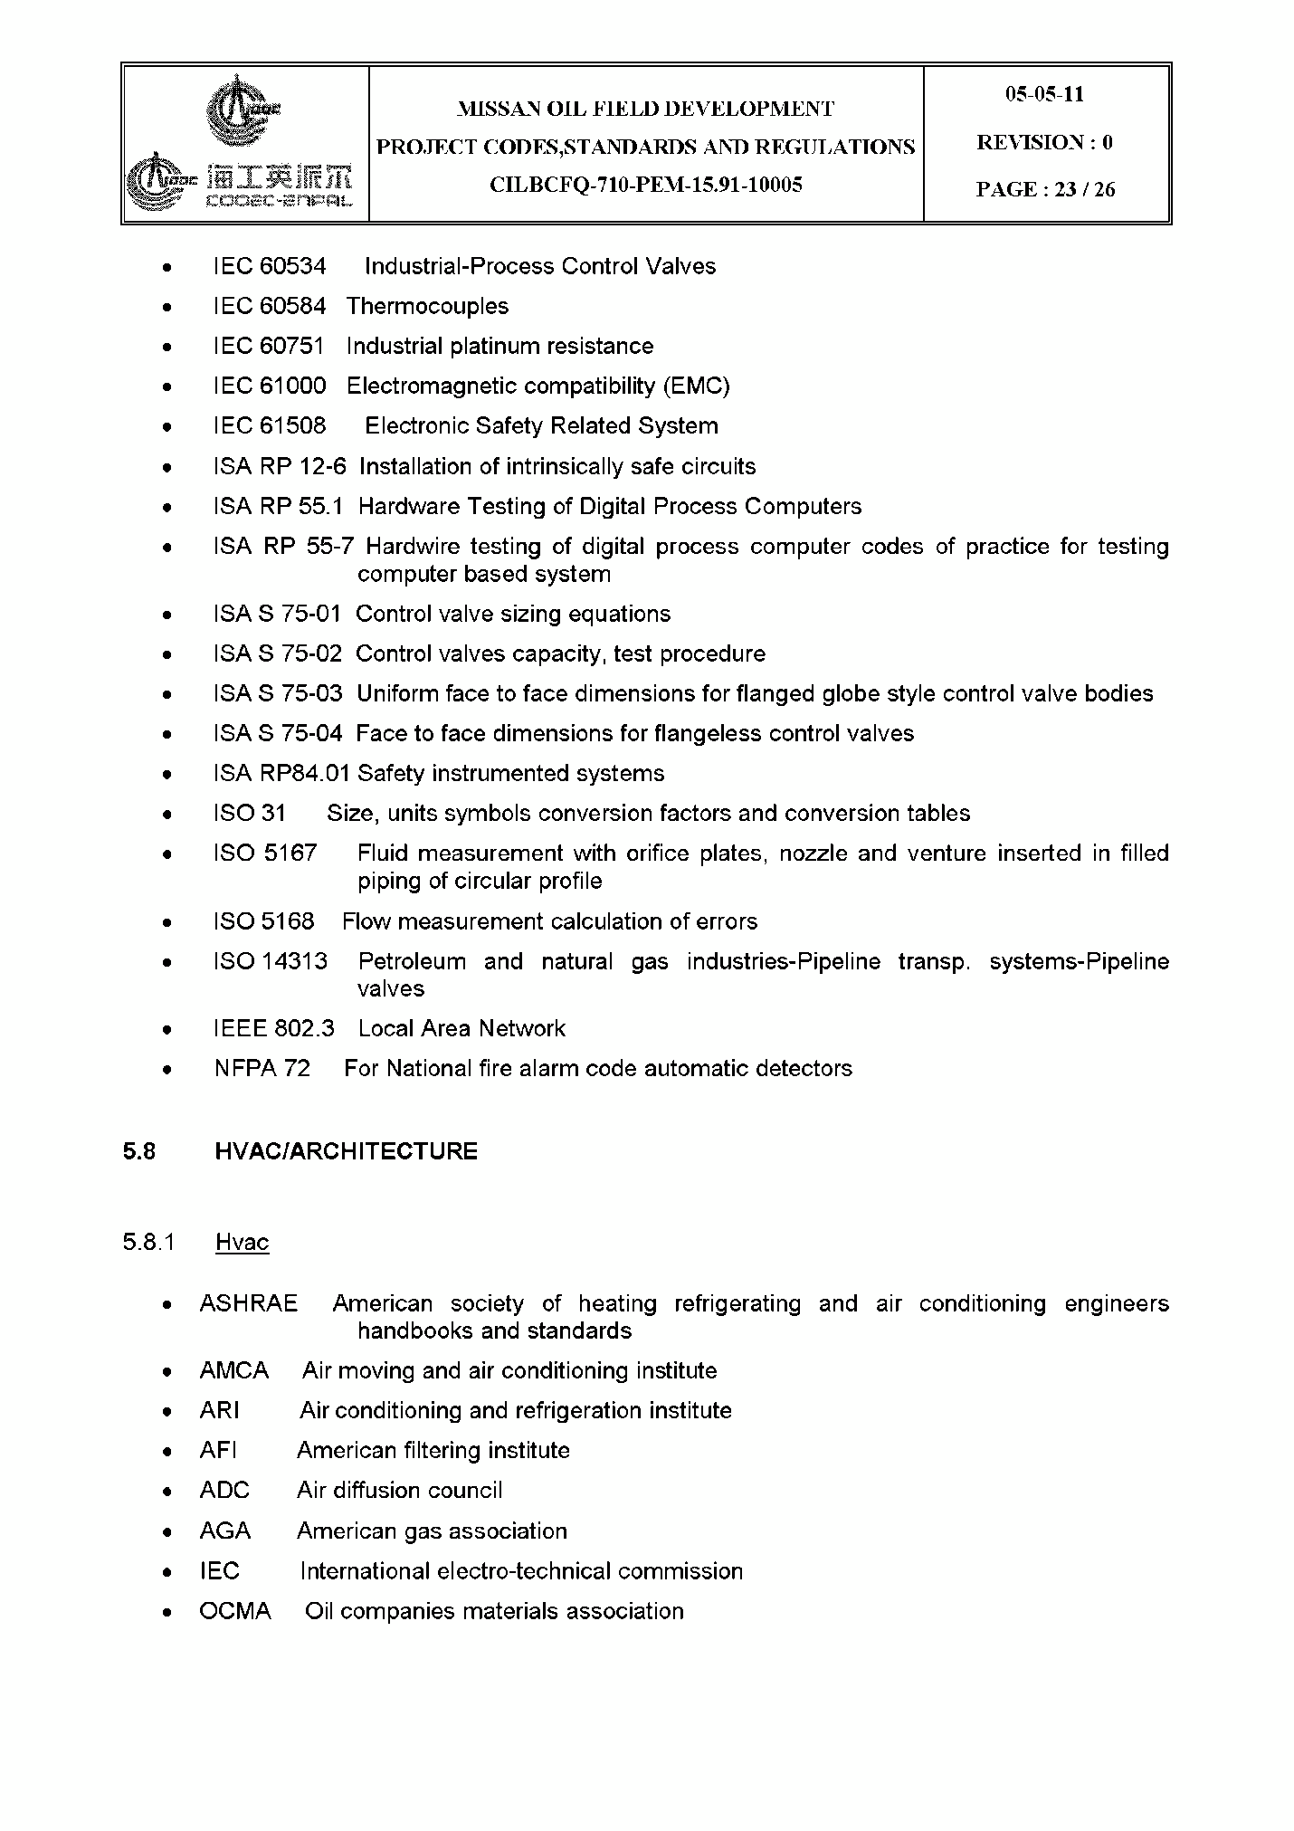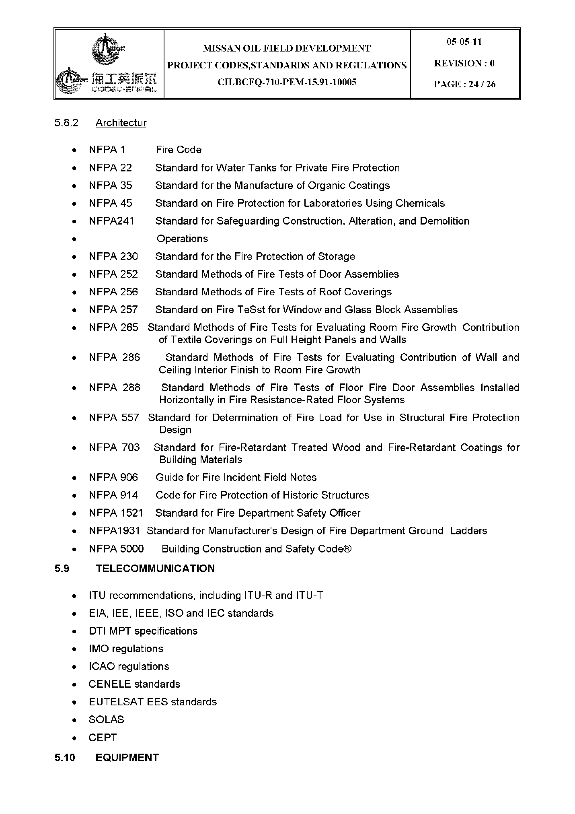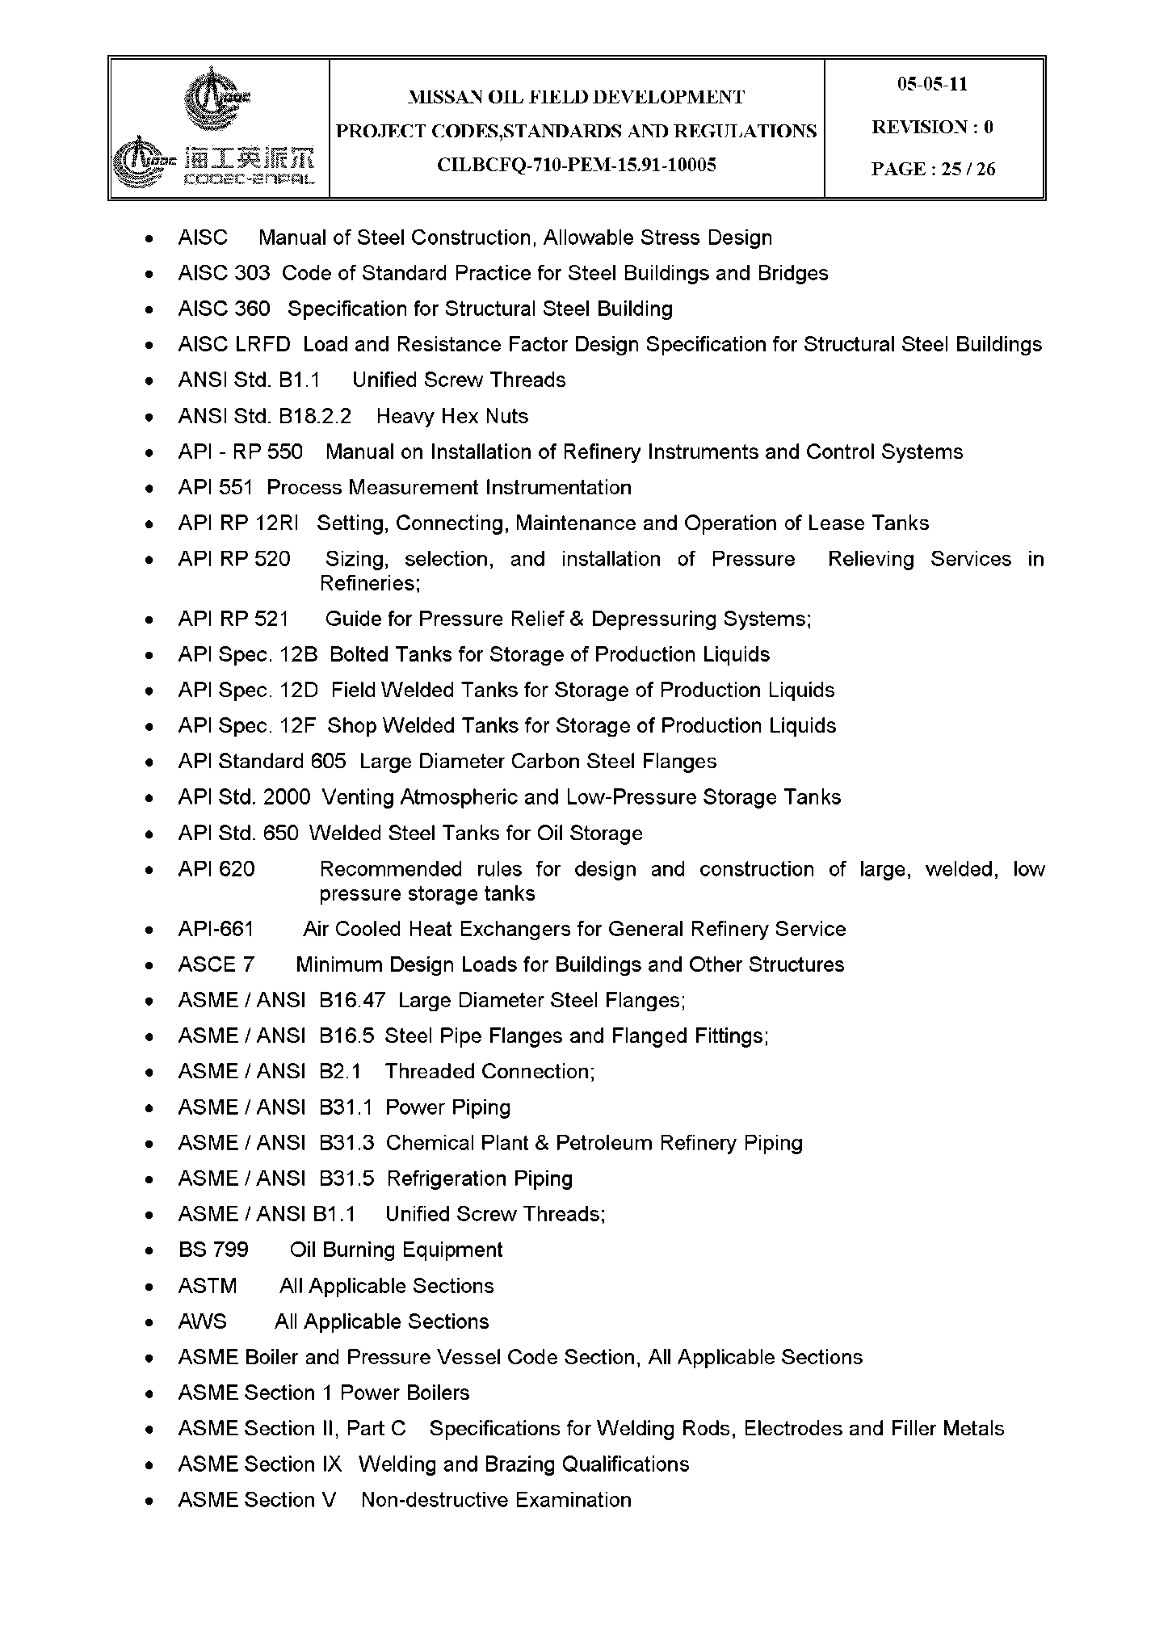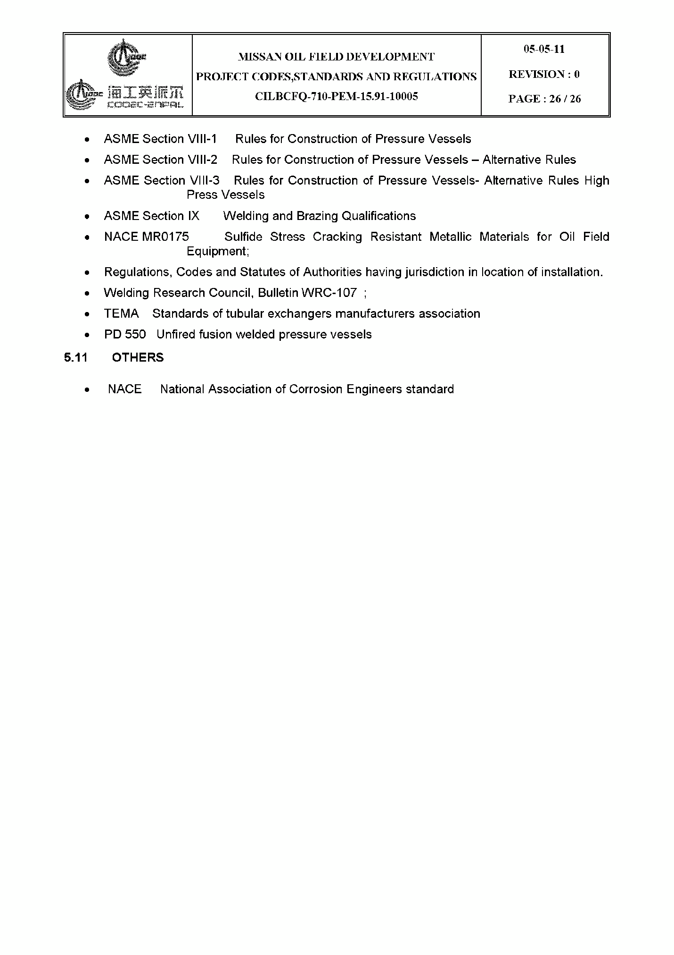

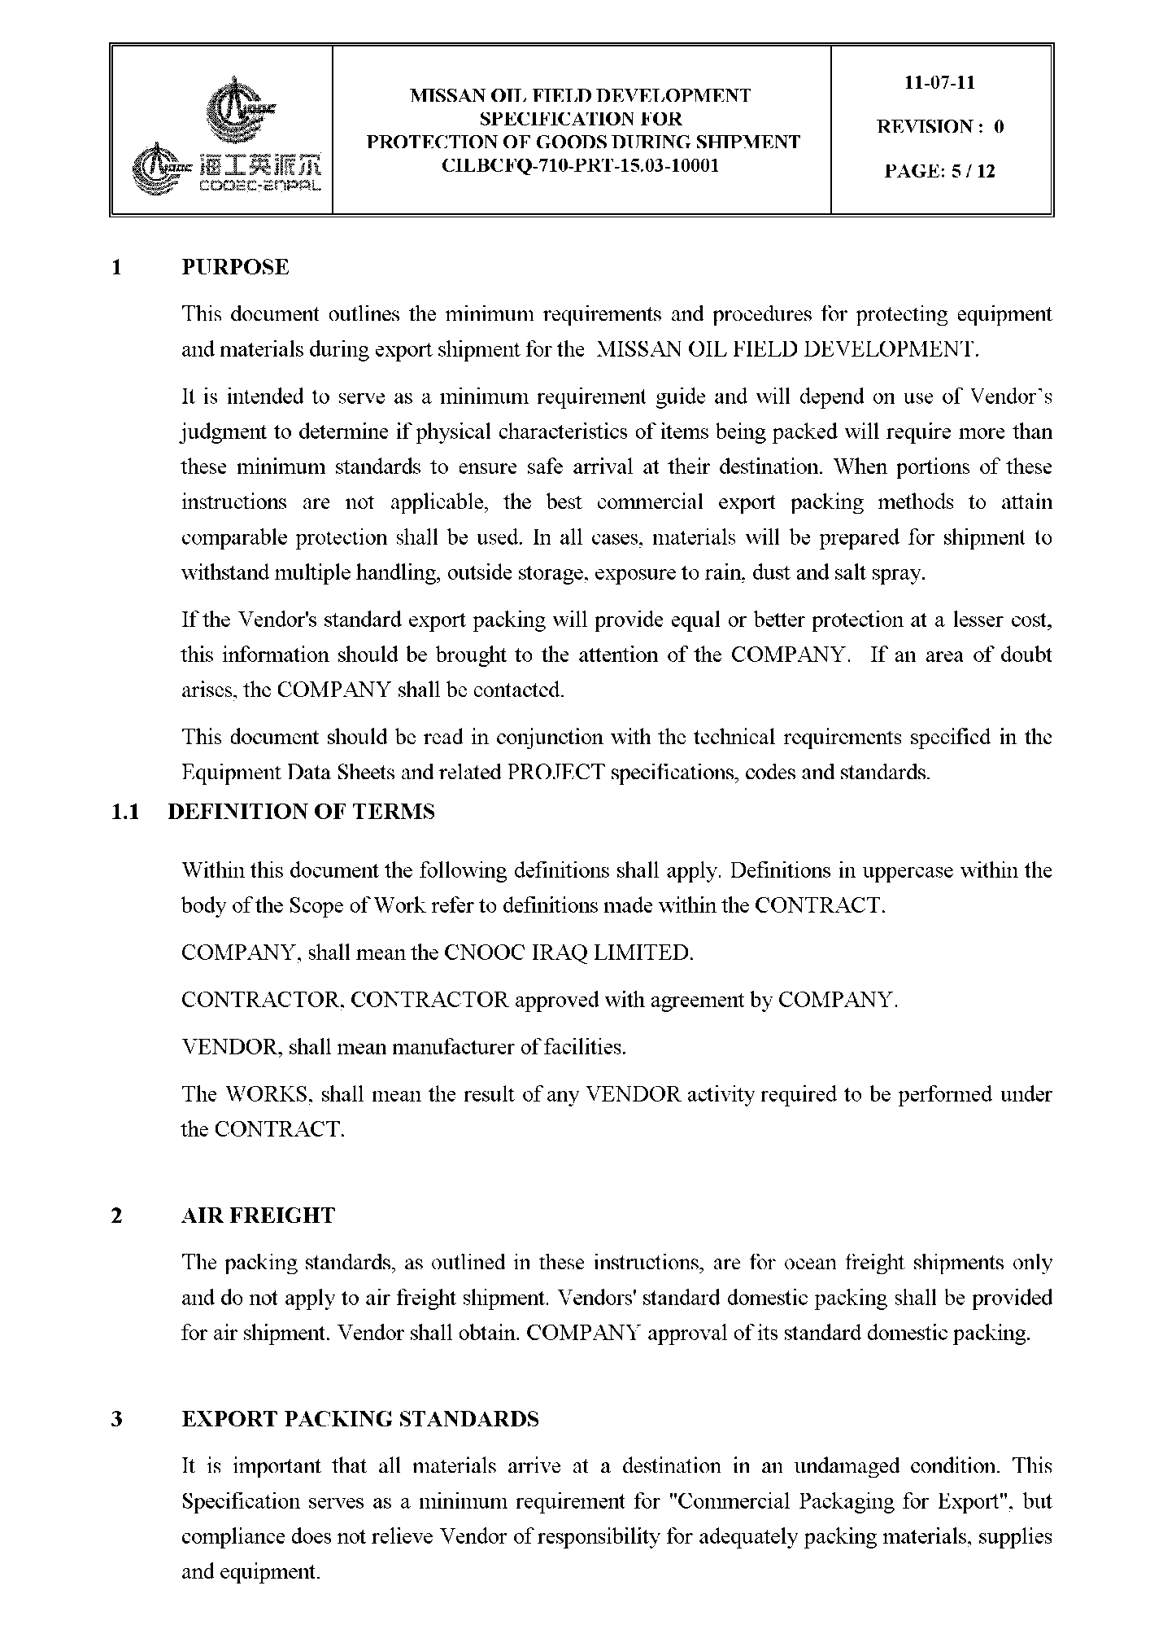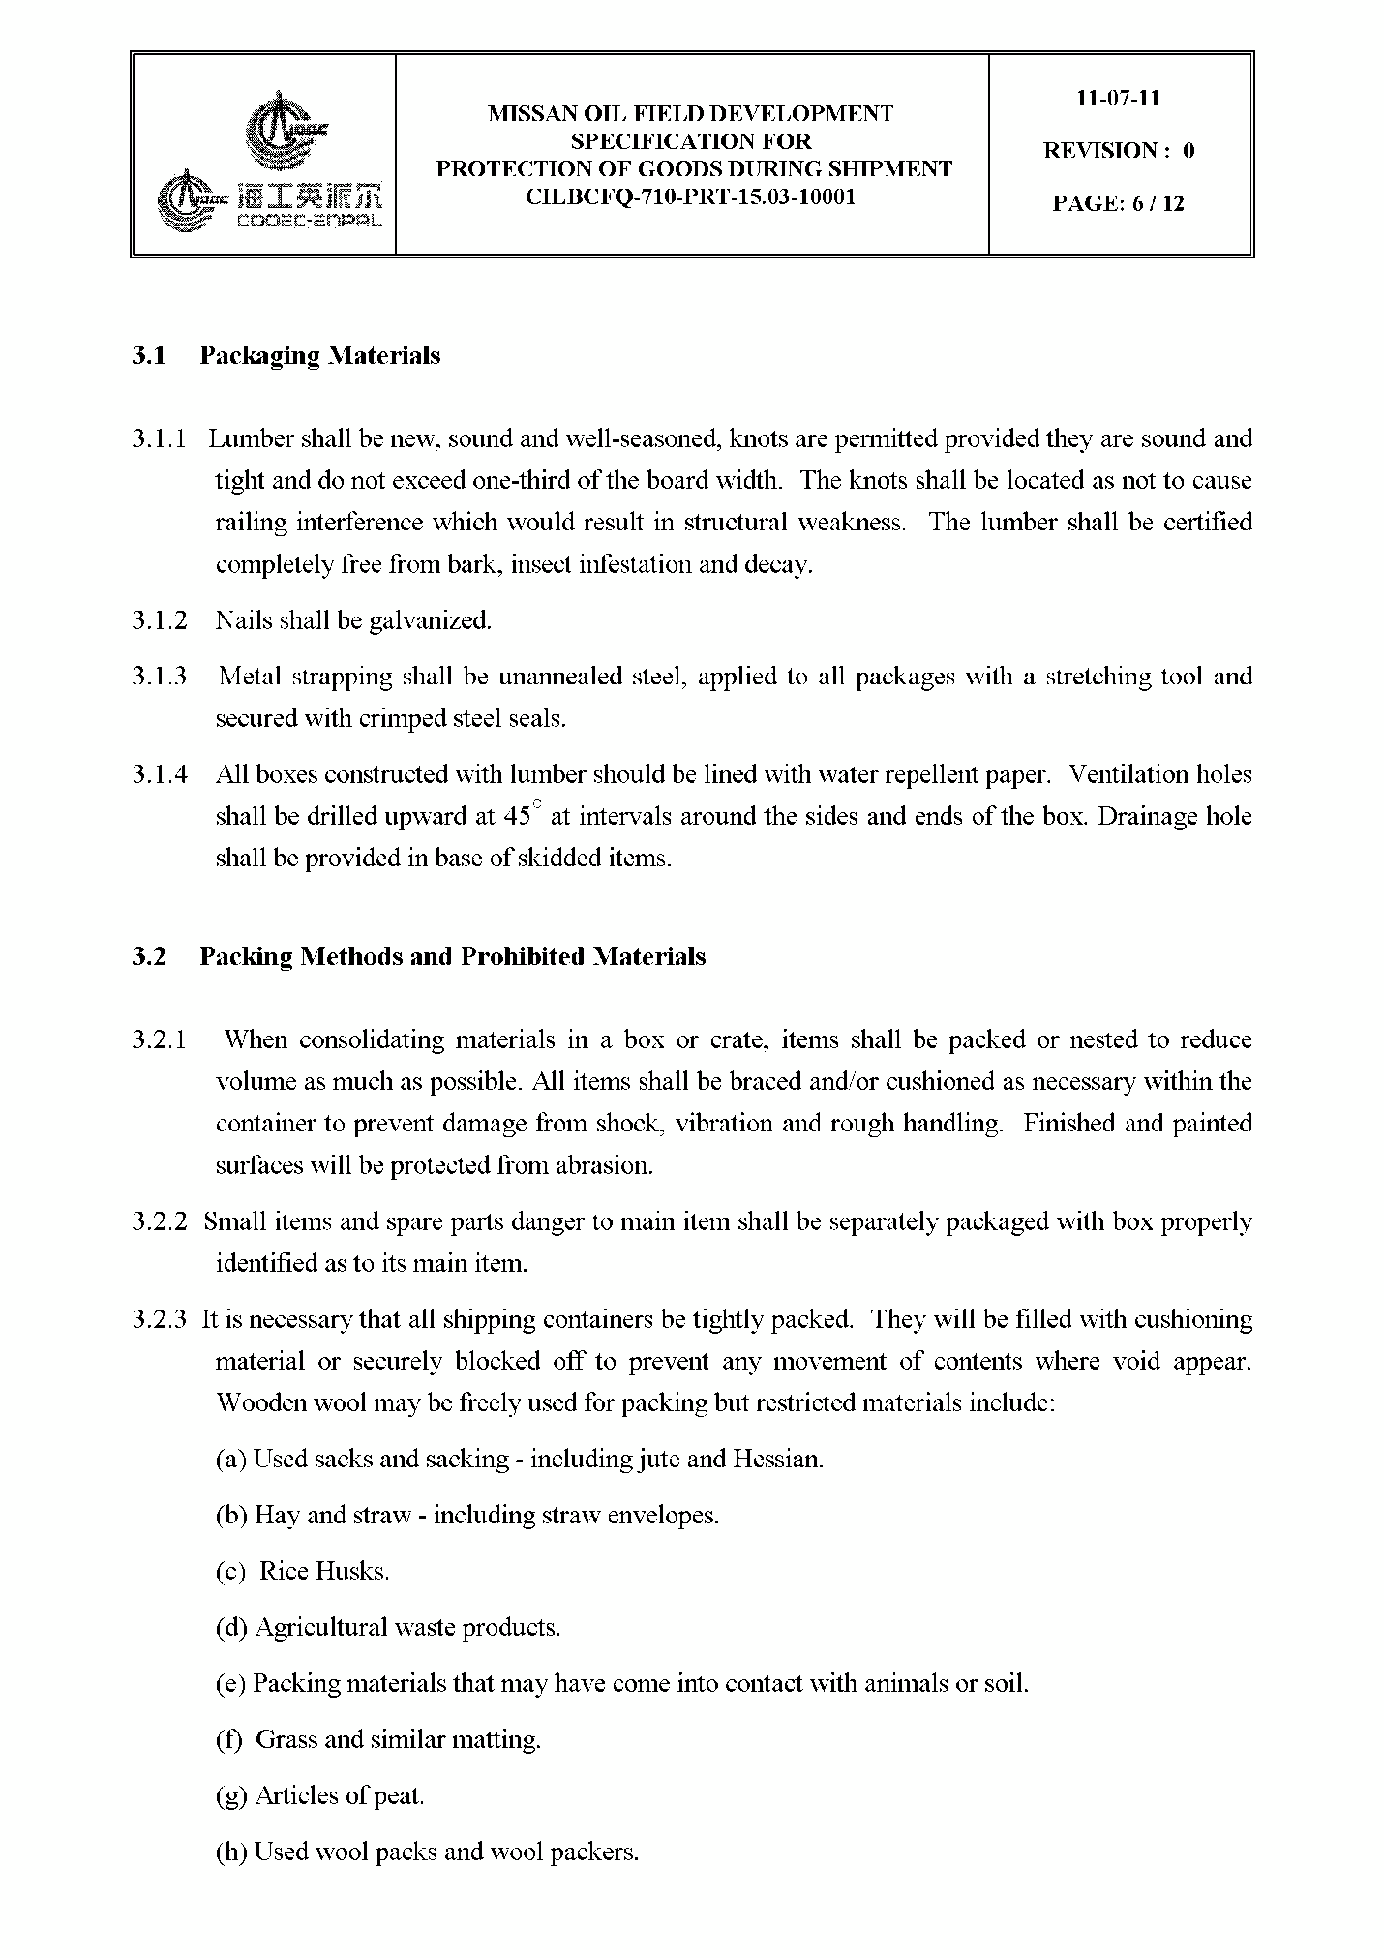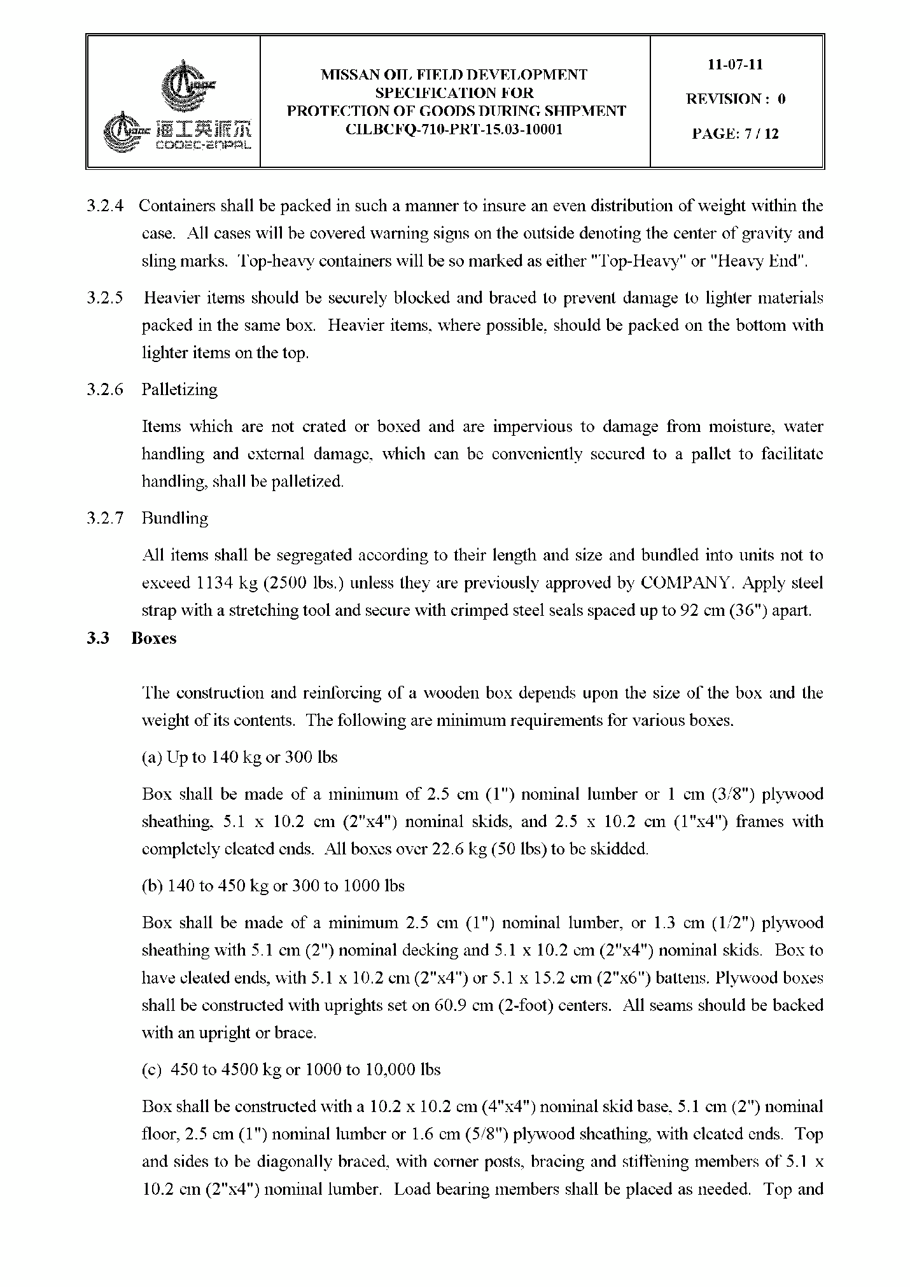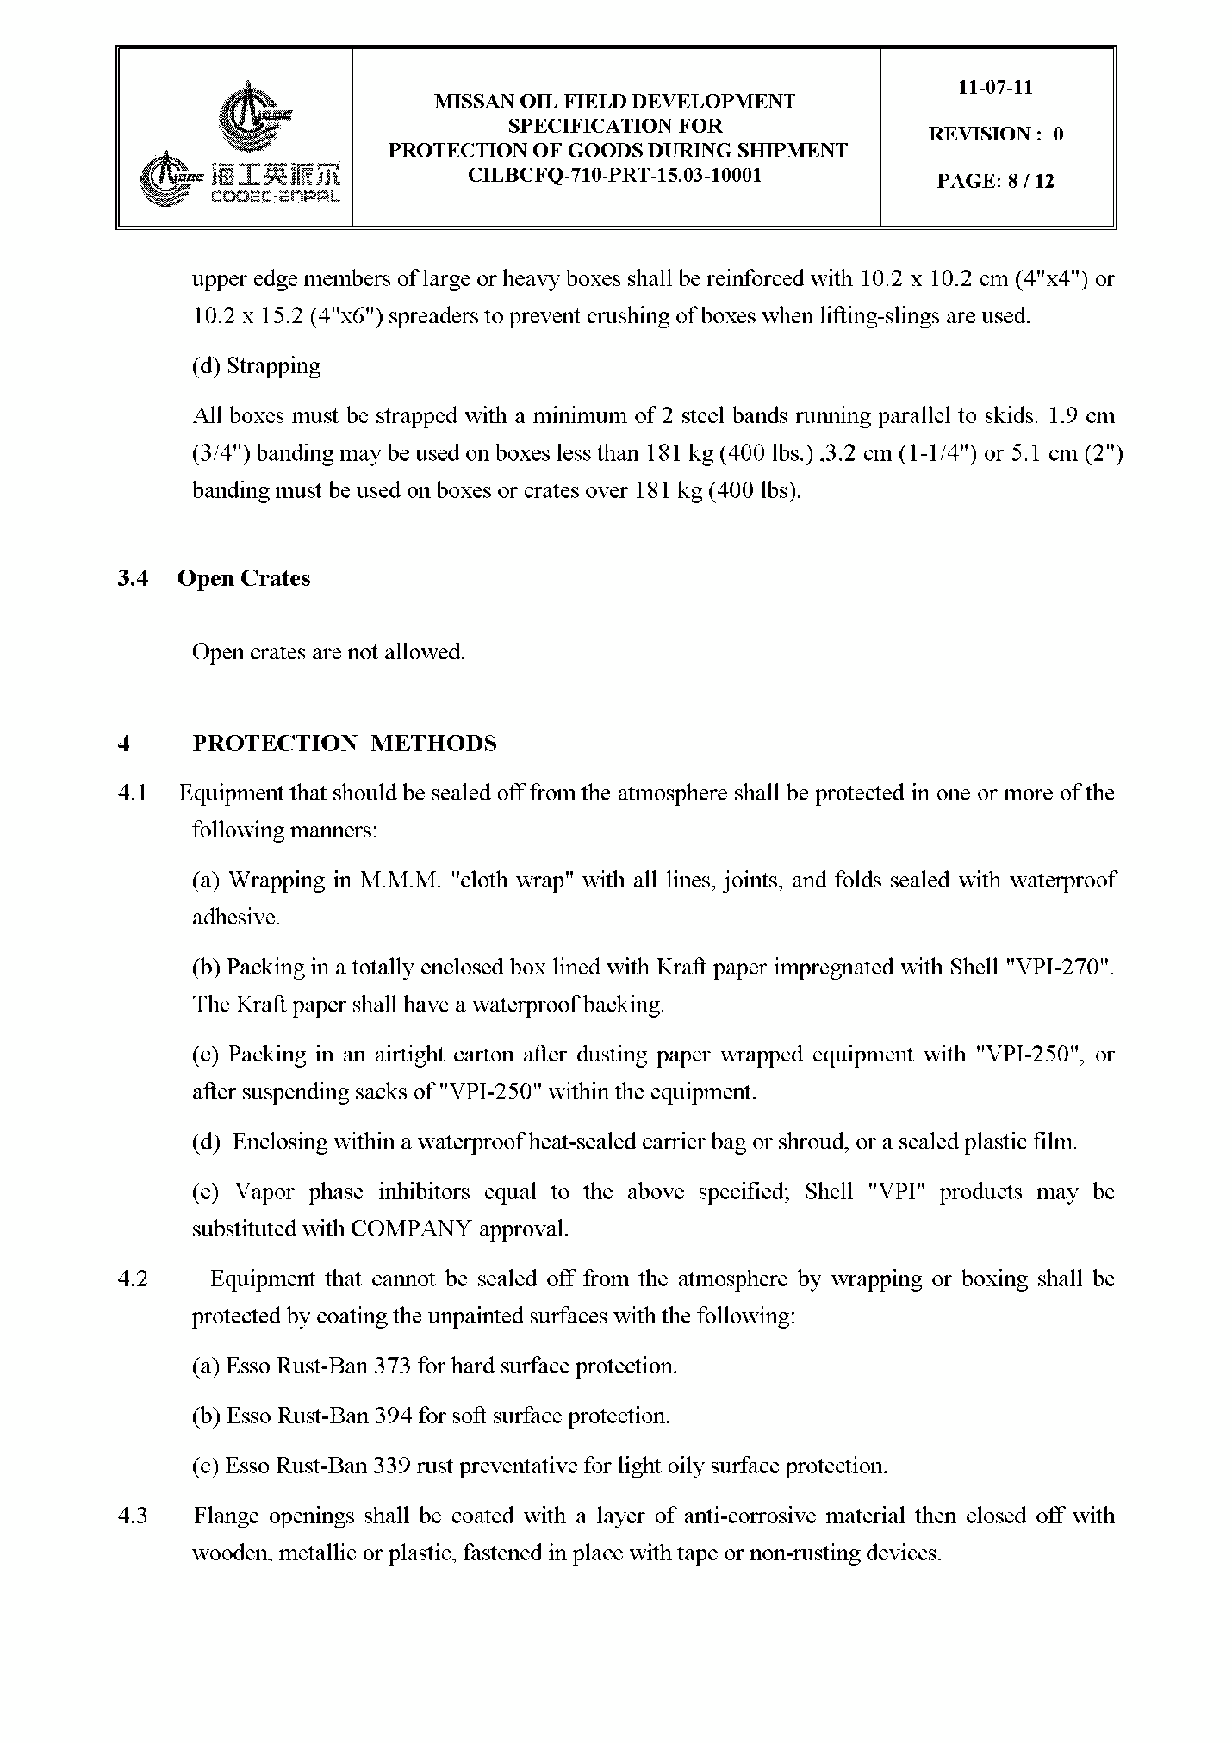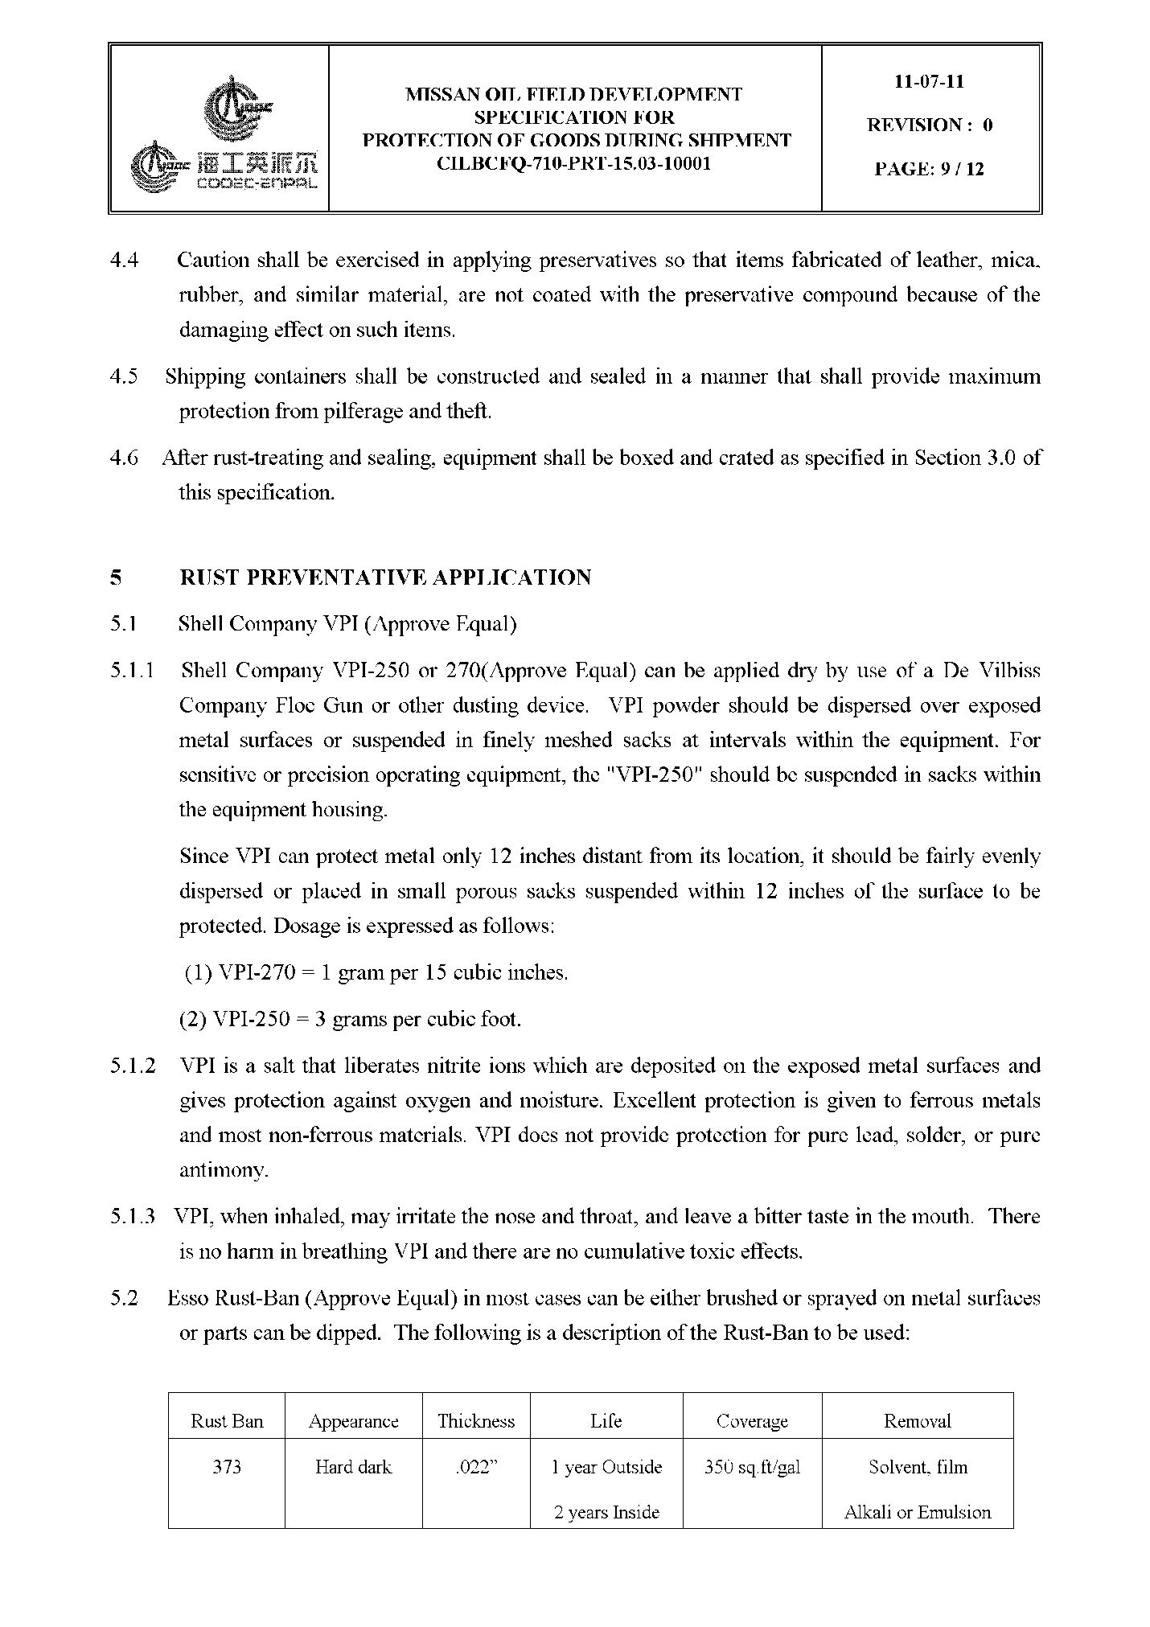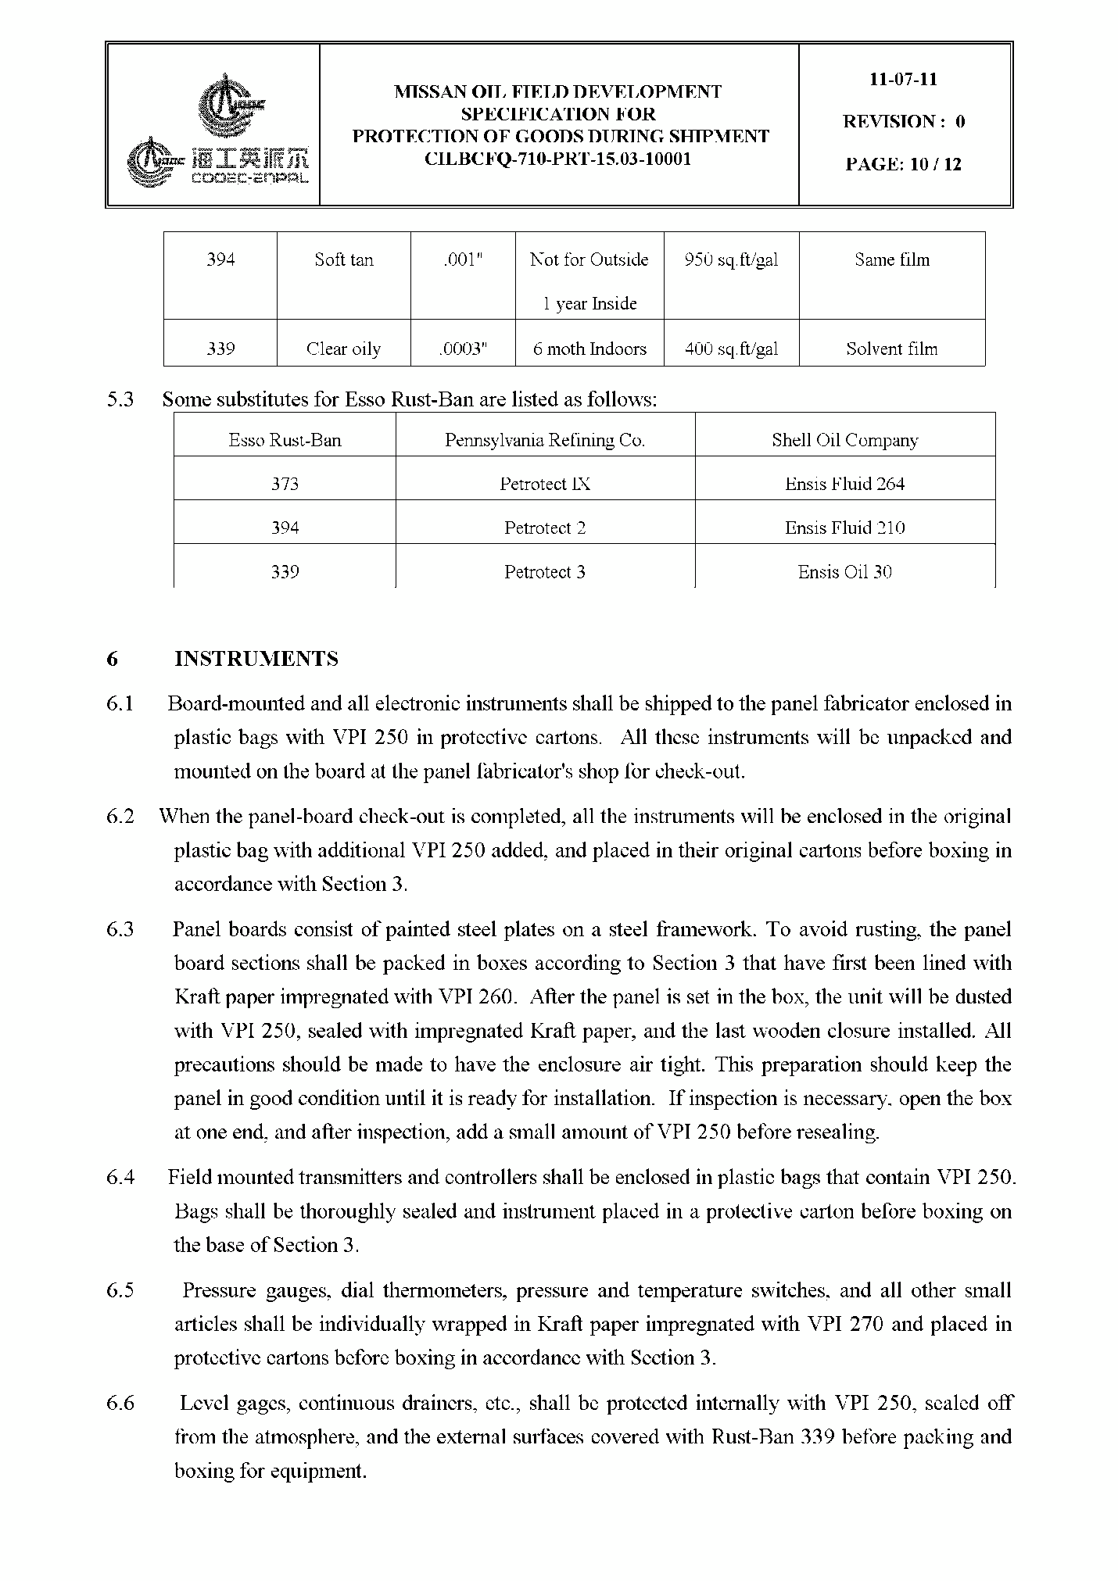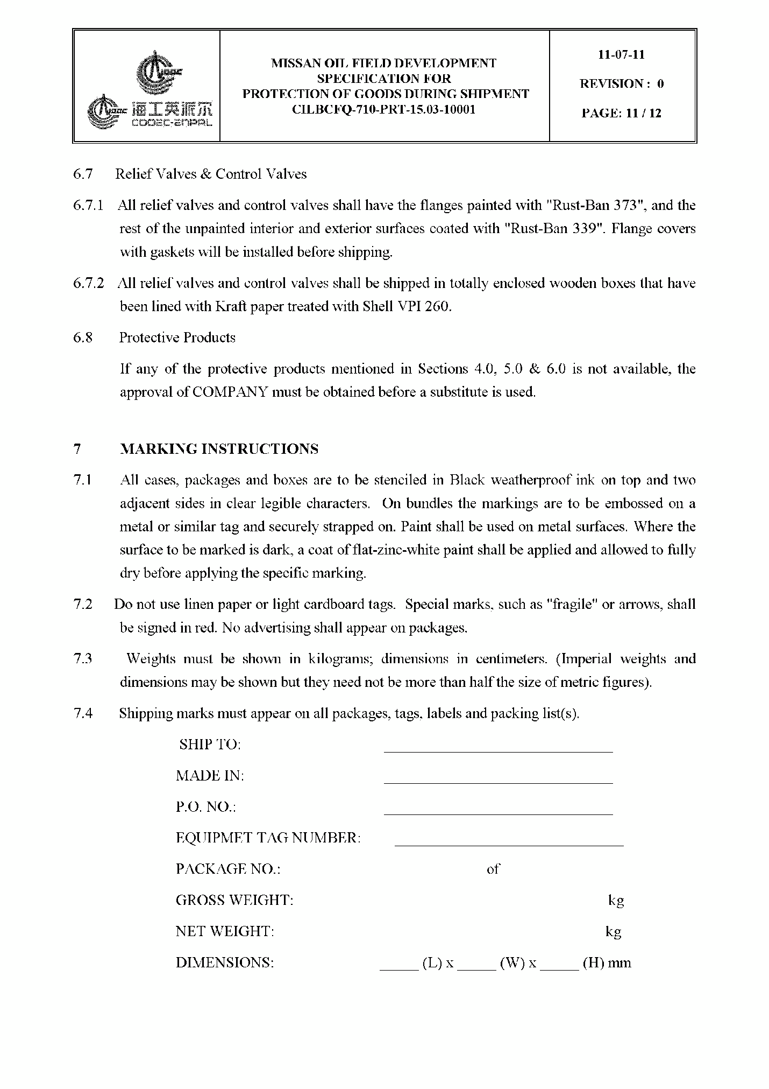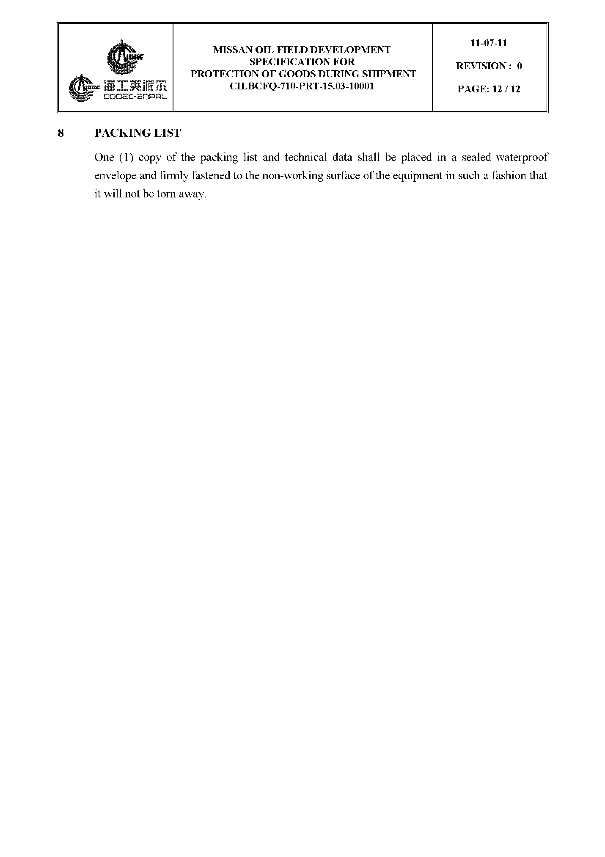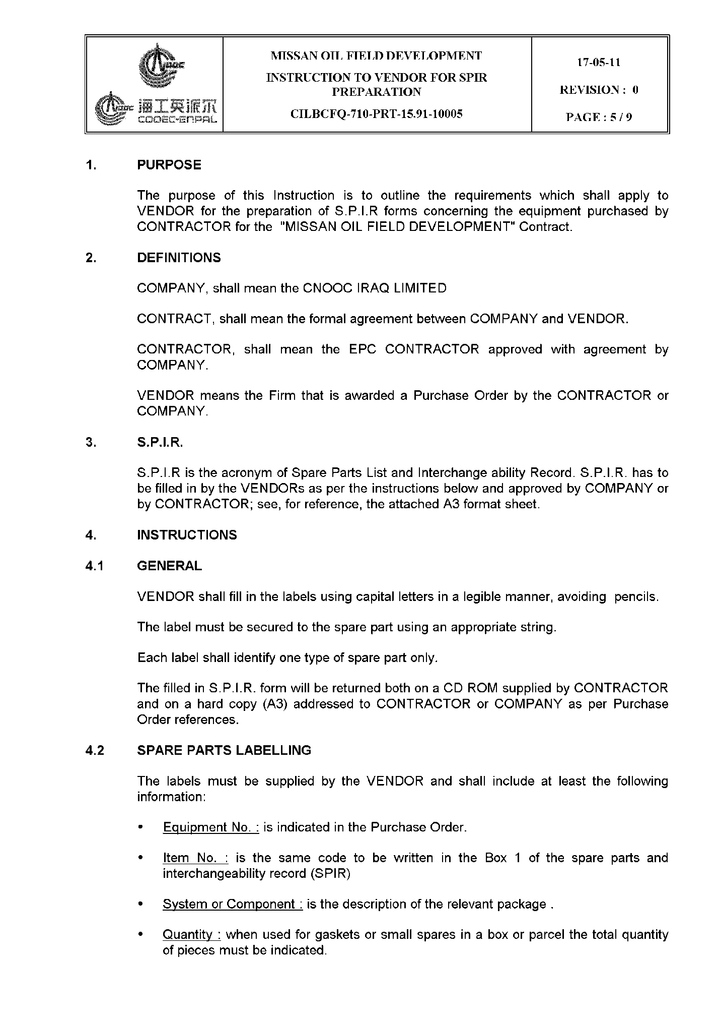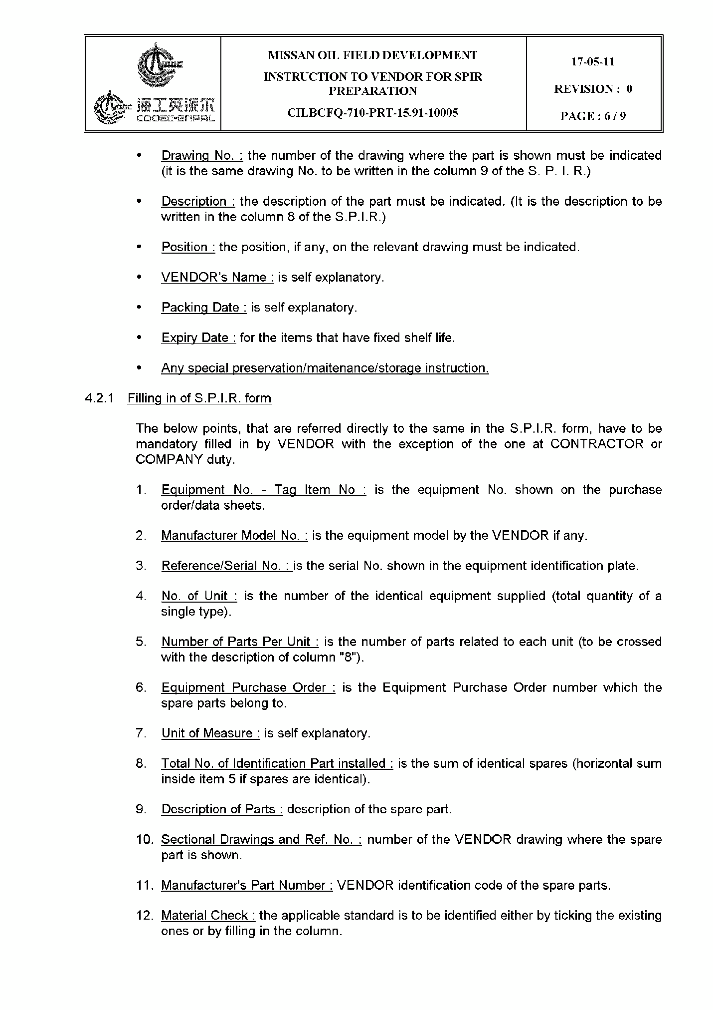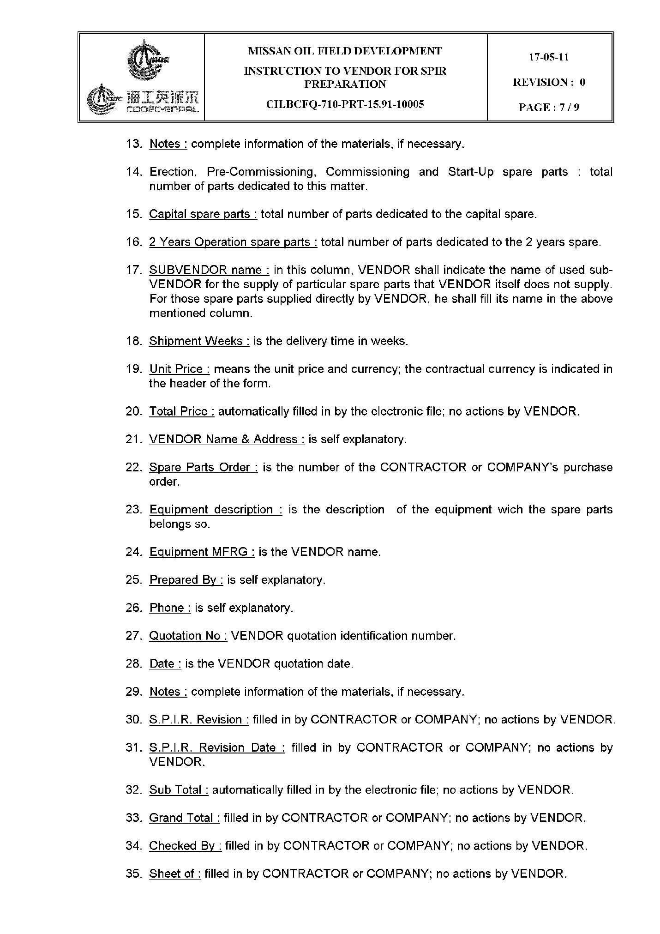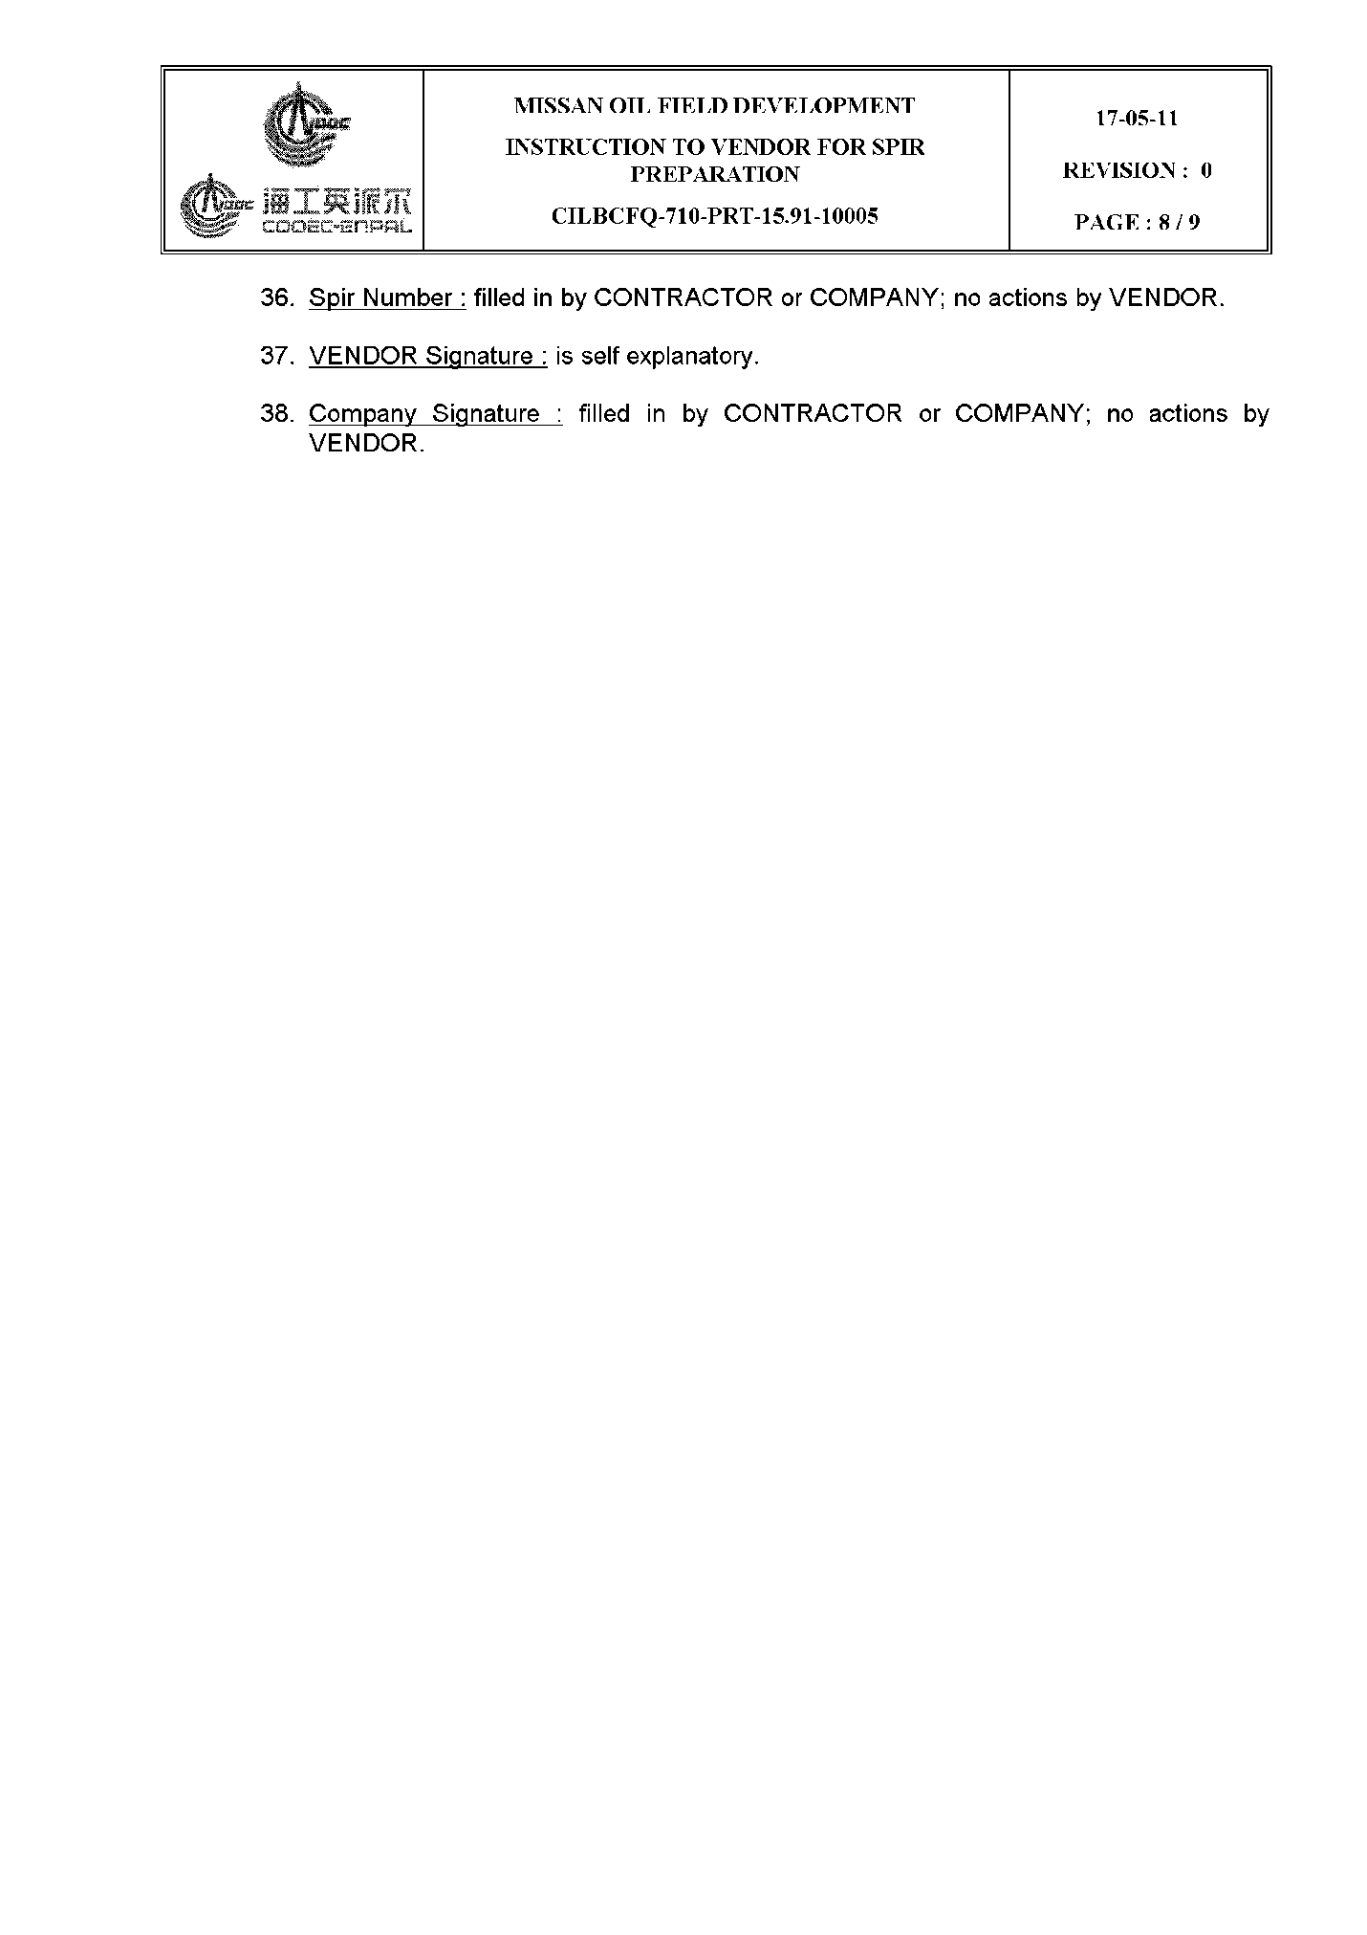

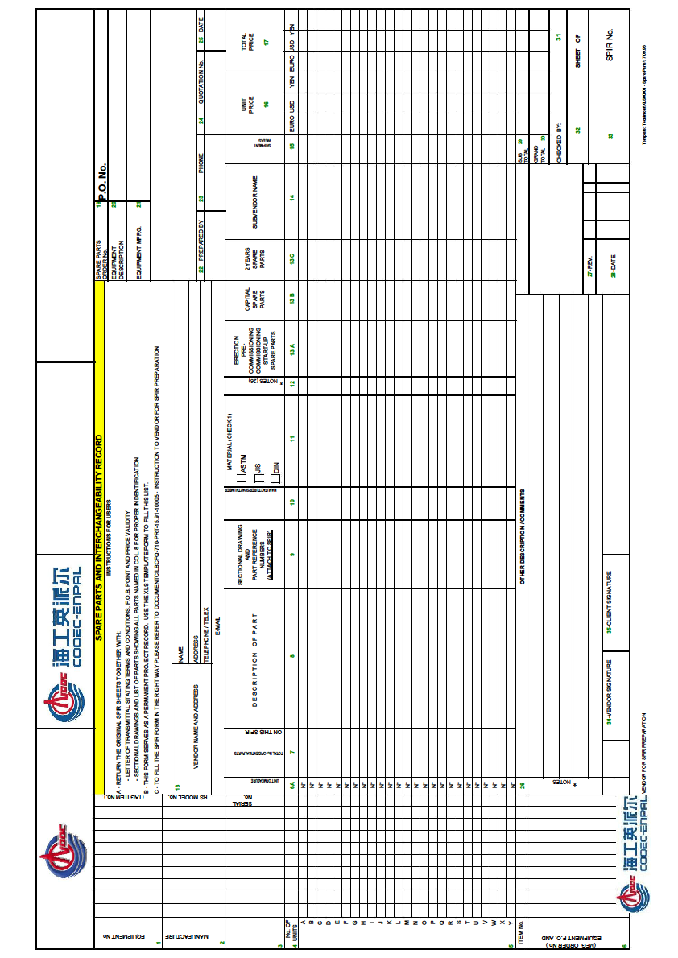

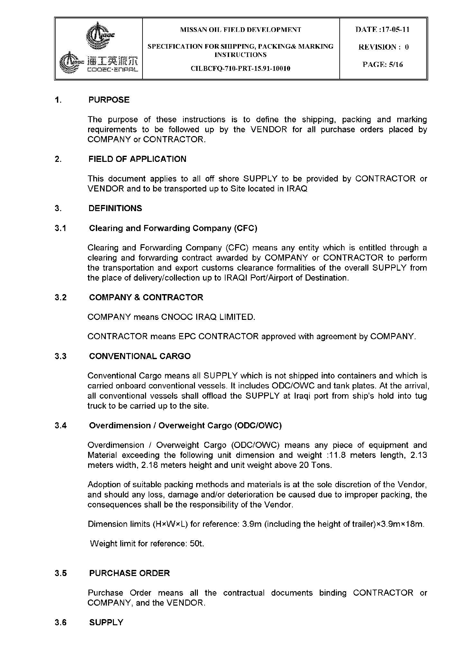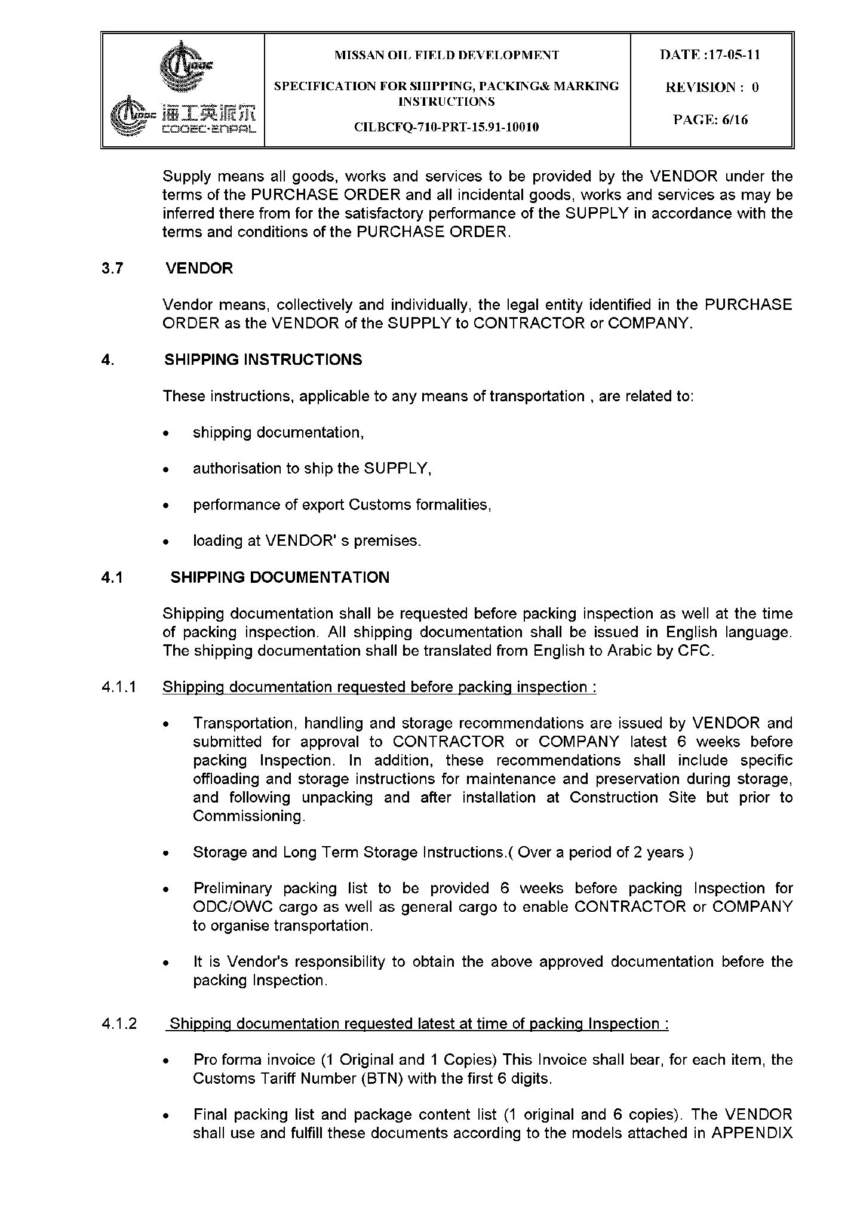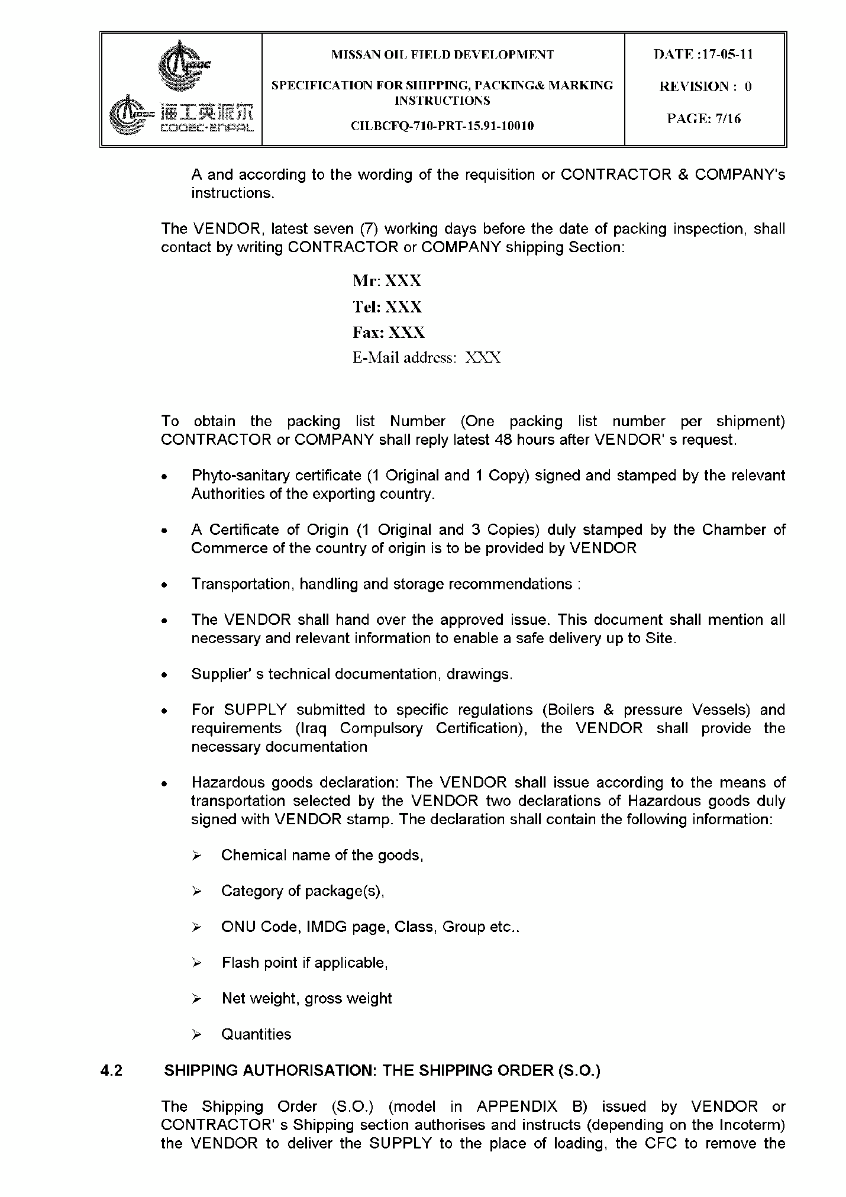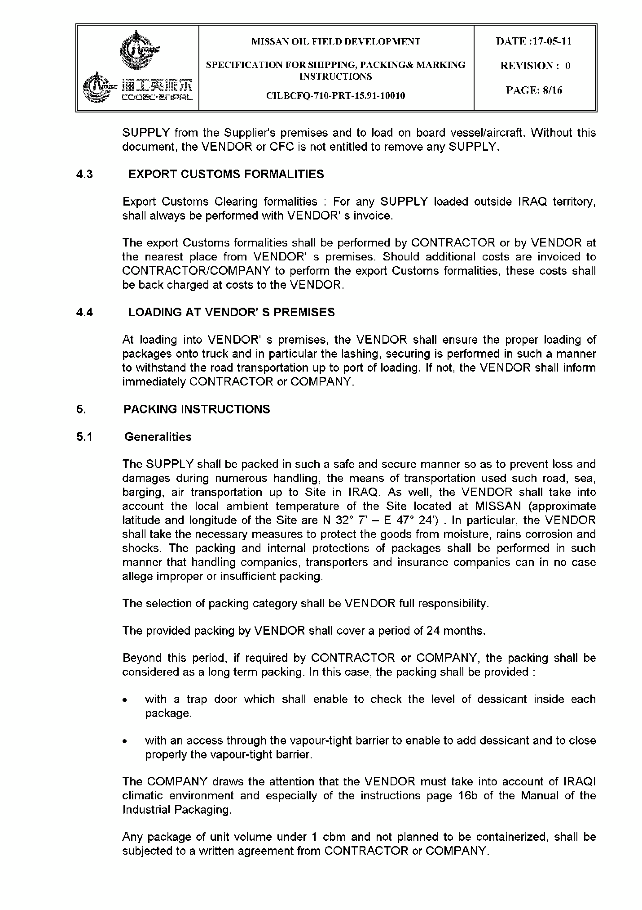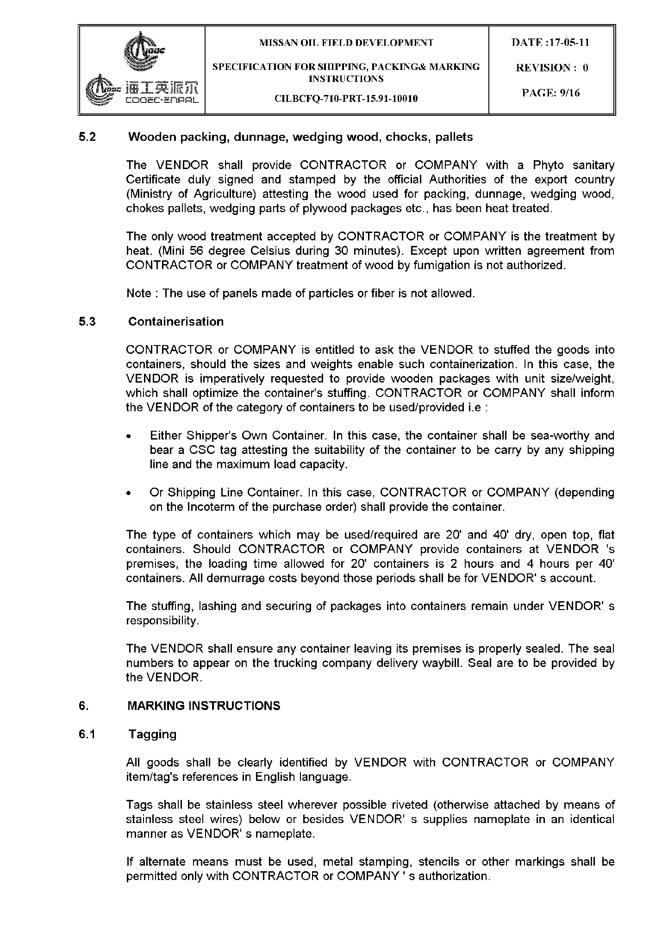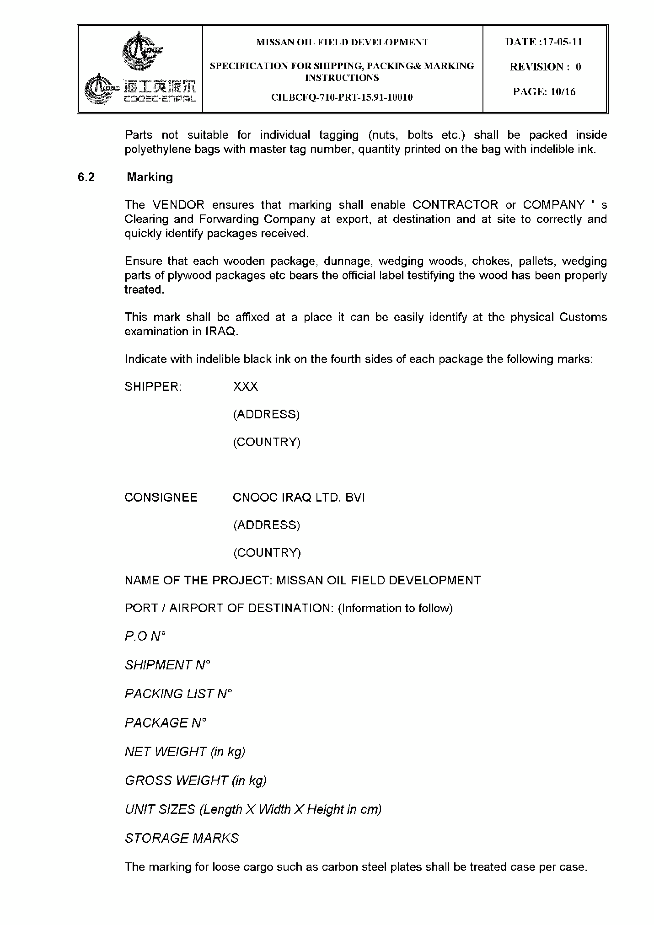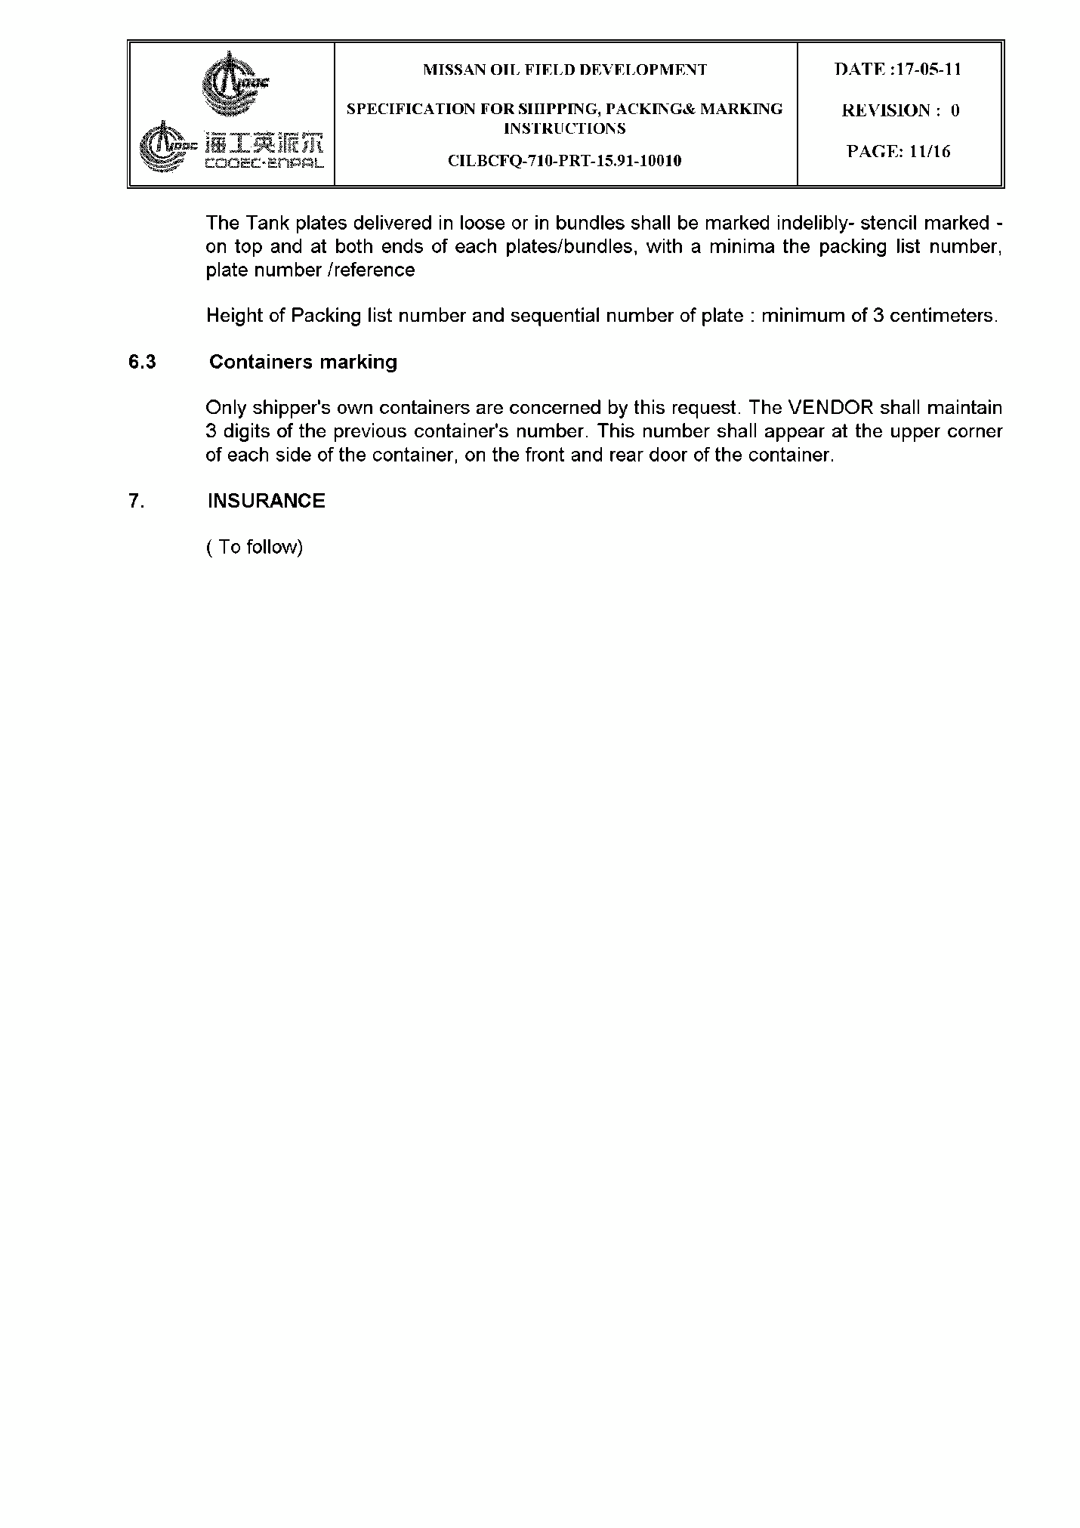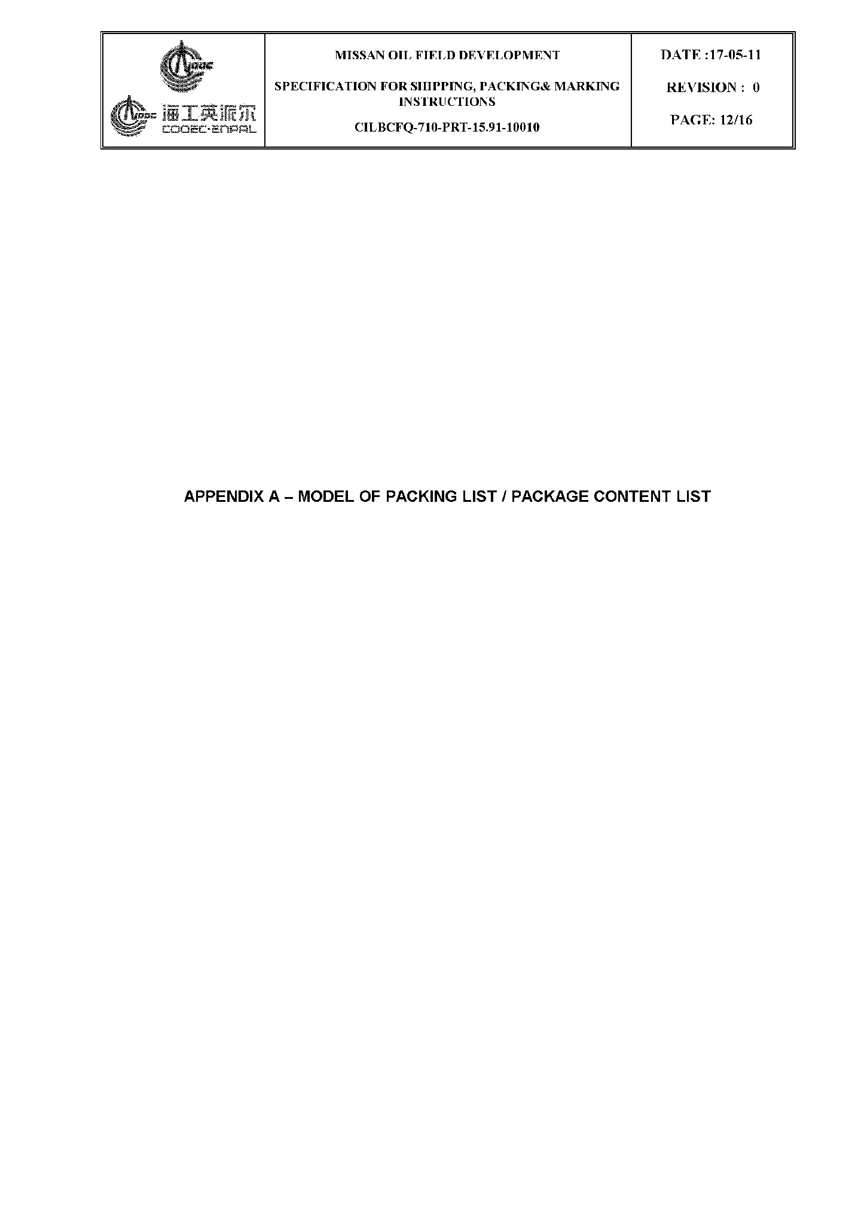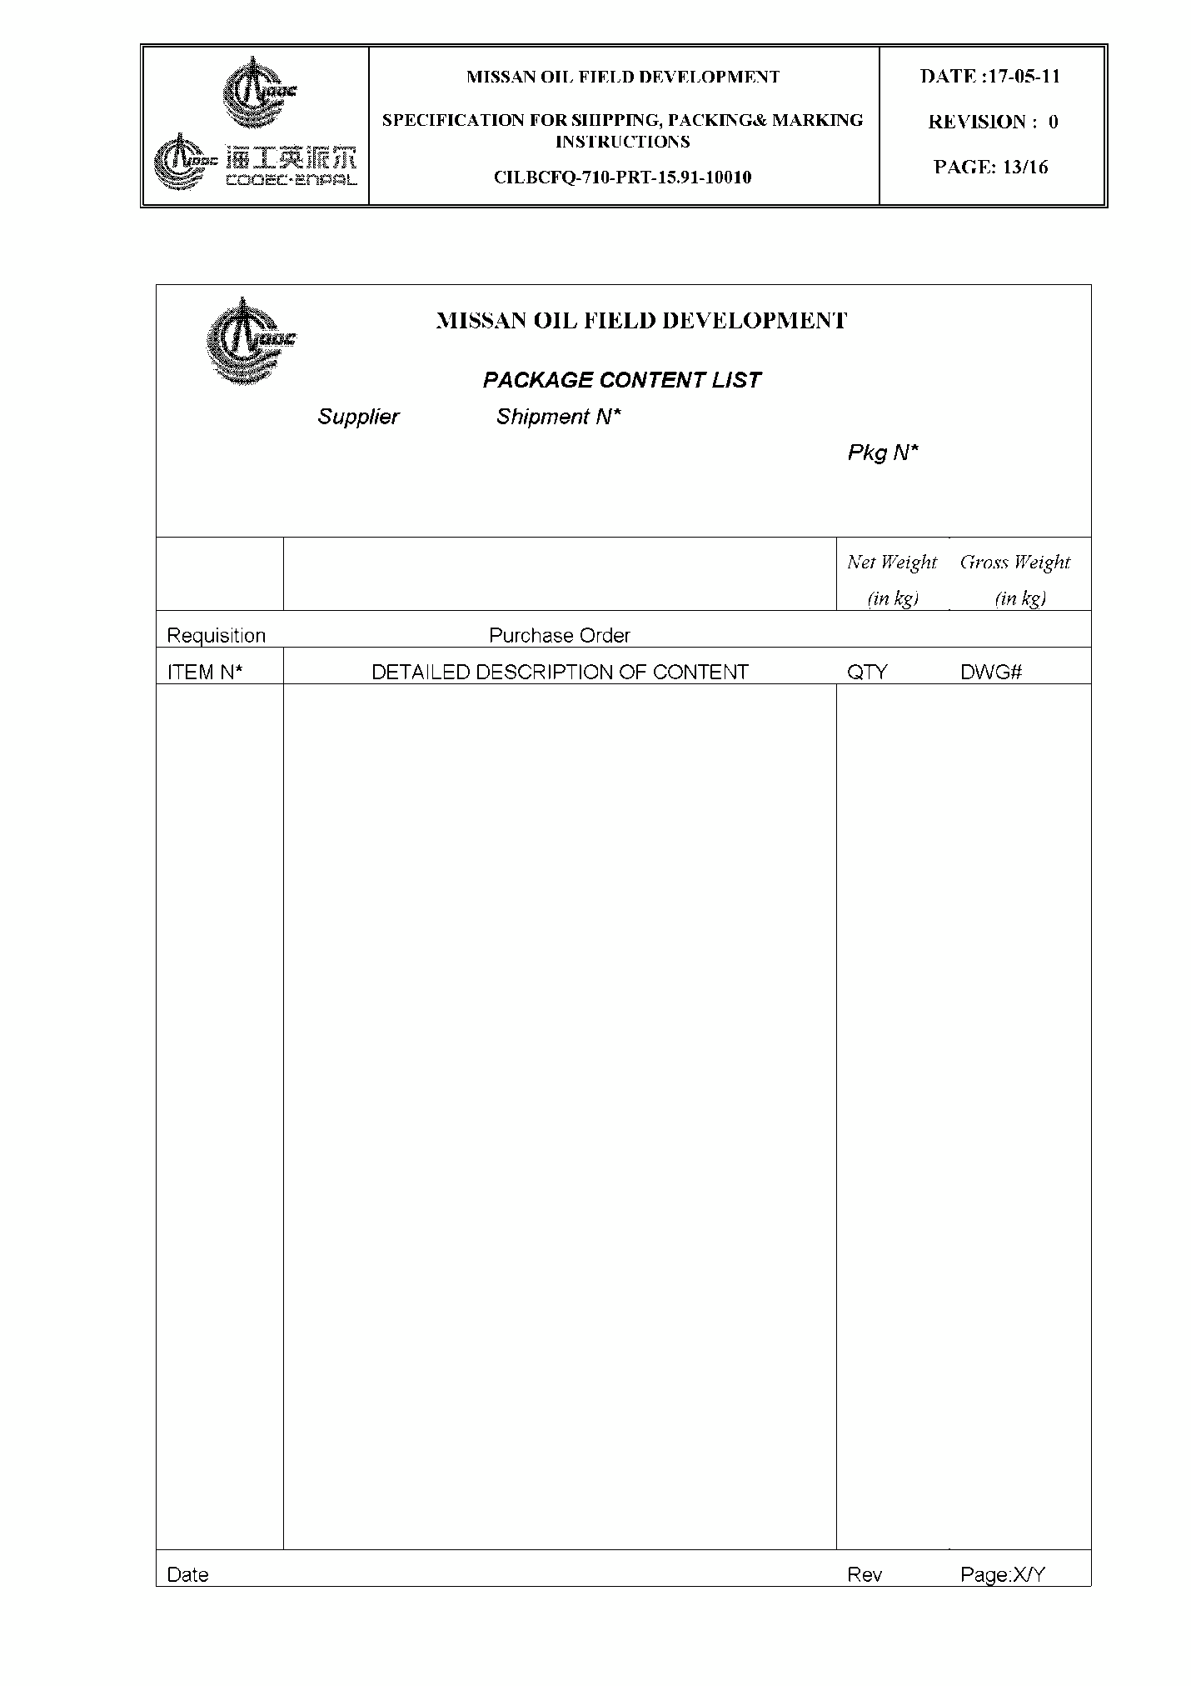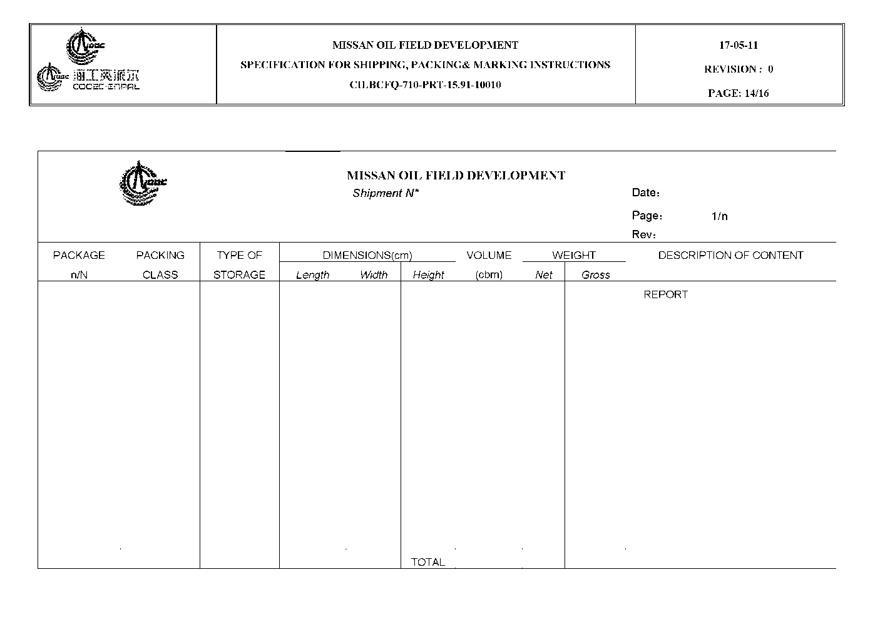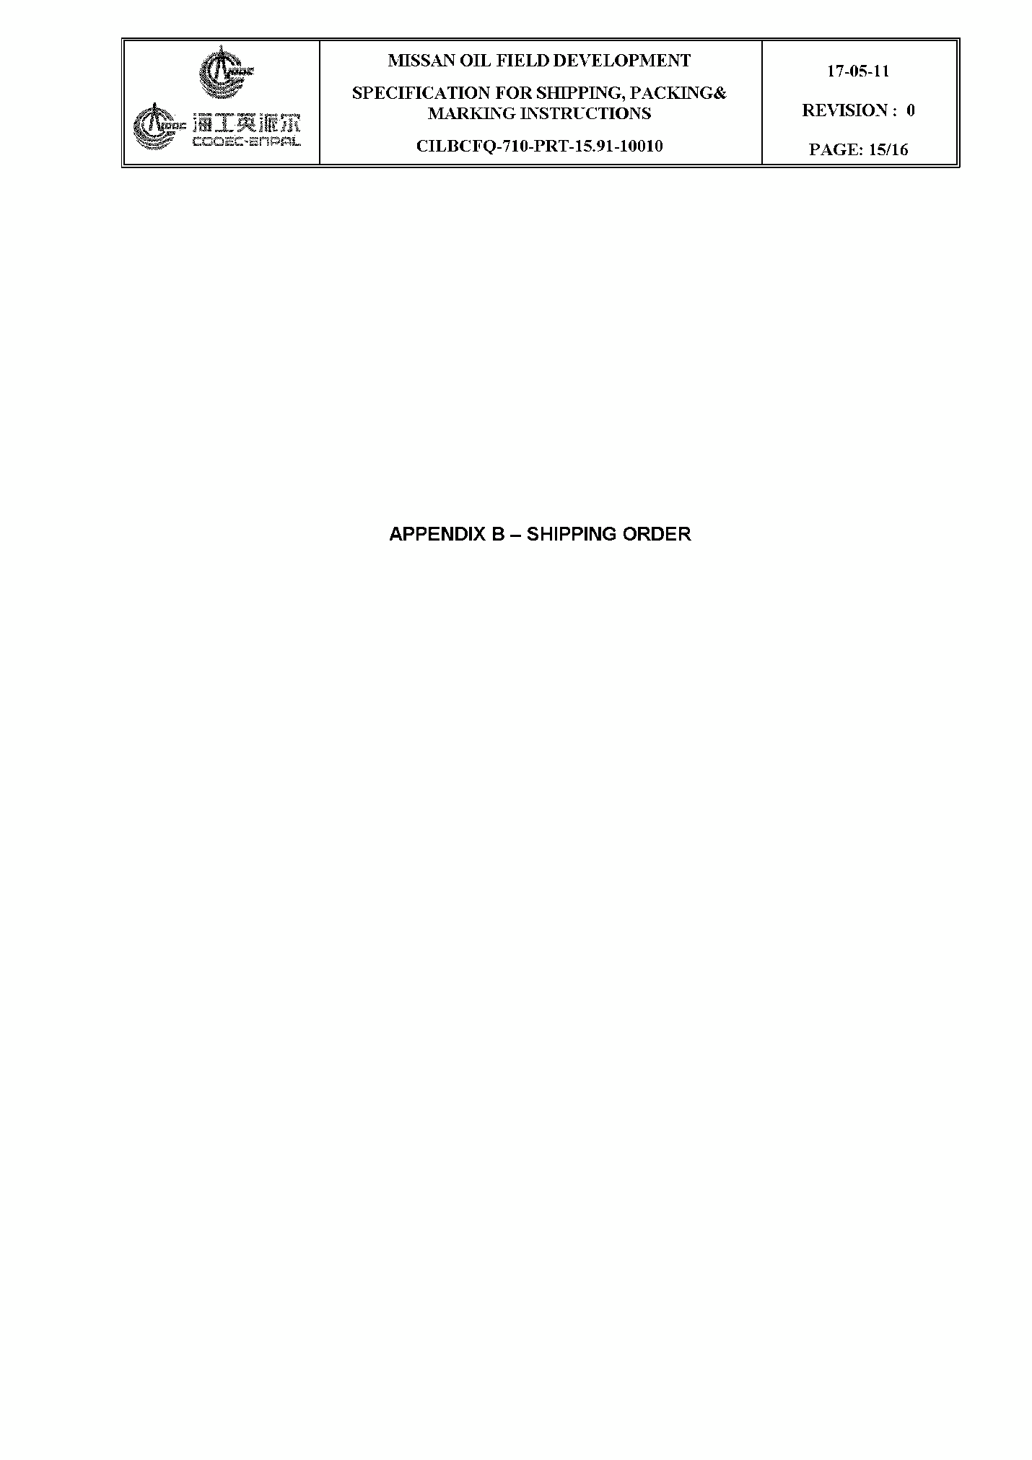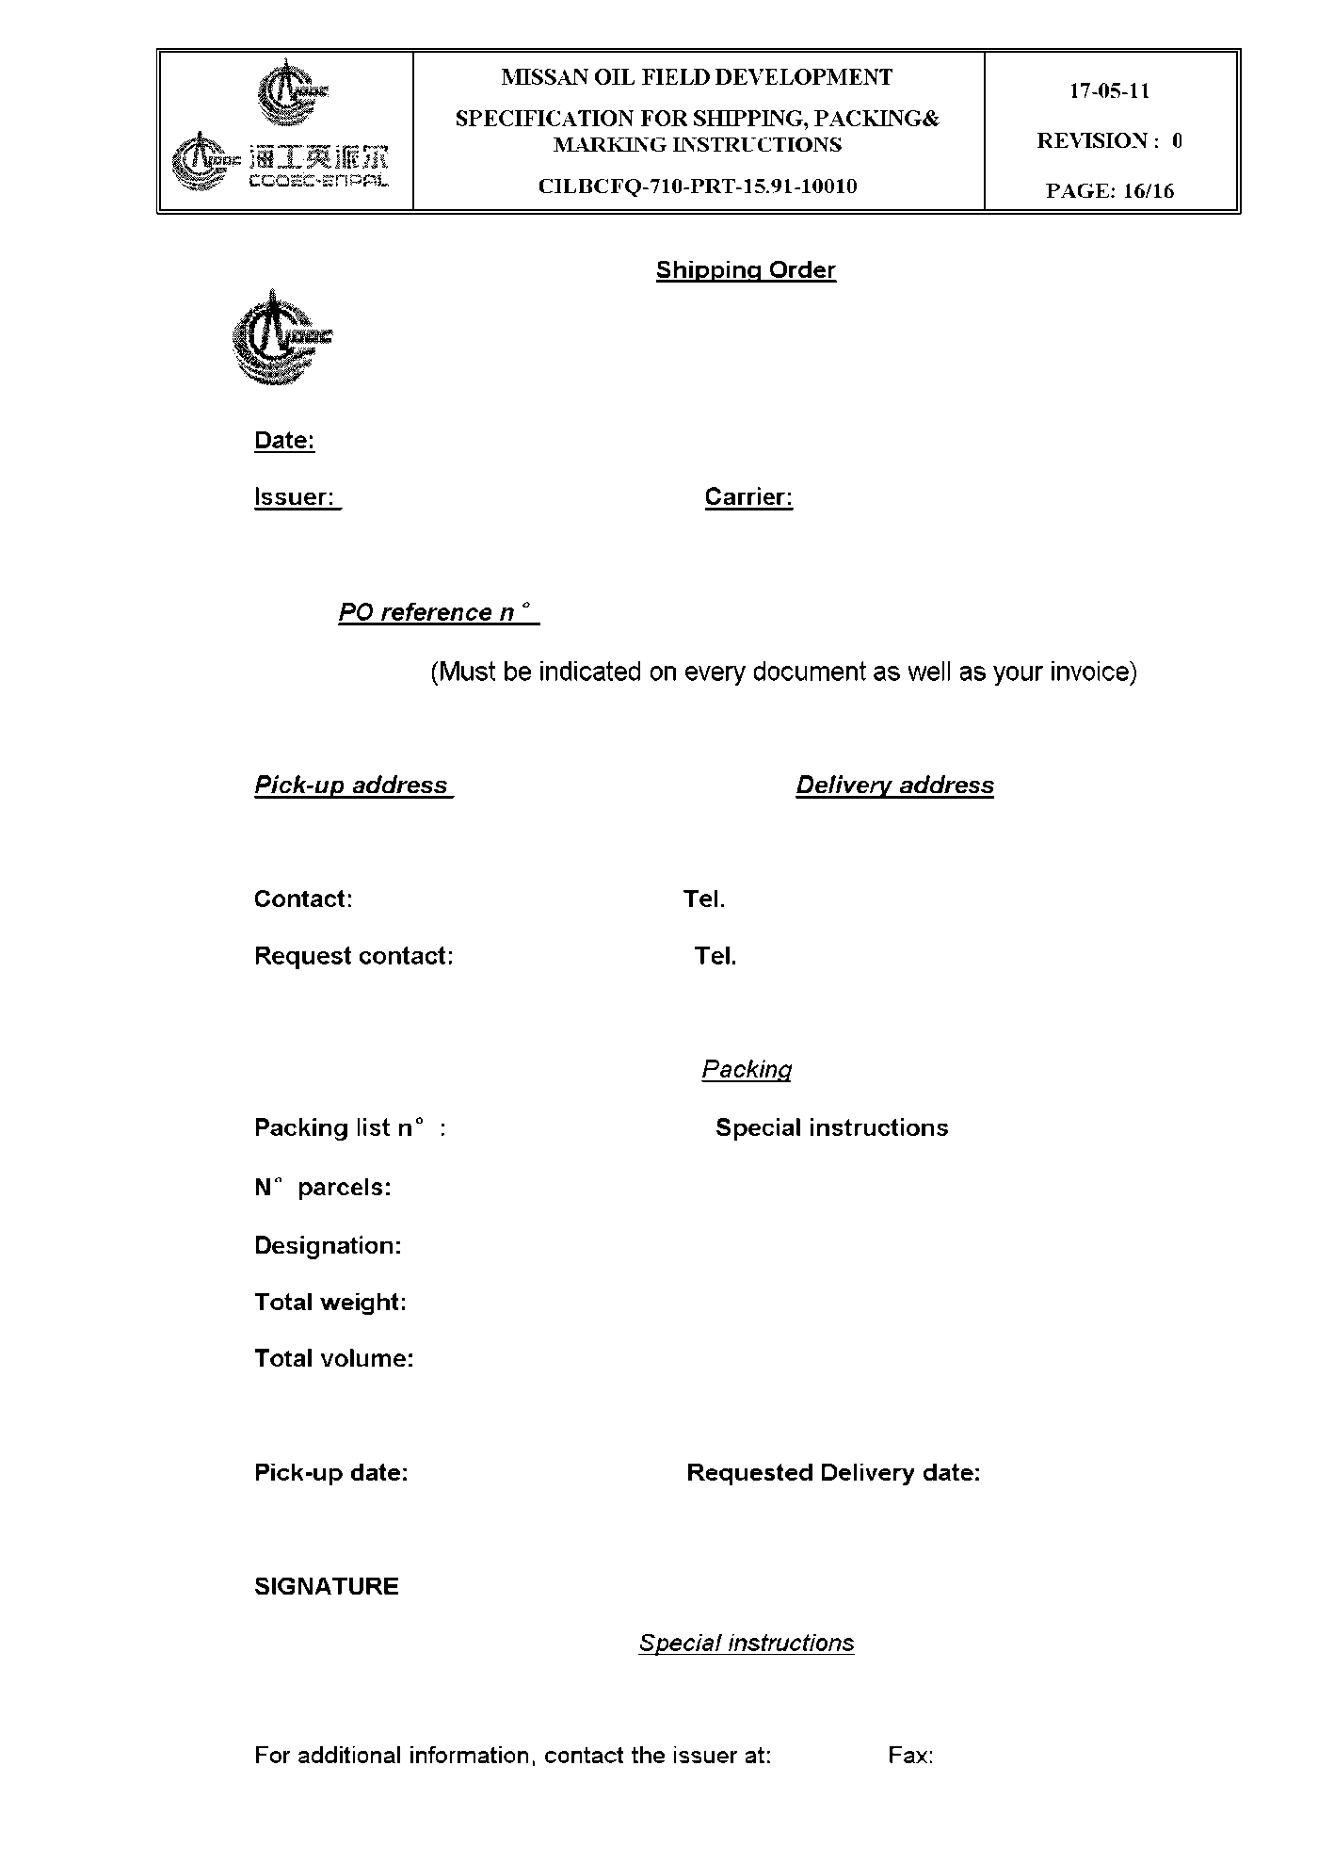

**EXHIBIT II**

**MATERIAL TAKE OFF AND DATA SHEET**

